Parte 1: Modello robusto con target quantitativo
Pozzoli,Farina
#Elaborato Data Mining - Marco Pozzoli , Emiliano Farina
#https://www.kaggle.com/datasets/shreyasur965/recent-earthquakes
# Column Descriptors:
# id: Unique identifier for each earthquake event.
# magnitude: The strength of the earthquake on the Richter scale.
# type: Type of seismic event (earthquake, explosion, etc.).
# title: Title of the earthquake event (place and magnitude).
# date: Date when the earthquake occurred.
# time: Time when the earthquake occurred.
# updated: Last updated timestamp for the event.
# url: Link to the earthquake event's details.
# detailUrl: Additional details URL.
# felt: Number of people who reported feeling the earthquake.
# cdi: Community Determined Intensity, how strongly the event was felt.
# mmi: Modified Mercalli Intensity, scale used to measure earthquake intensity.
# alert: Alert level (green, yellow, orange, red).
# status: Status of the event (reviewed, automatic).
# tsunami: Tsunami risk flag (0 = no risk, 1 = risk).
# sig: Significance of the earthquake, based on magnitude and impact.
# net: Network that detected the earthquake.
# code: Code assigned by the network.
# ids: IDs of other events related to the same earthquake.
# sources: Data sources for the event.
# types: Event types associated with the earthquake.
# nst: Number of seismic stations that recorded the event.
# dmin: Minimum distance to the earthquake event.
# rms: Root mean square of signal, used to measure earthquake intensity.
# gap: Data gap between stations detecting the earthquake.
# magType: Type of magnitude (e.g., mb, Ms).
# geometryType: Type of geometry for the location (usually "Point").
# depth: Depth of the earthquake in kilometers.
# latitude: Latitude of the earthquake's epicenter.
# longitude: Longitude of the earthquake's epicenter.
# place: General location description of the earthquake.
# distanceKM: Distance from the nearest populated place in kilometers.
# placeOnly: Flag indicating if only place information is available.
# location: Full address or description of the earthquake's location.
# continent: Continent where the earthquake occurred.
# country: Country where the earthquake occurred.
# subnational: Subnational region where the earthquake occurred.
# city: City closest to the earthquake.
# locality: Locality or neighborhood name.
# postcode: Postal code of the affected area.
# what3words: Unique 3-word code representing the location.
# timezone: Timezone of the earthquake.
# locationDetails: Additional details about the earthquake’s location.
#NB il tempo è indicato con il formato standard, che indica i millisecondi passati dal 01/01/1970.
# Carichiamo i dati -------------------------------------------------------
rm(list=ls())
#setwd("C:/Users/Università/Documents/Università/2024-25/Data Mining e Machine Learning/Elaborato")
#Carichiamo i dati:
#data <- read.csv("earthquakes.csv", stringsAsFactors = T, na.strings = "")
load("Pozzoli_Farina.RData")
data$tsunami = as.factor(data$tsunami)
data$mmi = as.factor(data$mmi)
data$cdi = as.factor(data$cdi)
#trattiamo tsunami, mmi e cdi come factors
#Visualizziamo la mappa, ogni punto corrisponde a un terremoto, il colore ne indica la profondità del sisma
library(ggplot2)
## Warning: il pacchetto 'ggplot2' è stato creato con R versione 4.4.1
library(ggmap)
## Warning: il pacchetto 'ggmap' è stato creato con R versione 4.4.1
## ℹ Google's Terms of Service: <https://mapsplatform.google.com>
## Stadia Maps' Terms of Service: <https://stadiamaps.com/terms-of-service/>
## OpenStreetMap's Tile Usage Policy: <https://operations.osmfoundation.org/policies/tiles/>
## ℹ Please cite ggmap if you use it! Use `citation("ggmap")` for details.
world_map <- map_data("world")
ggplot() +
geom_polygon(data = world_map, aes(x = long, y = lat, group = group),
fill = "gray", color = "white") +
geom_point(data = data, aes(x = longitude, y = latitude, color = depth),
size = 3, alpha = 0.7) +
scale_color_gradient(low = "green", high = "red") +
labs(title = "Mappa dei Terremoti",
x = "Longitudine", y = "Latitudine", color = "Profondità") +
theme_minimal()
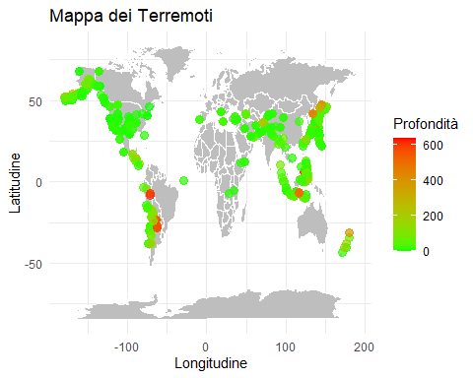
summary(data)
## id magnitude type
## tx2024mydx: 4 Min. :3.000 earthquake:1137
## tx2024myet: 4 1st Qu.:3.800
## tx2024oixr: 4 Median :5.300
## tx2024okxn: 4 Mean :4.857
## tx2024pedq: 4 3rd Qu.:5.600
## tx2024pefy: 4 Max. :7.600
## (Other) :1113
## title date
## M 5.3 - Izu Islands, Japan region: 12 2024-07-02T23:39:59: 8
## M 5.4 - Izu Islands, Japan region: 12 2024-07-03T00:04:35: 8
## M 5.5 - Izu Islands, Japan region: 12 2024-07-23T02:31:04: 8
## M 5.7 - Izu Islands, Japan region: 12 2024-08-03T17:24:28: 8
## M 3.5 - 54 km NW of Toyah, Texas : 10 2024-08-23T03:21:38: 8
## M 5.6 - Izu Islands, Japan region: 8 2024-09-08T02:37:22: 8
## (Other) :1071 (Other) :1089
## time updated
## Min. :1.688e+12 Min. :1.693e+12
## 1st Qu.:1.702e+12 1st Qu.:1.708e+12
## Median :1.714e+12 Median :1.720e+12
## Mean :1.712e+12 Mean :1.717e+12
## 3rd Qu.:1.723e+12 3rd Qu.:1.725e+12
## Max. :1.727e+12 Max. :1.727e+12
##
## url
## https://earthquake.usgs.gov/earthquakes/eventpage/tx2024mydx: 4
## https://earthquake.usgs.gov/earthquakes/eventpage/tx2024myet: 4
## https://earthquake.usgs.gov/earthquakes/eventpage/tx2024oixr: 4
## https://earthquake.usgs.gov/earthquakes/eventpage/tx2024okxn: 4
## https://earthquake.usgs.gov/earthquakes/eventpage/tx2024pedq: 4
## https://earthquake.usgs.gov/earthquakes/eventpage/tx2024pefy: 4
## (Other) :1113
## detailUrl
## https://earthquake.usgs.gov/earthquakes/feed/v1.0/detail/us6000n9xf.geojson: 4
## https://earthquake.usgs.gov/earthquakes/feed/v1.0/detail/us6000n9xs.geojson: 4
## https://earthquake.usgs.gov/earthquakes/feed/v1.0/detail/us6000nepl.geojson: 4
## https://earthquake.usgs.gov/earthquakes/feed/v1.0/detail/us6000nhxw.geojson: 4
## https://earthquake.usgs.gov/earthquakes/feed/v1.0/detail/us6000nnuf.geojson: 4
## https://earthquake.usgs.gov/earthquakes/feed/v1.0/detail/us6000nqee.geojson: 4
## (Other) :1113
## felt cdi mmi alert status
## Min. : 0.0 0 :365 4 :490 green :711 automatic: 6
## 1st Qu.: 0.0 3 :169 3 :210 orange: 6 reviewed :1127
## Median : 2.0 4 :156 5 :146 red : 9 REVIEWED : 4
## Mean : 414.4 5 :132 6 :105 yellow: 38
## 3rd Qu.: 24.0 6 : 79 7 : 84 NA's :373
## Max. :183786.0 2 : 77 2 : 42
## (Other):159 (Other): 60
## tsunami sig net code
## 0:1069 Min. : 138.0 us :794 2024mydx: 4
## 1: 68 1st Qu.: 234.0 tx :150 2024myet: 4
## Median : 449.0 ci : 68 2024oixr: 4
## Mean : 432.7 ak : 53 2024okxn: 4
## 3rd Qu.: 518.0 nn : 30 2024pedq: 4
## Max. :2419.0 nc : 13 2024pefy: 4
## (Other): 29 (Other) :1113
## ids
## ,us7000necw,tx2024shcj, : 6
## ,at00shzgbj,us6000nj9s,pt24223000,usauto6000nj9s,: 4
## ,pt23190000,us6000kr3t, : 4
## ,pt24001001,at00s6kml3,us6000m0xl, : 4
## ,tx2024rteg,us6000nqll, : 4
## ,tx2024rvqa,us7000ncvs, : 4
## (Other) :1111
## sources
## ,us, :244
## ,us,usauto, :146
## ,us,tx, :123
## ,us,usauto,pt, : 85
## ,usauto,us, : 74
## ,us,usauto,at,pt,: 45
## (Other) :420
## types
## ,dyfi,internal-moment-tensor,losspager,moment-tensor,origin,phase-data,shakemap, :111
## ,dyfi,losspager,moment-tensor,origin,phase-data,shakemap, :105
## ,origin,phase-data,shakemap, :104
## ,dyfi,moment-tensor,origin,phase-data,shakemap, : 70
## ,dyfi,internal-moment-tensor,internal-origin,losspager,moment-tensor,origin,phase-data,shakemap,: 69
## ,internal-moment-tensor,losspager,moment-tensor,origin,phase-data,shakemap, : 66
## (Other) :612
## nst dmin rms gap
## Min. : 0.0 Min. : 0.000 Min. :0.000 Min. : 0.00
## 1st Qu.: 37.0 1st Qu.: 0.100 1st Qu.:0.300 1st Qu.: 30.00
## Median :102.0 Median : 0.680 Median :0.630 Median : 49.00
## Mean :115.1 Mean : 1.343 Mean :0.586 Mean : 55.06
## 3rd Qu.:157.0 3rd Qu.: 2.061 3rd Qu.:0.780 3rd Qu.: 68.00
## Max. :619.0 Max. :12.457 Max. :2.520 Max. :256.00
##
## magType geometryType depth latitude
## mww :551 Point:1137 Min. : -0.25 Min. :-43.71
## ml :351 1st Qu.: 7.55 1st Qu.: 24.20
## mb :124 Median : 10.00 Median : 31.67
## mwr : 53 Mean : 41.29 Mean : 27.31
## mw : 36 3rd Qu.: 34.72 3rd Qu.: 37.50
## mb_lg : 16 Max. :639.50 Max. : 68.18
## (Other): 6
## longitude place distanceKM
## Min. :-179.807 Izu Islands, Japan region : 76 Min. : 0.00
## 1st Qu.:-104.452 56 km S of Whites City, New Mexico: 20 1st Qu.: 15.00
## Median : -68.682 54 km NW of Toyah, Texas : 18 Median : 37.00
## Mean : -3.931 57 km S of Whites City, New Mexico: 16 Mean : 52.29
## 3rd Qu.: 126.628 55 km S of Whites City, New Mexico: 14 3rd Qu.: 61.00
## Max. : 179.972 58 km S of Whites City, New Mexico: 12 Max. :298.00
## (Other) :981
## placeOnly location
## S of Whites City, New Mexico: 88 Whites City, New Mexico : 98
## Izu Islands, Japan region : 76 Izu Islands, Japan region: 76
## NW of Toyah, Texas : 32 Hualien City, Taiwan : 50
## S of Hualien City, Taiwan : 18 Toyah, Texas : 39
## NNE of Hermleigh, Texas : 17 Anamizu, Japan : 28
## NE of Anamizu, Japan : 16 Hermleigh, Texas : 25
## (Other) :890 (Other) :821
## continent country subnational
## North America:446 United States of America (the):423 Texas :222
## Asia :333 Japan : 68 California: 75
## South America: 75 Taiwan (Province of China) : 55 Nevada : 40
## Europe : 7 Indonesia : 38 Alaska : 37
## Africa : 3 China : 30 Ishikawa : 32
## (Other) : 3 (Other) :185 (Other) :310
## NA's :270 NA's :338 NA's :421
## city locality postcode
## Van Horn :130 Etc/GMT-9 :121 Min. : 8833
## Hawthorne : 24 Van Horn : 90 1st Qu.:79331
## Falls City: 20 Etc/GMT-8 : 59 Median :79772
## Suzu : 20 Etc/GMT-10 : 43 Mean :83086
## Pecos : 17 Culberson County: 40 3rd Qu.:92530
## (Other) :463 Taiwan : 40 Max. :99827
## NA's :463 (Other) :744 NA's :940
## what3words timezone
## adders.jockeyed.seaborne : 4 Min. :-720.00
## album.daybook.vibrate : 4 1st Qu.:-360.00
## amending.hoot.encamped : 4 Median :-180.00
## amplified.intermediate.vociferously: 4 Mean : 21.74
## anchovy.shampoo.impersonator : 4 3rd Qu.: 480.00
## apathy.boldest.humanlike : 4 Max. : 780.00
## (Other) :1113
## locationDetails
## [{'id': '9', 'wikidataId': 'Q49', 'name': 'North America', 'description': "continent on the Earth's northwestern quadrant", 'geonameId': '6255149', 'adminLevel': '0'}, {'id': '87153', 'wikidataId': '', 'name': 'America/Chicago', 'description': 'time zone', 'geonameId': '0', 'adminLevel': '0'}, {'id': '89129', 'wikidataId': '', 'name': '48-109-94015', 'description': 'FIPS code', 'geonameId': '0', 'adminLevel': '0'}, {'id': '86034', 'wikidataId': 'Q30', 'name': 'United States of America (the)', 'description': 'country in North America', 'geonameId': '6252001', 'adminLevel': '2'}, {'id': '161', 'wikidataId': 'Q1439', 'name': 'Texas', 'description': 'State in the southern United States', 'geonameId': '4736286', 'adminLevel': '4'}, {'id': '162', 'wikidataId': 'Q108607', 'name': 'Culberson County', 'description': 'county in Texas, United States', 'geonameId': '5519788', 'adminLevel': '6'}, {'id': '87565', 'wikidataId': 'Q976246', 'name': 'Van Horn', 'description': 'town in and the seat of Culberson County, Texas, United States', 'geonameId': '5532924', 'adminLevel': '8'}] : 60
## [{'id': '86373', 'wikidataId': 'Q1964385', 'name': 'Nanpo Islands', 'description': 'Japanese term 南方諸島 (literally "southern islands"). indefinitely refers Izu and Ogasawara Islands', 'geonameId': '2111702', 'adminLevel': '0'}, {'id': '87155', 'wikidataId': '', 'name': 'Etc/GMT-9', 'description': 'time zone', 'geonameId': '0', 'adminLevel': '0'}, {'id': '315', 'wikidataId': 'Q159183', 'name': 'Philippine Sea', 'description': 'sea located east and northeast of the Philippines', 'geonameId': '1818190', 'adminLevel': '0'}] : 45
## [{'id': '89129', 'wikidataId': '', 'name': '48-109-94015', 'description': 'FIPS code', 'geonameId': '0', 'adminLevel': '0'}, {'id': '9', 'wikidataId': 'Q49', 'name': 'North America', 'description': "continent on the Earth's northwestern quadrant", 'geonameId': '6255149', 'adminLevel': '0'}, {'id': '36', 'wikidataId': 'Q578170', 'name': 'contiguous United States', 'description': '48 states of the United States apart from Alaska and Hawaii', 'geonameId': '0', 'adminLevel': '0'}, {'id': '87153', 'wikidataId': '', 'name': 'America/Chicago', 'description': 'time zone', 'geonameId': '0', 'adminLevel': '0'}, {'id': '86034', 'wikidataId': 'Q30', 'name': 'United States of America (the)', 'description': 'country in North America', 'geonameId': '6252001', 'adminLevel': '2'}, {'id': '161', 'wikidataId': 'Q1439', 'name': 'Texas', 'description': 'State in the southern United States', 'geonameId': '4736286', 'adminLevel': '4'}, {'id': '162', 'wikidataId': 'Q108607', 'name': 'Culberson County', 'description': 'county in Texas, United States', 'geonameId': '5519788', 'adminLevel': '6'}, {'id': '87565', 'wikidataId': 'Q976246', 'name': 'Van Horn', 'description': 'town in and the seat of Culberson County, Texas, United States', 'geonameId': '5532924', 'adminLevel': '8'}]: 41
## [{'id': '9', 'wikidataId': 'Q49', 'name': 'North America', 'description': "continent on the Earth's northwestern quadrant", 'geonameId': '6255149', 'adminLevel': '0'}, {'id': '36', 'wikidataId': 'Q578170', 'name': 'contiguous United States', 'description': '48 states of the United States apart from Alaska and Hawaii', 'geonameId': '0', 'adminLevel': '0'}, {'id': '87153', 'wikidataId': '', 'name': 'America/Chicago', 'description': 'time zone', 'geonameId': '0', 'adminLevel': '0'}, {'id': '89129', 'wikidataId': '', 'name': '48-109-94015', 'description': 'FIPS code', 'geonameId': '0', 'adminLevel': '0'}, {'id': '86034', 'wikidataId': 'Q30', 'name': 'United States of America (the)', 'description': 'country in North America', 'geonameId': '6252001', 'adminLevel': '2'}, {'id': '161', 'wikidataId': 'Q1439', 'name': 'Texas', 'description': 'State in the southern United States', 'geonameId': '4736286', 'adminLevel': '4'}, {'id': '162', 'wikidataId': 'Q108607', 'name': 'Culberson County', 'description': 'county in Texas, United States', 'geonameId': '5519788', 'adminLevel': '6'}, {'id': '87565', 'wikidataId': 'Q976246', 'name': 'Van Horn', 'description': 'town in and the seat of Culberson County, Texas, United States', 'geonameId': '5532924', 'adminLevel': '8'}]: 29
## [{'id': '108', 'wikidataId': 'Q48', 'name': 'Asia', 'description': "continent, mainly on the Earth's northeastern quadrant", 'geonameId': '6255147', 'adminLevel': '0'}, {'id': '315', 'wikidataId': 'Q159183', 'name': 'Philippine Sea', 'description': 'sea located east and northeast of the Philippines', 'geonameId': '1818190', 'adminLevel': '0'}, {'id': '87203', 'wikidataId': '', 'name': 'Asia/Taipei', 'description': 'time zone', 'geonameId': '0', 'adminLevel': '0'}, {'id': '87713', 'wikidataId': 'Q7676514', 'name': 'Taiwan', 'description': 'controversial term that describes Taiwan and its related territories as part of China', 'geonameId': '7280291', 'adminLevel': '2'}, {'id': '86099', 'wikidataId': 'Q865', 'name': 'Taiwan (Province of China)', 'description': 'country in East Asia', 'geonameId': '1668284', 'adminLevel': '2'}] : 25
## [{'id': '108', 'wikidataId': 'Q48', 'name': 'Asia', 'description': "continent, mainly on the Earth's northeastern quadrant", 'geonameId': '6255147', 'adminLevel': '0'}, {'id': '315', 'wikidataId': 'Q159183', 'name': 'Philippine Sea', 'description': 'sea located east and northeast of the Philippines', 'geonameId': '1818190', 'adminLevel': '0'}, {'id': '87203', 'wikidataId': '', 'name': 'Asia/Taipei', 'description': 'time zone', 'geonameId': '0', 'adminLevel': '0'}, {'id': '86099', 'wikidataId': 'Q865', 'name': 'Taiwan (Province of China)', 'description': 'country in East Asia', 'geonameId': '1668284', 'adminLevel': '2'}, {'id': '87713', 'wikidataId': 'Q7676514', 'name': 'Taiwan', 'description': 'controversial term that describes Taiwan and its related territories as part of China', 'geonameId': '7280291', 'adminLevel': '2'}] : 19
## (Other) :918
#controlliamo i valori mancanti
sapply(data, function(x)(sum(is.na(x))))
## id magnitude type title date
## 0 0 0 0 0
## time updated url detailUrl felt
## 0 0 0 0 0
## cdi mmi alert status tsunami
## 0 0 373 0 0
## sig net code ids sources
## 0 0 0 0 0
## types nst dmin rms gap
## 0 0 0 0 0
## magType geometryType depth latitude longitude
## 0 0 0 0 0
## place distanceKM placeOnly location continent
## 0 0 0 0 270
## country subnational city locality postcode
## 338 421 463 0 940
## what3words timezone locationDetails
## 0 0 0
#Ho valori mancanti in alert (373), postcode (940), continent (270), country (338), subnational (421), city (463)
library(VIM)
## Warning: il pacchetto 'VIM' è stato creato con R versione 4.4.1
## Caricamento del pacchetto richiesto: colorspace
## Warning: il pacchetto 'colorspace' è stato creato con R versione 4.4.1
## Caricamento del pacchetto richiesto: grid
## VIM is ready to use.
##
## Suggestions and bug-reports can be submitted at: https://github.com/statistikat/VIM/issues
##
## Caricamento pacchetto: 'VIM'
##
## Il seguente oggetto è mascherato da 'package:datasets':
##
## sleep
missingness<- aggr(data[,c("continent","country","subnational","city","postcode","alert")], col=c('navyblue','yellow'), numbers=TRUE, sortVars=TRUE, cex.axis=.7,gap=3)
## Warning in plot.aggr(res, ...): not enough horizontal space to display
## frequencies
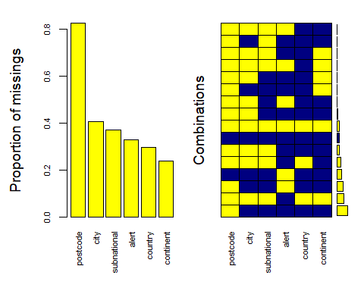
##
## Variables sorted by number of missings:
## Variable Count
## postcode 0.8267370
## city 0.4072120
## subnational 0.3702726
## alert 0.3280563
## country 0.2972735
## continent 0.2374670
#solo il 5 percento delle righe ha tutti i valori.
#Abbiamo già un modello in mente, droppiamo alcune covariate che non ci interessano:
library(dplyr)
## Warning: il pacchetto 'dplyr' è stato creato con R versione 4.4.1
##
## Caricamento pacchetto: 'dplyr'
##
## I seguenti oggetti sono mascherati da 'package:stats':
##
## filter, lag
##
## I seguenti oggetti sono mascherati da 'package:base':
##
## intersect, setdiff, setequal, union
dp <- data %>% select(-id,-type,-title,-date,-url,-detailUrl,-status,-sig,-magType,-geometryType,-place,-placeOnly,-location,-subnational,-city,-locality,-postcode,-what3words,-locationDetails,-types,-ids,-code, -sources, -timezone)
#vediamo un sommario dei nostri dati che useremo in regressione
summary(dp)
## magnitude time updated felt
## Min. :3.000 Min. :1.688e+12 Min. :1.693e+12 Min. : 0.0
## 1st Qu.:3.800 1st Qu.:1.702e+12 1st Qu.:1.708e+12 1st Qu.: 0.0
## Median :5.300 Median :1.714e+12 Median :1.720e+12 Median : 2.0
## Mean :4.857 Mean :1.712e+12 Mean :1.717e+12 Mean : 414.4
## 3rd Qu.:5.600 3rd Qu.:1.723e+12 3rd Qu.:1.725e+12 3rd Qu.: 24.0
## Max. :7.600 Max. :1.727e+12 Max. :1.727e+12 Max. :183786.0
##
## cdi mmi alert tsunami net
## 0 :365 4 :490 green :711 0:1069 us :794
## 3 :169 3 :210 orange: 6 1: 68 tx :150
## 4 :156 5 :146 red : 9 ci : 68
## 5 :132 6 :105 yellow: 38 ak : 53
## 6 : 79 7 : 84 NA's :373 nn : 30
## 2 : 77 2 : 42 nc : 13
## (Other):159 (Other): 60 (Other): 29
## nst dmin rms gap
## Min. : 0.0 Min. : 0.000 Min. :0.000 Min. : 0.00
## 1st Qu.: 37.0 1st Qu.: 0.100 1st Qu.:0.300 1st Qu.: 30.00
## Median :102.0 Median : 0.680 Median :0.630 Median : 49.00
## Mean :115.1 Mean : 1.343 Mean :0.586 Mean : 55.06
## 3rd Qu.:157.0 3rd Qu.: 2.061 3rd Qu.:0.780 3rd Qu.: 68.00
## Max. :619.0 Max. :12.457 Max. :2.520 Max. :256.00
##
## depth latitude longitude distanceKM
## Min. : -0.25 Min. :-43.71 Min. :-179.807 Min. : 0.00
## 1st Qu.: 7.55 1st Qu.: 24.20 1st Qu.:-104.452 1st Qu.: 15.00
## Median : 10.00 Median : 31.67 Median : -68.682 Median : 37.00
## Mean : 41.29 Mean : 27.31 Mean : -3.931 Mean : 52.29
## 3rd Qu.: 34.72 3rd Qu.: 37.50 3rd Qu.: 126.628 3rd Qu.: 61.00
## Max. :639.50 Max. : 68.18 Max. : 179.972 Max. :298.00
##
## continent country
## North America:446 United States of America (the):423
## Asia :333 Japan : 68
## South America: 75 Taiwan (Province of China) : 55
## Europe : 7 Indonesia : 38
## Africa : 3 China : 30
## (Other) : 3 (Other) :185
## NA's :270 NA's :338
#errore di spelling per l'oceania insolare
dp$continent[dp$continent == "Insluar Oceania"] <- "Insular Oceania"
# 1)Missing Values --------------------------------------------------------
#vediamo ora i missing values delle var rimanenti
sapply(dp, function(x)(sum(is.na(x))))
## magnitude time updated felt cdi mmi alert
## 0 0 0 0 0 0 373
## tsunami net nst dmin rms gap depth
## 0 0 0 0 0 0 0
## latitude longitude distanceKM continent country
## 0 0 0 270 338
#nel caso di alert un missing value indica una mancanza dell'emanazione dell'allerta, la definiamo come allerta bianca,
#in quanto indica un terremoto con conseguenze impercettibili
#facciamo imputazione.
library(Hmisc)
## Warning: il pacchetto 'Hmisc' è stato creato con R versione 4.4.1
##
## Caricamento pacchetto: 'Hmisc'
##
## I seguenti oggetti sono mascherati da 'package:dplyr':
##
## src, summarize
##
## I seguenti oggetti sono mascherati da 'package:base':
##
## format.pval, units
dp$alert=impute(dp$alert, "white")
#vediamo i pattern in cui si presentano i missing values di country e continent
missingness<- aggr(dp[,c("continent","country")], col=c('navyblue','yellow'), numbers=TRUE, sortVars=TRUE, cex.axis=.7,gap=3)
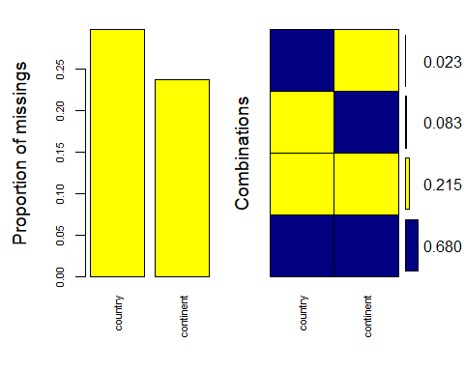
##
## Variables sorted by number of missings:
## Variable Count
## country 0.2972735
## continent 0.2374670
# il 2.3% delle righe ha la nazione ma non il continente
# il 8.3% ha il continente ma non la nazione
# al 21.5% mancano entrambi
# il 68% ha entrambi
datasicountry <- dp[is.na(dp$continent) & !is.na(dp$country) , ]
nrow(datasicountry)
## [1] 26
#Ho 26 ossrvazioni dove ho la nazione ma non il continente. Le correggiamo a mano.
unique(dp[is.na(dp$continent) & !is.na(dp$country) , ]$country)
## [1] United States of America (the) Japan
## [3] Taiwan (Province of China) Chile
## [5] Indonesia Peru
## 31 Levels: Afghanistan Argentina ... Viet Nam
dp <- dp %>%
mutate(continent = case_when(
country == "Chile" & is.na(continent) ~ factor("South America", levels = levels(continent)), # Nuova categoria
TRUE ~ continent # Mantieni i valori esistenti
))
dp <- dp %>%
mutate(continent = case_when(
country == "Peru" & is.na(continent) ~ factor("South America", levels = levels(continent)), # Nuova categoria
TRUE ~ continent # Mantieni i valori esistenti
))
dp <- dp %>%
mutate(continent = case_when(
country == "Japan" & is.na(continent) ~ factor("Asia", levels = levels(continent)), # Nuova categoria
TRUE ~ continent # Mantieni i valori esistenti
))
dp <- dp %>%
mutate(continent = case_when(
country == "Taiwan (Province of China)" & is.na(continent) ~ factor("Asia", levels = levels(continent)), # Nuova categoria
TRUE ~ continent # Mantieni i valori esistenti
))
dp <- dp %>%
mutate(continent = case_when(
country == "United States of America (the)" & is.na(continent) ~ factor("North America", levels = levels(continent)), # Nuova categoria
TRUE ~ continent # Mantieni i valori esistenti
))
dp <- dp %>%
mutate(continent = case_when(
country == "Indonesia" & is.na(continent) ~ factor("Insular Oceania", levels = levels(continent)), # Nuova categoria
TRUE ~ continent # Mantieni i valori esistenti
))
#Ho così risolto le righe in cui ho la nazione ma non il continente.
#Le osservazioni dove non ho nessuno dei due valori fanno riferimento a terremoti oceanici.
#gli do il valore "Ocean"
dataness <- dp[is.na(dp$continent) & is.na(dp$country) , ]
nrow(dataness)
## [1] 244
dp$continent <- factor(dp$continent, levels = c(levels(dp$continent), "Ocean"))
dp <- dp %>%
mutate(continent = case_when(
is.na(country) & is.na(continent) ~ "Ocean", # Sostituzione con "Ocean"
TRUE ~ as.factor(continent) # Mantieni i valori esistenti come caratteri
))
#A questo punto tutte le osservazioni hanno il continente, che è ciò che ci interessa, country non ci serve.
dp <- dp %>% select(-country)
colnames(dp)
## [1] "magnitude" "time" "updated" "felt" "cdi"
## [6] "mmi" "alert" "tsunami" "net" "nst"
## [11] "dmin" "rms" "gap" "depth" "latitude"
## [16] "longitude" "distanceKM" "continent"
dp$continent <- factor(dp$continent)
#+++++++++++++++++++++++++++++++++++++++
#world_map <- map_data("world")
#
# Crea la mappa con i punti colorati per magnitudo
# ggplot() +
# geom_polygon(data = world_map, aes(x = long, y = lat, group = group),
# fill = "gray", color = "white") +
# geom_point(data = datanocc, aes(x = longitude, y = latitude, color = magnitude),
# size = 3, alpha = 0.7) +
# scale_color_gradient(low = "green", high = "red") +
# labs(title = "Mappa dei Terremoti",
# x = "Longitudine", y = "Latitudine", color = "Magnitudo") +
# theme_minimal()
#OSSERVO CHE LE OSSERVAZIONI CON MISSING VALUE IN COUNTRY E CONTINENT SONO TERREMOTI MARITTIMI
#OSSERVAZIONI CON COUNTRY MA NON CONTINENT SONO TERREMOTI MOLTO VICINI ALLA COSTA
#++++++++++++++++++++++++++++++++++++++++++
# 1.b)Collinearità --------------------------------------------------------
#creiamo il nostro primo modello (starting model)
lm <- lm(depth ~ .,dp)
summary(lm)
##
## Call:
## lm(formula = depth ~ ., data = dp)
##
## Residuals:
## Min 1Q Median 3Q Max
## -171.26 -25.95 -2.90 21.11 480.03
##
## Coefficients:
## Estimate Std. Error t value Pr(>|t|)
## (Intercept) 1.087e+03 4.494e+02 2.419 0.015732 *
## magnitude 6.100e+01 5.430e+00 11.234 < 2e-16 ***
## time 1.944e-09 6.334e-10 3.070 0.002197 **
## updated -2.680e-09 7.204e-10 -3.720 0.000209 ***
## felt 3.738e-04 3.148e-04 1.187 0.235341
## cdi1 2.851e+01 9.600e+00 2.970 0.003046 **
## cdi2 1.139e+00 7.407e+00 0.154 0.877793
## cdi3 1.866e+01 5.887e+00 3.170 0.001566 **
## cdi4 2.412e+01 6.360e+00 3.793 0.000157 ***
## cdi5 2.942e+01 7.166e+00 4.105 4.35e-05 ***
## cdi6 1.966e+00 8.598e+00 0.229 0.819198
## cdi7 -7.220e+00 1.003e+01 -0.720 0.471724
## cdi8 2.766e+00 1.383e+01 0.200 0.841485
## cdi9 -3.007e+00 1.846e+01 -0.163 0.870649
## mmi2 9.361e+00 1.507e+01 0.621 0.534495
## mmi3 -1.273e+02 1.413e+01 -9.012 < 2e-16 ***
## mmi4 -1.915e+02 1.452e+01 -13.185 < 2e-16 ***
## mmi5 -2.241e+02 1.585e+01 -14.141 < 2e-16 ***
## mmi6 -2.472e+02 1.629e+01 -15.171 < 2e-16 ***
## mmi7 -2.550e+02 1.696e+01 -15.037 < 2e-16 ***
## mmi8 -2.788e+02 2.655e+01 -10.497 < 2e-16 ***
## mmi9 -3.230e+02 4.995e+01 -6.466 1.52e-10 ***
## alertorange -4.883e+00 3.174e+01 -0.154 0.877764
## alertred 5.507e+00 3.688e+01 0.149 0.881310
## alertyellow -8.693e+00 1.448e+01 -0.600 0.548426
## alertwhite 2.997e+01 7.602e+00 3.943 8.58e-05 ***
## tsunami1 4.845e+00 9.517e+00 0.509 0.610750
## netat 1.367e+02 3.380e+01 4.044 5.62e-05 ***
## netci 5.777e+01 1.450e+01 3.985 7.19e-05 ***
## netnc 6.706e+01 2.029e+01 3.304 0.000983 ***
## netnm 7.832e+01 3.594e+01 2.179 0.029562 *
## netnn 6.246e+01 1.600e+01 3.904 0.000100 ***
## netok 9.875e+01 2.210e+01 4.468 8.73e-06 ***
## nettx 9.583e+01 1.361e+01 7.040 3.39e-12 ***
## netus 8.571e+01 1.263e+01 6.784 1.91e-11 ***
## netuu 7.052e+01 2.291e+01 3.078 0.002136 **
## netuw 2.008e+01 4.245e+01 0.473 0.636275
## nst 2.000e-03 3.067e-02 0.065 0.948027
## dmin -9.557e-01 1.391e+00 -0.687 0.492281
## rms 4.171e+00 9.542e+00 0.437 0.662141
## gap -5.868e-01 6.230e-02 -9.419 < 2e-16 ***
## latitude -2.529e-02 1.577e-01 -0.160 0.872669
## longitude 6.314e-02 4.707e-02 1.341 0.180078
## distanceKM 1.507e-01 3.887e-02 3.877 0.000112 ***
## continentAsia 1.674e+01 3.446e+01 0.486 0.627236
## continentEurope 3.387e+01 4.346e+01 0.779 0.436028
## continentInsular Oceania 1.475e+02 3.885e+01 3.798 0.000154 ***
## continentNorth America 7.469e+01 3.530e+01 2.116 0.034601 *
## continentOcean -2.754e+01 3.486e+01 -0.790 0.429731
## continentOceania 3.319e+00 6.738e+01 0.049 0.960724
## continentSouth America 9.807e+01 3.550e+01 2.762 0.005835 **
## ---
## Signif. codes: 0 '***' 0.001 '**' 0.01 '*' 0.05 '.' 0.1 ' ' 1
##
## Residual standard error: 57.19 on 1086 degrees of freedom
## Multiple R-squared: 0.595, Adjusted R-squared: 0.5763
## F-statistic: 31.91 on 50 and 1086 DF, p-value: < 2.2e-16
drop1(lm,test="F")
## Single term deletions
##
## Model:
## depth ~ magnitude + time + updated + felt + cdi + mmi + alert +
## tsunami + net + nst + dmin + rms + gap + latitude + longitude +
## distanceKM + continent
## Df Sum of Sq RSS AIC F value Pr(>F)
## <none> 3552220 9251.4
## magnitude 1 412786 3965006 9374.4 126.1986 < 2.2e-16 ***
## time 1 30818 3583038 9259.2 9.4219 0.0021973 **
## updated 1 45276 3597496 9263.8 13.8421 0.0002090 ***
## felt 1 4612 3556832 9250.8 1.4099 0.2353406
## cdi 9 138580 3690800 9276.9 4.7075 3.736e-06 ***
## mmi 8 1695598 5247818 9679.1 64.7982 < 2.2e-16 ***
## alert 4 51745 3603965 9259.8 3.9549 0.0034188 **
## tsunami 1 848 3553068 9249.6 0.2592 0.6107497
## net 10 223566 3775786 9300.8 6.8349 2.066e-10 ***
## nst 1 14 3552234 9249.4 0.0043 0.9480269
## dmin 1 1543 3553763 9249.9 0.4719 0.4922809
## rms 1 625 3552845 9249.6 0.1910 0.6621413
## gap 1 290218 3842438 9338.7 88.7266 < 2.2e-16 ***
## latitude 1 84 3552304 9249.4 0.0257 0.8726688
## longitude 1 5885 3558105 9251.2 1.7993 0.1800782
## distanceKM 1 49177 3601397 9265.0 15.0347 0.0001119 ***
## continent 7 705396 4257616 9443.3 30.8081 < 2.2e-16 ***
## ---
## Signif. codes: 0 '***' 0.001 '**' 0.01 '*' 0.05 '.' 0.1 ' ' 1
par(mfrow=c(2,2))
plot(lm)
## Warning: non si riesce a fare il plot senza sfruttarne uno:
## 476
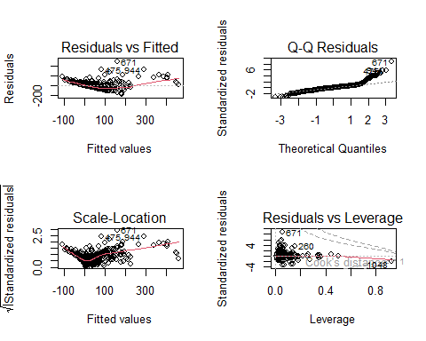
par(mfrow=c(1,1))
num<-unlist(lapply(dp,is.numeric))
Cor=round(cor(dp[ , num]),3)
Cor
## magnitude time updated felt nst dmin rms gap depth
## magnitude 1.000 -0.574 -0.499 -0.008 0.667 0.527 0.600 -0.245 0.310
## time -0.574 1.000 0.956 0.025 -0.496 -0.506 -0.322 0.167 -0.227
## updated -0.499 0.956 1.000 0.068 -0.432 -0.506 -0.315 0.138 -0.237
## felt -0.008 0.025 0.068 1.000 0.037 -0.040 -0.037 0.005 -0.027
## nst 0.667 -0.496 -0.432 0.037 1.000 0.430 0.313 -0.246 0.233
## dmin 0.527 -0.506 -0.506 -0.040 0.430 1.000 0.371 -0.071 0.201
## rms 0.600 -0.322 -0.315 -0.037 0.313 0.371 1.000 -0.105 0.250
## gap -0.245 0.167 0.138 0.005 -0.246 -0.071 -0.105 1.000 -0.144
## depth 0.310 -0.227 -0.237 -0.027 0.233 0.201 0.250 -0.144 1.000
## latitude -0.411 0.368 0.335 0.034 -0.250 -0.214 -0.253 0.067 -0.340
## longitude 0.747 -0.609 -0.556 -0.051 0.614 0.538 0.436 -0.275 0.112
## distanceKM 0.098 0.124 0.115 -0.056 -0.043 0.022 0.201 0.133 0.173
## latitude longitude distanceKM
## magnitude -0.411 0.747 0.098
## time 0.368 -0.609 0.124
## updated 0.335 -0.556 0.115
## felt 0.034 -0.051 -0.056
## nst -0.250 0.614 -0.043
## dmin -0.214 0.538 0.022
## rms -0.253 0.436 0.201
## gap 0.067 -0.275 0.133
## depth -0.340 0.112 0.173
## latitude 1.000 -0.225 0.036
## longitude -0.225 1.000 -0.054
## distanceKM 0.036 -0.054 1.000
library(corrplot)
## Warning: il pacchetto 'corrplot' è stato creato con R versione 4.4.1
## corrplot 0.94 loaded
corrplot(Cor)
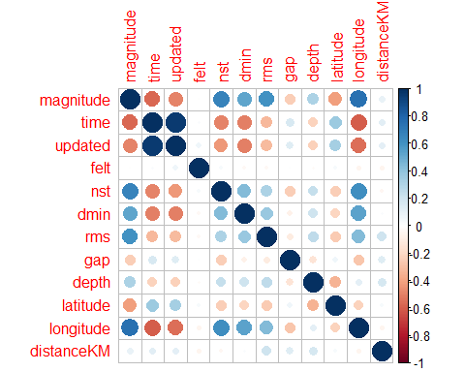
#Valutiamo VIF e TOL
#usiamo target fittizio
y = as.numeric(row.names(dp))
#selezioniamo covariate.
cov=attr(terms(lm), "term.labels")
d_numeric <- dp[,cov]%>% dplyr::select_if(is.numeric)
X<-d_numeric
X=as.matrix(X)
library(mctest)
#vediamo vif e tol
fit=lm(y ~ X)
imcdiag(fit)
##
## Call:
## imcdiag(mod = fit)
##
##
## All Individual Multicollinearity Diagnostics Result
##
## VIF TOL Wi Fi Leamer CVIF Klein IND1
## Xmagnitude 4.1835 0.2390 358.4617 398.6445 0.4889 6.0625 1 0.0021
## Xtime 14.8329 0.0674 1557.5826 1732.1843 0.2596 21.4949 1 0.0006
## Xupdated 13.1855 0.0758 1372.0865 1525.8945 0.2754 19.1076 1 0.0007
## Xfelt 1.0391 0.9623 4.4072 4.9012 0.9810 1.5059 0 0.0085
## Xnst 2.0156 0.4961 114.3570 127.1762 0.7044 2.9209 1 0.0044
## Xdmin 1.6466 0.6073 72.8114 80.9734 0.7793 2.3862 1 0.0054
## Xrms 1.6913 0.5913 77.8348 86.5600 0.7689 2.4509 1 0.0053
## Xgap 1.1302 0.8848 14.6647 16.3086 0.9406 1.6379 0 0.0079
## Xlatitude 1.3127 0.7618 35.2079 39.1547 0.8728 1.9023 1 0.0068
## Xlongitude 2.9217 0.3423 216.3881 240.6447 0.5850 4.2340 1 0.0030
## XdistanceKM 1.1526 0.8676 17.1832 19.1095 0.9315 1.6703 1 0.0077
## IND2
## Xmagnitude 1.6399
## Xtime 2.0098
## Xupdated 1.9916
## Xfelt 0.0812
## Xnst 1.0859
## Xdmin 0.8463
## Xrms 0.8808
## Xgap 0.2483
## Xlatitude 0.5133
## Xlongitude 1.4175
## XdistanceKM 0.2853
##
## 1 --> COLLINEARITY is detected by the test
## 0 --> COLLINEARITY is not detected by the test
##
## Xmagnitude , Xfelt , Xnst , Xdmin , Xrms , Xgap , Xlongitude , XdistanceKM , coefficient(s) are non-significant may be due to multicollinearity
##
## R-square of y on all x: 0.1208
##
## * use method argument to check which regressors may be the reason of collinearity
## ===================================
#rimuovo time
X <- as.data.frame(X) %>% select(-time) %>% as.matrix()
fit=lm(y ~ X)
imcdiag(fit)
##
## Call:
## imcdiag(mod = fit)
##
##
## All Individual Multicollinearity Diagnostics Result
##
## VIF TOL Wi Fi Leamer CVIF Klein IND1 IND2
## Xmagnitude 3.9958 0.2503 375.1388 422.4056 0.5003 5.0845 1 0.0020 2.0768
## Xupdated 1.7227 0.5805 90.4922 101.8941 0.7619 2.1920 1 0.0046 1.1620
## Xfelt 1.0216 0.9788 2.7072 3.0483 0.9894 1.3000 0 0.0078 0.0586
## Xnst 2.0041 0.4990 125.7395 141.5824 0.7064 2.5502 1 0.0040 1.3879
## Xdmin 1.6396 0.6099 80.0886 90.1797 0.7810 2.0863 1 0.0049 1.0806
## Xrms 1.6615 0.6019 82.8392 93.2768 0.7758 2.1142 1 0.0048 1.1029
## Xgap 1.1302 0.8848 16.3060 18.3606 0.9406 1.4382 1 0.0071 0.3192
## Xlatitude 1.3021 0.7680 37.8355 42.6027 0.8763 1.6569 1 0.0061 0.6428
## Xlongitude 2.8908 0.3459 236.7715 266.6043 0.5882 3.6784 1 0.0028 1.8118
## XdistanceKM 1.1481 0.8710 18.5513 20.8887 0.9333 1.4610 1 0.0070 0.3574
##
## 1 --> COLLINEARITY is detected by the test
## 0 --> COLLINEARITY is not detected by the test
##
## Xmagnitude , Xfelt , Xnst , Xdmin , Xrms , Xgap , Xlongitude , coefficient(s) are non-significant may be due to multicollinearity
##
## R-square of y on all x: 0.1068
##
## * use method argument to check which regressors may be the reason of collinearity
## ===================================
#Ora ho ridotto la collinearità a valori accettabili.
lm2 <-lm(depth~ .-time, dp)
summary(lm2)
##
## Call:
## lm(formula = depth ~ . - time, data = dp)
##
## Residuals:
## Min 1Q Median 3Q Max
## -171.88 -26.36 -3.57 22.35 485.73
##
## Coefficients:
## Estimate Std. Error t value Pr(>|t|)
## (Intercept) 8.775e+02 4.459e+02 1.968 0.049349 *
## magnitude 5.932e+01 5.423e+00 10.938 < 2e-16 ***
## updated -6.161e-10 2.593e-10 -2.375 0.017701 *
## felt 2.439e-04 3.131e-04 0.779 0.436227
## cdi1 2.931e+01 9.633e+00 3.043 0.002399 **
## cdi2 1.320e+00 7.435e+00 0.178 0.859133
## cdi3 1.993e+01 5.896e+00 3.380 0.000750 ***
## cdi4 2.440e+01 6.384e+00 3.822 0.000140 ***
## cdi5 3.000e+01 7.191e+00 4.172 3.26e-05 ***
## cdi6 2.188e+00 8.631e+00 0.253 0.799960
## cdi7 -8.649e+00 1.006e+01 -0.860 0.389964
## cdi8 4.948e+00 1.386e+01 0.357 0.721200
## cdi9 -1.023e+01 1.839e+01 -0.556 0.577999
## mmi2 9.478e+00 1.512e+01 0.627 0.530966
## mmi3 -1.281e+02 1.418e+01 -9.037 < 2e-16 ***
## mmi4 -1.917e+02 1.458e+01 -13.151 < 2e-16 ***
## mmi5 -2.249e+02 1.591e+01 -14.140 < 2e-16 ***
## mmi6 -2.487e+02 1.635e+01 -15.209 < 2e-16 ***
## mmi7 -2.542e+02 1.702e+01 -14.934 < 2e-16 ***
## mmi8 -2.765e+02 2.665e+01 -10.376 < 2e-16 ***
## mmi9 -3.399e+02 4.984e+01 -6.821 1.50e-11 ***
## alertorange -4.205e+00 3.186e+01 -0.132 0.895015
## alertred 7.839e+00 3.701e+01 0.212 0.832294
## alertyellow -1.072e+01 1.452e+01 -0.738 0.460483
## alertwhite 2.868e+01 7.619e+00 3.764 0.000176 ***
## tsunami1 4.140e+00 9.551e+00 0.434 0.664726
## netat 1.435e+02 3.386e+01 4.239 2.44e-05 ***
## netci 5.628e+01 1.454e+01 3.870 0.000116 ***
## netnc 6.769e+01 2.037e+01 3.323 0.000921 ***
## netnm 7.108e+01 3.601e+01 1.974 0.048631 *
## netnn 6.094e+01 1.605e+01 3.796 0.000155 ***
## netok 8.868e+01 2.194e+01 4.041 5.69e-05 ***
## nettx 9.131e+01 1.358e+01 6.722 2.89e-11 ***
## netus 8.605e+01 1.268e+01 6.785 1.90e-11 ***
## netuu 6.952e+01 2.300e+01 3.023 0.002561 **
## netuw 2.130e+01 4.261e+01 0.500 0.617295
## nst -9.316e-03 3.057e-02 -0.305 0.760601
## dmin -9.202e-01 1.397e+00 -0.659 0.510145
## rms 3.848e+00 9.579e+00 0.402 0.687981
## gap -5.914e-01 6.252e-02 -9.459 < 2e-16 ***
## latitude -1.017e-02 1.583e-01 -0.064 0.948783
## longitude 5.766e-02 4.722e-02 1.221 0.222333
## distanceKM 1.560e-01 3.899e-02 4.000 6.76e-05 ***
## continentAsia 2.095e+01 3.456e+01 0.606 0.544646
## continentEurope 4.374e+01 4.351e+01 1.005 0.315066
## continentInsular Oceania 1.465e+02 3.900e+01 3.757 0.000181 ***
## continentNorth America 8.144e+01 3.537e+01 2.302 0.021496 *
## continentOcean -2.146e+01 3.494e+01 -0.614 0.539169
## continentOceania 7.130e+00 6.763e+01 0.105 0.916060
## continentSouth America 1.028e+02 3.560e+01 2.888 0.003957 **
## ---
## Signif. codes: 0 '***' 0.001 '**' 0.01 '*' 0.05 '.' 0.1 ' ' 1
##
## Residual standard error: 57.41 on 1087 degrees of freedom
## Multiple R-squared: 0.5915, Adjusted R-squared: 0.5731
## F-statistic: 32.12 on 49 and 1087 DF, p-value: < 2.2e-16
drop1(lm2,test="F")
## Single term deletions
##
## Model:
## depth ~ (magnitude + time + updated + felt + cdi + mmi + alert +
## tsunami + net + nst + dmin + rms + gap + latitude + longitude +
## distanceKM + continent) - time
## Df Sum of Sq RSS AIC F value Pr(>F)
## <none> 3583038 9259.2
## magnitude 1 394358 3977396 9375.9 119.6379 < 2.2e-16 ***
## updated 1 18600 3601638 9263.1 5.6426 0.01770 *
## felt 1 2000 3585038 9257.8 0.6066 0.43623
## cdi 9 149485 3732523 9287.7 5.0389 1.107e-06 ***
## mmi 8 1699693 5282731 9684.6 64.4553 < 2.2e-16 ***
## alert 4 48320 3631358 9266.4 3.6648 0.00567 **
## tsunami 1 619 3583658 9257.4 0.1879 0.66473
## net 10 213565 3796603 9305.0 6.4790 9.090e-10 ***
## nst 1 306 3583344 9257.3 0.0929 0.76060
## dmin 1 1431 3584469 9257.6 0.4341 0.51015
## rms 1 532 3583570 9257.4 0.1614 0.68798
## gap 1 294946 3877984 9347.1 89.4789 < 2.2e-16 ***
## latitude 1 14 3583052 9257.2 0.0041 0.94878
## longitude 1 4915 3587953 9258.7 1.4910 0.22233
## distanceKM 1 52744 3635783 9273.8 16.0012 6.758e-05 ***
## continent 7 689261 4272300 9445.2 29.8720 < 2.2e-16 ***
## ---
## Signif. codes: 0 '***' 0.001 '**' 0.01 '*' 0.05 '.' 0.1 ' ' 1
#vediamo ora la collinearità per i valori categorici
d_fac <- dp[,cov]%>% dplyr::select_if(is.factor)
library(plyr)
## Warning: il pacchetto 'plyr' è stato creato con R versione 4.4.1
## ------------------------------------------------------------------------------
## You have loaded plyr after dplyr - this is likely to cause problems.
## If you need functions from both plyr and dplyr, please load plyr first, then dplyr:
## library(plyr); library(dplyr)
## ------------------------------------------------------------------------------
##
## Caricamento pacchetto: 'plyr'
##
## I seguenti oggetti sono mascherati da 'package:Hmisc':
##
## is.discrete, summarize
##
## I seguenti oggetti sono mascherati da 'package:dplyr':
##
## arrange, count, desc, failwith, id, mutate, rename, summarise,
## summarize
combos <- combn(ncol(d_fac),2)
adply(combos, 2, function(x) {
test <- chisq.test(d_fac[, x[1]],d_fac[, x[2]])
tab <- table(d_fac[, x[1]], d_fac[, x[2]])
out <- data.frame("Row" = colnames(d_fac)[x[1]]
, "Column" = colnames(d_fac[x[2]])
, "Chi.Square" = round(test$statistic,3)
, "df"= test$parameter
, "p.value" = round(test$p.value, 3)
, "n" = sum(table(d_fac[,x[1]], d_fac[,x[2]]))
, "u1" =length(unique(d_fac[,x[1]]))-1
, "u2" =length(unique(d_fac[,x[2]]))-1
, "nMinu1u2" =sum(table(d_fac[,x[1]], d_fac[,x[2]]))* min(length(unique(d_fac[,x[1]]))-1 , length(unique(d_fac[,x[2]]))-1)
, "Chi.Square norm" =test$statistic/(sum(table(d_fac[,x[1]], d_fac[,x[2]]))* min(length(unique(d_fac[,x[1]]))-1 , length(unique(d_fac[,x[2]]))-1))
)
return(out)
})
## Warning in chisq.test(d_fac[, x[1]], d_fac[, x[2]]): L'approssimazione al
## Chi-quadrato potrebbe essere inesatta
## Warning in chisq.test(d_fac[, x[1]], d_fac[, x[2]]): L'approssimazione al
## Chi-quadrato potrebbe essere inesatta
## Warning in chisq.test(d_fac[, x[1]], d_fac[, x[2]]): L'approssimazione al
## Chi-quadrato potrebbe essere inesatta
## Warning in chisq.test(d_fac[, x[1]], d_fac[, x[2]]): L'approssimazione al
## Chi-quadrato potrebbe essere inesatta
## Warning in chisq.test(d_fac[, x[1]], d_fac[, x[2]]): L'approssimazione al
## Chi-quadrato potrebbe essere inesatta
## Warning in chisq.test(d_fac[, x[1]], d_fac[, x[2]]): L'approssimazione al
## Chi-quadrato potrebbe essere inesatta
## Warning in chisq.test(d_fac[, x[1]], d_fac[, x[2]]): L'approssimazione al
## Chi-quadrato potrebbe essere inesatta
## Warning in chisq.test(d_fac[, x[1]], d_fac[, x[2]]): L'approssimazione al
## Chi-quadrato potrebbe essere inesatta
## Warning in chisq.test(d_fac[, x[1]], d_fac[, x[2]]): L'approssimazione al
## Chi-quadrato potrebbe essere inesatta
## Warning in chisq.test(d_fac[, x[1]], d_fac[, x[2]]): L'approssimazione al
## Chi-quadrato potrebbe essere inesatta
## Warning in chisq.test(d_fac[, x[1]], d_fac[, x[2]]): L'approssimazione al
## Chi-quadrato potrebbe essere inesatta
## Warning in chisq.test(d_fac[, x[1]], d_fac[, x[2]]): L'approssimazione al
## Chi-quadrato potrebbe essere inesatta
## Warning in chisq.test(d_fac[, x[1]], d_fac[, x[2]]): L'approssimazione al
## Chi-quadrato potrebbe essere inesatta
## Warning in chisq.test(d_fac[, x[1]], d_fac[, x[2]]): L'approssimazione al
## Chi-quadrato potrebbe essere inesatta
## Warning in chisq.test(d_fac[, x[1]], d_fac[, x[2]]): L'approssimazione al
## Chi-quadrato potrebbe essere inesatta
## X1 Row Column Chi.Square df p.value n u1 u2 nMinu1u2
## 1 1 cdi mmi 1226.883 72 0.000 1137 9 8 9096
## 2 2 cdi alert 718.358 36 0.000 1137 9 4 4548
## 3 3 cdi tsunami 95.212 9 0.000 1137 9 1 1137
## 4 4 cdi net 290.904 90 0.000 1137 9 10 10233
## 5 5 cdi continent 485.856 63 0.000 1137 9 7 7959
## 6 6 mmi alert 1711.721 32 0.000 1137 8 4 4548
## 7 7 mmi tsunami 58.975 8 0.000 1137 8 1 1137
## 8 8 mmi net 389.397 80 0.000 1137 8 10 9096
## 9 9 mmi continent 617.836 56 0.000 1137 8 7 7959
## 10 10 alert tsunami 42.711 4 0.000 1137 4 1 1137
## 11 11 alert net 464.411 40 0.000 1137 4 10 4548
## 12 12 alert continent 589.844 28 0.000 1137 4 7 4548
## 13 13 tsunami net 89.891 10 0.000 1137 1 10 1137
## 14 14 tsunami continent 10.307 7 0.172 1137 1 7 1137
## 15 15 net continent 650.489 70 0.000 1137 10 7 7959
## Chi.Square.norm
## 1 0.134881609
## 2 0.157950370
## 3 0.083739545
## 4 0.028427994
## 5 0.061044842
## 6 0.376367905
## 7 0.051868651
## 8 0.042809660
## 9 0.077627329
## 10 0.037564664
## 11 0.102113130
## 12 0.129692958
## 13 0.079060084
## 14 0.009064989
## 15 0.081729999
#Ho un chi quadro normalizzato maggiore di 0.3 tra mmi e alert.
#tolgo alert in quanto ha chi quadri piuttosto elevati con tutte le altre var qualitative
dp <- dp %>% select(-alert)
d_fac <- dp[,c("cdi","mmi","tsunami","net","continent")]
library(plyr)
combos <- combn(ncol(d_fac),2)
adply(combos, 2, function(x) {
test <- chisq.test(d_fac[, x[1]],d_fac[, x[2]])
tab <- table(d_fac[, x[1]], d_fac[, x[2]])
out <- data.frame("Row" = colnames(d_fac)[x[1]]
, "Column" = colnames(d_fac[x[2]])
, "Chi.Square" = round(test$statistic,3)
, "df"= test$parameter
, "p.value" = round(test$p.value, 3)
, "n" = sum(table(d_fac[,x[1]], d_fac[,x[2]]))
, "u1" =length(unique(d_fac[,x[1]]))-1
, "u2" =length(unique(d_fac[,x[2]]))-1
, "nMinu1u2" =sum(table(d_fac[,x[1]], d_fac[,x[2]]))* min(length(unique(d_fac[,x[1]]))-1 , length(unique(d_fac[,x[2]]))-1)
, "Chi.Square norm" =test$statistic/(sum(table(d_fac[,x[1]], d_fac[,x[2]]))* min(length(unique(d_fac[,x[1]]))-1 , length(unique(d_fac[,x[2]]))-1))
)
return(out)
})
## Warning in chisq.test(d_fac[, x[1]], d_fac[, x[2]]): L'approssimazione al
## Chi-quadrato potrebbe essere inesatta
## Warning in chisq.test(d_fac[, x[1]], d_fac[, x[2]]): L'approssimazione al
## Chi-quadrato potrebbe essere inesatta
## Warning in chisq.test(d_fac[, x[1]], d_fac[, x[2]]): L'approssimazione al
## Chi-quadrato potrebbe essere inesatta
## Warning in chisq.test(d_fac[, x[1]], d_fac[, x[2]]): L'approssimazione al
## Chi-quadrato potrebbe essere inesatta
## Warning in chisq.test(d_fac[, x[1]], d_fac[, x[2]]): L'approssimazione al
## Chi-quadrato potrebbe essere inesatta
## Warning in chisq.test(d_fac[, x[1]], d_fac[, x[2]]): L'approssimazione al
## Chi-quadrato potrebbe essere inesatta
## Warning in chisq.test(d_fac[, x[1]], d_fac[, x[2]]): L'approssimazione al
## Chi-quadrato potrebbe essere inesatta
## Warning in chisq.test(d_fac[, x[1]], d_fac[, x[2]]): L'approssimazione al
## Chi-quadrato potrebbe essere inesatta
## Warning in chisq.test(d_fac[, x[1]], d_fac[, x[2]]): L'approssimazione al
## Chi-quadrato potrebbe essere inesatta
## Warning in chisq.test(d_fac[, x[1]], d_fac[, x[2]]): L'approssimazione al
## Chi-quadrato potrebbe essere inesatta
## X1 Row Column Chi.Square df p.value n u1 u2 nMinu1u2
## 1 1 cdi mmi 1226.883 72 0.000 1137 9 8 9096
## 2 2 cdi tsunami 95.212 9 0.000 1137 9 1 1137
## 3 3 cdi net 290.904 90 0.000 1137 9 10 10233
## 4 4 cdi continent 485.856 63 0.000 1137 9 7 7959
## 5 5 mmi tsunami 58.975 8 0.000 1137 8 1 1137
## 6 6 mmi net 389.397 80 0.000 1137 8 10 9096
## 7 7 mmi continent 617.836 56 0.000 1137 8 7 7959
## 8 8 tsunami net 89.891 10 0.000 1137 1 10 1137
## 9 9 tsunami continent 10.307 7 0.172 1137 1 7 1137
## 10 10 net continent 650.489 70 0.000 1137 10 7 7959
## Chi.Square.norm
## 1 0.134881609
## 2 0.083739545
## 3 0.028427994
## 4 0.061044842
## 5 0.051868651
## 6 0.042809660
## 7 0.077627329
## 8 0.079060084
## 9 0.009064989
## 10 0.081729999
#non ho più chi quadri normalizzati maggiori di 0.3
#otteniamo il seguente modello senza collinearità:
lm2 <-lm(depth~ magnitude + updated + felt + cdi + mmi + tsunami + net + nst + dmin + rms + gap + latitude + distanceKM + continent + longitude, dp)
summary(lm2)
##
## Call:
## lm(formula = depth ~ magnitude + updated + felt + cdi + mmi +
## tsunami + net + nst + dmin + rms + gap + latitude + distanceKM +
## continent + longitude, data = dp)
##
## Residuals:
## Min 1Q Median 3Q Max
## -177.57 -26.55 -2.94 19.54 496.63
##
## Coefficients:
## Estimate Std. Error t value Pr(>|t|)
## (Intercept) 8.335e+02 4.417e+02 1.887 0.059408 .
## magnitude 5.076e+01 4.964e+00 10.226 < 2e-16 ***
## updated -5.541e-10 2.561e-10 -2.163 0.030733 *
## felt 1.287e-04 3.129e-04 0.411 0.680972
## cdi1 2.621e+01 9.641e+00 2.718 0.006663 **
## cdi2 7.830e-01 7.463e+00 0.105 0.916459
## cdi3 1.750e+01 5.881e+00 2.975 0.002997 **
## cdi4 2.057e+01 6.315e+00 3.257 0.001159 **
## cdi5 2.639e+01 7.146e+00 3.694 0.000232 ***
## cdi6 -2.420e-01 8.638e+00 -0.028 0.977653
## cdi7 -9.437e+00 9.997e+00 -0.944 0.345364
## cdi8 5.417e+00 1.381e+01 0.392 0.694848
## cdi9 -8.057e+00 1.831e+01 -0.440 0.659992
## mmi2 6.433e+00 1.517e+01 0.424 0.671658
## mmi3 -1.315e+02 1.419e+01 -9.266 < 2e-16 ***
## mmi4 -1.944e+02 1.461e+01 -13.306 < 2e-16 ***
## mmi5 -2.336e+02 1.578e+01 -14.807 < 2e-16 ***
## mmi6 -2.559e+02 1.629e+01 -15.713 < 2e-16 ***
## mmi7 -2.622e+02 1.666e+01 -15.739 < 2e-16 ***
## mmi8 -2.856e+02 2.176e+01 -13.123 < 2e-16 ***
## mmi9 -3.297e+02 3.419e+01 -9.644 < 2e-16 ***
## tsunami1 6.050e+00 9.560e+00 0.633 0.526974
## netat 1.571e+02 3.383e+01 4.643 3.85e-06 ***
## netci 5.470e+01 1.456e+01 3.756 0.000182 ***
## netnc 6.518e+01 2.044e+01 3.190 0.001466 **
## netnm 7.607e+01 3.613e+01 2.105 0.035484 *
## netnn 5.445e+01 1.602e+01 3.399 0.000702 ***
## netok 8.619e+01 2.203e+01 3.913 9.69e-05 ***
## nettx 8.773e+01 1.359e+01 6.454 1.64e-10 ***
## netus 8.240e+01 1.269e+01 6.495 1.26e-10 ***
## netuu 6.768e+01 2.308e+01 2.932 0.003436 **
## netuw 2.222e+01 4.280e+01 0.519 0.603812
## nst -1.521e-03 3.036e-02 -0.050 0.960057
## dmin -1.196e+00 1.383e+00 -0.864 0.387583
## rms 3.476e+00 9.617e+00 0.361 0.717870
## gap -5.931e-01 6.257e-02 -9.480 < 2e-16 ***
## latitude 2.557e-02 1.584e-01 0.161 0.871797
## distanceKM 1.457e-01 3.905e-02 3.732 0.000200 ***
## continentAsia 1.923e+01 3.463e+01 0.555 0.578868
## continentEurope 3.795e+01 4.364e+01 0.870 0.384696
## continentInsular Oceania 1.484e+02 3.910e+01 3.797 0.000155 ***
## continentNorth America 7.701e+01 3.546e+01 2.172 0.030065 *
## continentOcean -2.487e+01 3.503e+01 -0.710 0.477791
## continentOceania 1.309e+01 6.792e+01 0.193 0.847216
## continentSouth America 9.960e+01 3.570e+01 2.790 0.005359 **
## longitude 3.453e-02 4.653e-02 0.742 0.458282
## ---
## Signif. codes: 0 '***' 0.001 '**' 0.01 '*' 0.05 '.' 0.1 ' ' 1
##
## Residual standard error: 57.69 on 1091 degrees of freedom
## Multiple R-squared: 0.586, Adjusted R-squared: 0.5689
## F-statistic: 34.31 on 45 and 1091 DF, p-value: < 2.2e-16
drop1(lm2,test="F")
## Single term deletions
##
## Model:
## depth ~ magnitude + updated + felt + cdi + mmi + tsunami + net +
## nst + dmin + rms + gap + latitude + distanceKM + continent +
## longitude
## Df Sum of Sq RSS AIC F value Pr(>F)
## <none> 3631358 9266.4
## magnitude 1 348057 3979415 9368.5 104.5697 < 2.2e-16 ***
## updated 1 15577 3646935 9269.3 4.6799 0.0307333 *
## felt 1 563 3631921 9264.6 0.1691 0.6809719
## cdi 9 125457 3756816 9287.0 4.1880 2.450e-05 ***
## mmi 8 1816180 5447538 9711.5 68.2063 < 2.2e-16 ***
## tsunami 1 1333 3632691 9264.8 0.4005 0.5269745
## net 10 206406 3837764 9309.3 6.2012 2.872e-09 ***
## nst 1 8 3631367 9264.4 0.0025 0.9600568
## dmin 1 2487 3633845 9265.2 0.7471 0.3875829
## rms 1 435 3631793 9264.6 0.1306 0.7178705
## gap 1 299104 3930462 9354.4 89.8623 < 2.2e-16 ***
## latitude 1 87 3631445 9264.4 0.0261 0.8717968
## distanceKM 1 46366 3677724 9278.8 13.9300 0.0001995 ***
## continent 7 700622 4331980 9453.0 30.0705 < 2.2e-16 ***
## longitude 1 1832 3633191 9265.0 0.5505 0.4582823
## ---
## Signif. codes: 0 '***' 0.001 '**' 0.01 '*' 0.05 '.' 0.1 ' ' 1
#Guardiamo il diagnostic plot
par(mfrow=c(2,2))
plot(lm2)
## Warning: non si riesce a fare il plot senza sfruttarne uno:
## 476
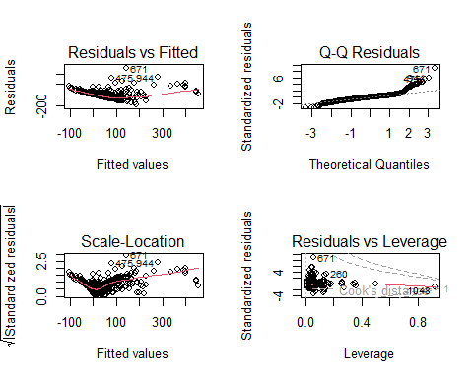
par(mfrow=c(1,1))
#molto male:
# primo plot: ipotesi linearità -> RIFIUTO
# secondo: hp normalità residui -> RIFIUTO
# terzo: hp omoschedasticità -> RIFIUTO
# quarto: outliers -> ci sono outliers da sistemare.
# 2)Analisi eteroschedasticità e Linearità --------
# Trasformazioni, Additive models (loess o splines)
#trasformazione Box-Cox
library(MASS)
##
## Caricamento pacchetto: 'MASS'
##
## Il seguente oggetto è mascherato da 'package:dplyr':
##
## select
#boxcoxreg1<-boxcox(lm2)
#abbiamo bisogno di un target positivo, modifichiamo il target.
#depth ha minimo -0.25
dp$depth = dp$depth + 0.5
lm3 <- lm(depth ~ magnitude + updated + felt + cdi + mmi + tsunami + net + nst + dmin + rms + gap + latitude + distanceKM + continent + longitude, dp)
summary(lm3)
##
## Call:
## lm(formula = depth ~ magnitude + updated + felt + cdi + mmi +
## tsunami + net + nst + dmin + rms + gap + latitude + distanceKM +
## continent + longitude, data = dp)
##
## Residuals:
## Min 1Q Median 3Q Max
## -177.57 -26.55 -2.94 19.54 496.63
##
## Coefficients:
## Estimate Std. Error t value Pr(>|t|)
## (Intercept) 8.340e+02 4.417e+02 1.888 0.059256 .
## magnitude 5.076e+01 4.964e+00 10.226 < 2e-16 ***
## updated -5.541e-10 2.561e-10 -2.163 0.030733 *
## felt 1.287e-04 3.129e-04 0.411 0.680972
## cdi1 2.621e+01 9.641e+00 2.718 0.006663 **
## cdi2 7.830e-01 7.463e+00 0.105 0.916459
## cdi3 1.750e+01 5.881e+00 2.975 0.002997 **
## cdi4 2.057e+01 6.315e+00 3.257 0.001159 **
## cdi5 2.639e+01 7.146e+00 3.694 0.000232 ***
## cdi6 -2.420e-01 8.638e+00 -0.028 0.977653
## cdi7 -9.437e+00 9.997e+00 -0.944 0.345364
## cdi8 5.417e+00 1.381e+01 0.392 0.694848
## cdi9 -8.057e+00 1.831e+01 -0.440 0.659992
## mmi2 6.433e+00 1.517e+01 0.424 0.671658
## mmi3 -1.315e+02 1.419e+01 -9.266 < 2e-16 ***
## mmi4 -1.944e+02 1.461e+01 -13.306 < 2e-16 ***
## mmi5 -2.336e+02 1.578e+01 -14.807 < 2e-16 ***
## mmi6 -2.559e+02 1.629e+01 -15.713 < 2e-16 ***
## mmi7 -2.622e+02 1.666e+01 -15.739 < 2e-16 ***
## mmi8 -2.856e+02 2.176e+01 -13.123 < 2e-16 ***
## mmi9 -3.297e+02 3.419e+01 -9.644 < 2e-16 ***
## tsunami1 6.050e+00 9.560e+00 0.633 0.526974
## netat 1.571e+02 3.383e+01 4.643 3.85e-06 ***
## netci 5.470e+01 1.456e+01 3.756 0.000182 ***
## netnc 6.518e+01 2.044e+01 3.190 0.001466 **
## netnm 7.607e+01 3.613e+01 2.105 0.035484 *
## netnn 5.445e+01 1.602e+01 3.399 0.000702 ***
## netok 8.619e+01 2.203e+01 3.913 9.69e-05 ***
## nettx 8.773e+01 1.359e+01 6.454 1.64e-10 ***
## netus 8.240e+01 1.269e+01 6.495 1.26e-10 ***
## netuu 6.768e+01 2.308e+01 2.932 0.003436 **
## netuw 2.222e+01 4.280e+01 0.519 0.603812
## nst -1.521e-03 3.036e-02 -0.050 0.960057
## dmin -1.196e+00 1.383e+00 -0.864 0.387583
## rms 3.476e+00 9.617e+00 0.361 0.717870
## gap -5.931e-01 6.257e-02 -9.480 < 2e-16 ***
## latitude 2.557e-02 1.584e-01 0.161 0.871797
## distanceKM 1.457e-01 3.905e-02 3.732 0.000200 ***
## continentAsia 1.923e+01 3.463e+01 0.555 0.578868
## continentEurope 3.795e+01 4.364e+01 0.870 0.384696
## continentInsular Oceania 1.484e+02 3.910e+01 3.797 0.000155 ***
## continentNorth America 7.701e+01 3.546e+01 2.172 0.030065 *
## continentOcean -2.487e+01 3.503e+01 -0.710 0.477791
## continentOceania 1.309e+01 6.792e+01 0.193 0.847216
## continentSouth America 9.960e+01 3.570e+01 2.790 0.005359 **
## longitude 3.453e-02 4.653e-02 0.742 0.458282
## ---
## Signif. codes: 0 '***' 0.001 '**' 0.01 '*' 0.05 '.' 0.1 ' ' 1
##
## Residual standard error: 57.69 on 1091 degrees of freedom
## Multiple R-squared: 0.586, Adjusted R-squared: 0.5689
## F-statistic: 34.31 on 45 and 1091 DF, p-value: < 2.2e-16
boxcoxreg1<-boxcox(lm3)
title("Lambda")
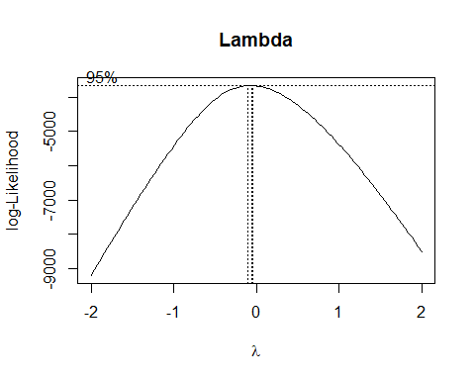
lambda=boxcoxreg1$x[which.max(boxcoxreg1$y)]
lambda
## [1] -0.06060606
#la lambda ha valore -0.06060606, suggerisce una trasformazione logaritmica in quanto vicina allo zero.
lm3_log <- lm(log(depth) ~ magnitude + updated + felt + cdi + mmi + tsunami + net + nst + dmin + rms + gap + latitude + distanceKM + continent + longitude , dp)
summary(lm3_log)
##
## Call:
## lm(formula = log(depth) ~ magnitude + updated + felt + cdi +
## mmi + tsunami + net + nst + dmin + rms + gap + latitude +
## distanceKM + continent + longitude, data = dp)
##
## Residuals:
## Min 1Q Median 3Q Max
## -3.3683 -0.4075 0.0033 0.4455 2.6625
##
## Coefficients:
## Estimate Std. Error t value Pr(>|t|)
## (Intercept) 5.902e-01 5.863e+00 0.101 0.919844
## magnitude 6.968e-01 6.590e-02 10.574 < 2e-16 ***
## updated -2.783e-13 3.400e-12 -0.082 0.934789
## felt -2.361e-07 4.155e-06 -0.057 0.954697
## cdi1 -1.362e-01 1.280e-01 -1.064 0.287356
## cdi2 1.525e-02 9.907e-02 0.154 0.877660
## cdi3 1.823e-01 7.808e-02 2.335 0.019746 *
## cdi4 1.691e-01 8.384e-02 2.017 0.043902 *
## cdi5 2.392e-01 9.487e-02 2.521 0.011836 *
## cdi6 1.355e-01 1.147e-01 1.181 0.237779
## cdi7 1.367e-01 1.327e-01 1.030 0.303082
## cdi8 3.082e-01 1.833e-01 1.682 0.092935 .
## cdi9 1.666e-01 2.431e-01 0.685 0.493343
## mmi2 1.396e-01 2.014e-01 0.693 0.488295
## mmi3 -1.461e-01 1.884e-01 -0.775 0.438217
## mmi4 -8.163e-01 1.939e-01 -4.209 2.77e-05 ***
## mmi5 -1.552e+00 2.095e-01 -7.411 2.51e-13 ***
## mmi6 -2.154e+00 2.162e-01 -9.961 < 2e-16 ***
## mmi7 -2.351e+00 2.212e-01 -10.629 < 2e-16 ***
## mmi8 -2.621e+00 2.889e-01 -9.069 < 2e-16 ***
## mmi9 -3.483e+00 4.539e-01 -7.674 3.70e-14 ***
## tsunami1 -1.529e-01 1.269e-01 -1.205 0.228497
## netat 7.078e-01 4.491e-01 1.576 0.115326
## netci -5.435e-02 1.933e-01 -0.281 0.778669
## netnc -8.822e-01 2.713e-01 -3.252 0.001182 **
## netnm 1.383e-01 4.797e-01 0.288 0.773109
## netnn -2.835e-01 2.127e-01 -1.333 0.182886
## netok 6.447e-02 2.924e-01 0.220 0.825544
## nettx 1.040e-01 1.805e-01 0.576 0.564466
## netus 9.580e-02 1.684e-01 0.569 0.569591
## netuu 2.590e-02 3.064e-01 0.085 0.932641
## netuw 7.201e-02 5.682e-01 0.127 0.899167
## nst 5.710e-04 4.030e-04 1.417 0.156829
## dmin -6.762e-02 1.837e-02 -3.682 0.000243 ***
## rms 4.471e-01 1.277e-01 3.502 0.000481 ***
## gap -2.937e-03 8.306e-04 -3.536 0.000423 ***
## latitude -1.045e-03 2.103e-03 -0.497 0.619366
## distanceKM 7.134e-04 5.184e-04 1.376 0.169041
## continentAsia 5.144e-01 4.597e-01 1.119 0.263415
## continentEurope 3.007e-01 5.793e-01 0.519 0.603882
## continentInsular Oceania 1.376e+00 5.191e-01 2.651 0.008145 **
## continentNorth America -1.248e-01 4.707e-01 -0.265 0.790912
## continentOcean -3.846e-01 4.650e-01 -0.827 0.408388
## continentOceania 5.750e-01 9.017e-01 0.638 0.523849
## continentSouth America 8.741e-01 4.739e-01 1.844 0.065390 .
## longitude -1.746e-03 6.178e-04 -2.826 0.004806 **
## ---
## Signif. codes: 0 '***' 0.001 '**' 0.01 '*' 0.05 '.' 0.1 ' ' 1
##
## Residual standard error: 0.7659 on 1091 degrees of freedom
## Multiple R-squared: 0.6049, Adjusted R-squared: 0.5887
## F-statistic: 37.13 on 45 and 1091 DF, p-value: < 2.2e-16
#passo da un R2adj=0.5689 a uno con R2adj=0.5887
#c'è un miglioramento.
par(mfrow=c(2,2))
plot(lm3_log)
## Warning: non si riesce a fare il plot senza sfruttarne uno:
## 476
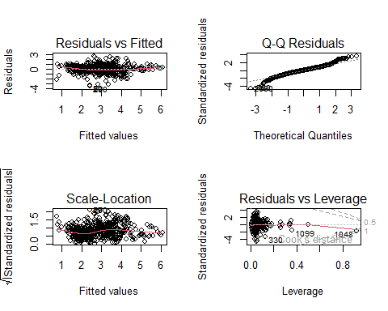
par(mfrow=c(1,1))
#la situazione è migliorata, ma non è ancora buona.
#Proviamo a usare i Generalized Additive Models
library(gam)
## Warning: il pacchetto 'gam' è stato creato con R versione 4.4.1
## Caricamento del pacchetto richiesto: splines
## Caricamento del pacchetto richiesto: foreach
## Warning: il pacchetto 'foreach' è stato creato con R versione 4.4.1
## Loaded gam 1.22-5
#riscriviamo lm3_log con questa libreria, in modo da poter fare comparazioni
lm3_log <- gam(log(depth) ~ magnitude + updated + felt + cdi + mmi + tsunami + net + nst + dmin + rms + gap + latitude + distanceKM + continent + longitude , data=dp)
lm3_log_gam <- gam(log(depth) ~ s(magnitude) + s(updated) + s(felt) + cdi + mmi + tsunami + net + s(nst) + s(dmin) + s(rms) + s(gap) + s(latitude) + s(distanceKM) + continent + s(longitude) , data=dp)
summary(lm3_log_gam)
##
## Call: gam(formula = log(depth) ~ s(magnitude) + s(updated) + s(felt) +
## cdi + mmi + tsunami + net + s(nst) + s(dmin) + s(rms) + s(gap) +
## s(latitude) + s(distanceKM) + continent + s(longitude), data = dp)
## Deviance Residuals:
## Min 1Q Median 3Q Max
## -3.174320 -0.356526 0.001197 0.392575 2.264782
##
## (Dispersion Parameter for gaussian family taken to be 0.4683)
##
## Null Deviance: 1620.109 on 1136 degrees of freedom
## Residual Deviance: 496.8903 on 1061.001 degrees of freedom
## AIC: 2439.48
##
## Number of Local Scoring Iterations: NA
##
## Anova for Parametric Effects
## Df Sum Sq Mean Sq F value Pr(>F)
## s(magnitude) 1 426.67 426.67 911.0511 < 2.2e-16 ***
## s(updated) 1 35.58 35.58 75.9757 < 2.2e-16 ***
## s(felt) 1 1.18 1.18 2.5249 0.1123631
## cdi 9 69.36 7.71 16.4549 < 2.2e-16 ***
## mmi 8 164.27 20.53 43.8456 < 2.2e-16 ***
## tsunami 1 25.60 25.60 54.6666 2.893e-13 ***
## net 10 38.94 3.89 8.3139 4.301e-13 ***
## s(nst) 1 2.57 2.57 5.4813 0.0194055 *
## s(dmin) 1 5.85 5.85 12.4987 0.0004248 ***
## s(rms) 1 2.80 2.80 5.9877 0.0145673 *
## s(gap) 1 21.76 21.76 46.4715 1.557e-11 ***
## s(latitude) 1 76.42 76.42 163.1880 < 2.2e-16 ***
## s(distanceKM) 1 0.00 0.00 0.0018 0.9661601
## continent 7 73.65 10.52 22.4675 < 2.2e-16 ***
## s(longitude) 1 0.25 0.25 0.5233 0.4696089
## Residuals 1061 496.89 0.47
## ---
## Signif. codes: 0 '***' 0.001 '**' 0.01 '*' 0.05 '.' 0.1 ' ' 1
##
## Anova for Nonparametric Effects
## Npar Df Npar F Pr(F)
## (Intercept)
## s(magnitude) 3 4.6092 0.0032738 **
## s(updated) 3 17.8642 2.576e-11 ***
## s(felt) 3 3.4314 0.0165593 *
## cdi
## mmi
## tsunami
## net
## s(nst) 3 3.1189 0.0253235 *
## s(dmin) 3 6.2797 0.0003179 ***
## s(rms) 3 6.0829 0.0004191 ***
## s(gap) 3 7.7644 3.941e-05 ***
## s(latitude) 3 15.6385 5.879e-10 ***
## s(distanceKM) 3 10.0657 1.528e-06 ***
## continent
## s(longitude) 3 20.6371 5.327e-13 ***
## ---
## Signif. codes: 0 '***' 0.001 '**' 0.01 '*' 0.05 '.' 0.1 ' ' 1
lm3_log_gamlo <- gam(log(depth) ~ lo(magnitude) + lo(updated) + lo(felt) + cdi + mmi + tsunami + net + lo(nst) + lo(dmin) + lo(rms) + lo(gap) + lo(latitude) + lo(distanceKM) + continent + lo(longitude) , data=dp)
## Warning in lo.wam(x, z, wz, fit$smooth, which, fit$smooth.frame, bf.maxit, :
## lo.wam convergence not obtained in 30 iterations
## Warning in lo.wam(x, z, wz, fit$smooth, which, fit$smooth.frame, bf.maxit, :
## lo.wam convergence not obtained in 30 iterations
summary(lm3_log_gamlo)
##
## Call: gam(formula = log(depth) ~ lo(magnitude) + lo(updated) + lo(felt) +
## cdi + mmi + tsunami + net + lo(nst) + lo(dmin) + lo(rms) +
## lo(gap) + lo(latitude) + lo(distanceKM) + continent + lo(longitude),
## data = dp)
## Deviance Residuals:
## Min 1Q Median 3Q Max
## -3.26528 -0.38683 0.01718 0.37349 2.31993
##
## (Dispersion Parameter for gaussian family taken to be 0.5124)
##
## Null Deviance: 1620.109 on 1136 degrees of freedom
## Residual Deviance: 541.5215 on 1056.879 degrees of freedom
## AIC: 2545.52
##
## Number of Local Scoring Iterations: NA
##
## Anova for Parametric Effects
## Df Sum Sq Mean Sq F value Pr(>F)
## lo(magnitude) 1.0 416.19 416.19 812.2816 < 2.2e-16 ***
## lo(updated) 1.0 59.52 59.52 116.1560 < 2.2e-16 ***
## lo(felt) 1.0 0.20 0.20 0.3846 0.5353054
## cdi 9.0 101.71 11.30 22.0559 < 2.2e-16 ***
## mmi 8.0 174.81 21.85 42.6457 < 2.2e-16 ***
## tsunami 1.0 43.06 43.06 84.0421 < 2.2e-16 ***
## net 10.0 74.24 7.42 14.4902 < 2.2e-16 ***
## lo(nst) 1.0 3.09 3.09 6.0392 0.0141517 *
## lo(dmin) 1.0 7.44 7.44 14.5227 0.0001465 ***
## lo(rms) 1.0 1.97 1.97 3.8437 0.0501942 .
## lo(gap) 1.0 25.74 25.74 50.2298 2.496e-12 ***
## lo(latitude) 1.0 58.73 58.73 114.6261 < 2.2e-16 ***
## lo(distanceKM) 1.0 0.00 0.00 0.0014 0.9706568
## continent 7.0 63.66 9.09 17.7496 < 2.2e-16 ***
## lo(longitude) 1.0 3.52 3.52 6.8650 0.0089163 **
## Residuals 1056.9 541.52 0.51
## ---
## Signif. codes: 0 '***' 0.001 '**' 0.01 '*' 0.05 '.' 0.1 ' ' 1
##
## Anova for Nonparametric Effects
## Npar Df Npar F Pr(F)
## (Intercept)
## lo(magnitude) 2.7 11.0754 1.257e-06 ***
## lo(updated) 3.5 7.6570 1.362e-05 ***
## lo(felt) 5.7 -10.7860 1.0000000
## cdi
## mmi
## tsunami
## net
## lo(nst) 3.4 1.6510 0.1698646
## lo(dmin) 3.5 5.1249 0.0008331 ***
## lo(rms) 2.9 4.9986 0.0021118 **
## lo(gap) 3.1 5.3160 0.0011294 **
## lo(latitude) 3.8 16.0323 3.983e-12 ***
## lo(distanceKM) 2.8 9.4115 6.170e-06 ***
## continent
## lo(longitude) 2.8 21.2463 1.103e-12 ***
## ---
## Signif. codes: 0 '***' 0.001 '**' 0.01 '*' 0.05 '.' 0.1 ' ' 1
anova(lm3_log, lm3_log_gam , lm3_log_gamlo , test="F")
## Analysis of Deviance Table
##
## Model 1: log(depth) ~ magnitude + updated + felt + cdi + mmi + tsunami +
## net + nst + dmin + rms + gap + latitude + distanceKM + continent +
## longitude
## Model 2: log(depth) ~ s(magnitude) + s(updated) + s(felt) + cdi + mmi +
## tsunami + net + s(nst) + s(dmin) + s(rms) + s(gap) + s(latitude) +
## s(distanceKM) + continent + s(longitude)
## Model 3: log(depth) ~ lo(magnitude) + lo(updated) + lo(felt) + cdi + mmi +
## tsunami + net + lo(nst) + lo(dmin) + lo(rms) + lo(gap) +
## lo(latitude) + lo(distanceKM) + continent + lo(longitude)
## Resid. Df Resid. Dev Df Deviance F Pr(>F)
## 1 1091.0 640.03
## 2 1061.0 496.89 29.9995 143.141 9.3124 < 2.2e-16 ***
## 3 1056.9 541.52 4.1211 -44.631
## ---
## Signif. codes: 0 '***' 0.001 '**' 0.01 '*' 0.05 '.' 0.1 ' ' 1
#il GAM usando splines è SIGNIFICATIVAMENTE migliore del modello log-lineare.
#il GAM usando splines è anche migliore del gam usando loess.
par(mfrow=c(3,3))
plot(lm3_log_gam)
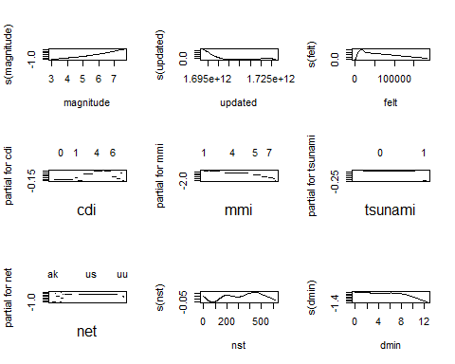
par(mfrow=c(1,1))
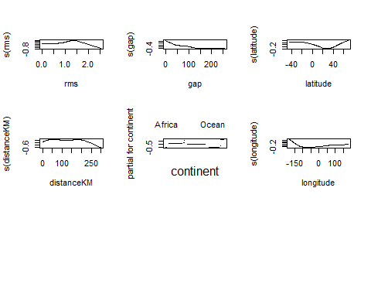
#Trasformiamo le covariate linearizzandole.
library(lmtest)
## Warning: il pacchetto 'lmtest' è stato creato con R versione 4.4.1
## Caricamento del pacchetto richiesto: zoo
## Warning: il pacchetto 'zoo' è stato creato con R versione 4.4.1
##
## Caricamento pacchetto: 'zoo'
##
## I seguenti oggetti sono mascherati da 'package:base':
##
## as.Date, as.Date.numeric
dp2 <- dp
dp2$gap = dp2$gap + 1 #in modo da poter usare il log di gap
dp2$longitude = dp2$longitude + 200
lm3_lin <- lm(log(depth) ~ magnitude + I(updated^3) + felt + cdi + mmi + tsunami
+ net + I(nst^3 + nst^2) + I(dmin^3) + I(rms^2) + I(log(gap)) + I(latitude^2)
+ I(distanceKM^3) + continent + I(log(longitude)) , data=dp2)
summary(lm3_lin)#R2 = 0.6023
##
## Call:
## lm(formula = log(depth) ~ magnitude + I(updated^3) + felt + cdi +
## mmi + tsunami + net + I(nst^3 + nst^2) + I(dmin^3) + I(rms^2) +
## I(log(gap)) + I(latitude^2) + I(distanceKM^3) + continent +
## I(log(longitude)), data = dp2)
##
## Residuals:
## Min 1Q Median 3Q Max
## -3.03173 -0.39454 0.01493 0.40548 2.66847
##
## Coefficients:
## Estimate Std. Error t value Pr(>|t|)
## (Intercept) 2.453e+00 2.100e+00 1.168 0.243132
## magnitude 7.578e-01 6.028e-02 12.572 < 2e-16 ***
## I(updated^3) -1.021e-37 3.780e-37 -0.270 0.787040
## felt 9.727e-07 4.073e-06 0.239 0.811293
## cdi1 -1.155e-01 1.259e-01 -0.917 0.359154
## cdi2 4.114e-02 9.856e-02 0.417 0.676431
## cdi3 1.908e-01 7.622e-02 2.503 0.012452 *
## cdi4 1.746e-01 8.190e-02 2.132 0.033235 *
## cdi5 2.257e-01 9.256e-02 2.438 0.014915 *
## cdi6 9.339e-02 1.120e-01 0.834 0.404516
## cdi7 8.954e-02 1.291e-01 0.694 0.488116
## cdi8 2.560e-01 1.797e-01 1.424 0.154654
## cdi9 1.153e-01 2.384e-01 0.484 0.628748
## mmi2 1.910e-01 1.993e-01 0.958 0.338036
## mmi3 6.364e-02 1.884e-01 0.338 0.735555
## mmi4 -5.797e-01 1.931e-01 -3.002 0.002746 **
## mmi5 -1.331e+00 2.072e-01 -6.423 1.99e-10 ***
## mmi6 -1.933e+00 2.137e-01 -9.044 < 2e-16 ***
## mmi7 -2.184e+00 2.220e-01 -9.836 < 2e-16 ***
## mmi8 -2.516e+00 2.866e-01 -8.780 < 2e-16 ***
## mmi9 -3.325e+00 4.494e-01 -7.399 2.74e-13 ***
## tsunami1 -2.090e-01 1.239e-01 -1.686 0.092040 .
## netat 1.622e+00 4.948e-01 3.278 0.001078 **
## netci 1.272e+00 2.799e-01 4.545 6.12e-06 ***
## netnc 3.551e-01 3.346e-01 1.061 0.288877
## netnm 1.569e+00 5.223e-01 3.003 0.002734 **
## netnn 1.005e+00 3.033e-01 3.314 0.000949 ***
## netok 1.470e+00 3.616e-01 4.064 5.17e-05 ***
## nettx 1.513e+00 2.870e-01 5.271 1.64e-07 ***
## netus 1.522e+00 2.804e-01 5.426 7.11e-08 ***
## netuu 1.377e+00 3.762e-01 3.660 0.000264 ***
## netuw 1.297e+00 5.911e-01 2.194 0.028473 *
## I(nst^3 + nst^2) -5.844e-10 1.498e-09 -0.390 0.696534
## I(dmin^3) -5.521e-04 1.835e-04 -3.008 0.002692 **
## I(rms^2) 1.934e-01 7.106e-02 2.722 0.006591 **
## I(log(gap)) -3.169e-01 5.109e-02 -6.202 7.92e-10 ***
## I(latitude^2) 9.011e-05 4.787e-05 1.882 0.060067 .
## I(distanceKM^3) -1.936e-08 8.568e-09 -2.260 0.024015 *
## continentAsia 4.759e-01 4.489e-01 1.060 0.289300
## continentEurope 2.462e-01 5.646e-01 0.436 0.662903
## continentInsular Oceania 1.499e+00 5.081e-01 2.949 0.003252 **
## continentNorth America -3.291e-01 4.570e-01 -0.720 0.471586
## continentOcean -5.209e-01 4.542e-01 -1.147 0.251730
## continentOceania 5.779e-01 8.826e-01 0.655 0.512791
## continentSouth America 8.241e-01 4.577e-01 1.800 0.072067 .
## I(log(longitude)) -4.789e-01 8.561e-02 -5.594 2.81e-08 ***
## ---
## Signif. codes: 0 '***' 0.001 '**' 0.01 '*' 0.05 '.' 0.1 ' ' 1
##
## Residual standard error: 0.7531 on 1091 degrees of freedom
## Multiple R-squared: 0.6181, Adjusted R-squared: 0.6023
## F-statistic: 39.24 on 45 and 1091 DF, p-value: < 2.2e-16
resettest(lm3_lin, power = 3, type = "fitted", data = dp2)#0.002679
##
## RESET test
##
## data: lm3_lin
## RESET = 9.0554, df1 = 1, df2 = 1090, p-value = 0.002679
#Ho ottenuto il miglior R2 e reset test possibile per ora trasformando.
par(mfrow=c(2,2))
plot(lm3_lin)
## Warning: non si riesce a fare il plot senza sfruttarne uno:
## 476
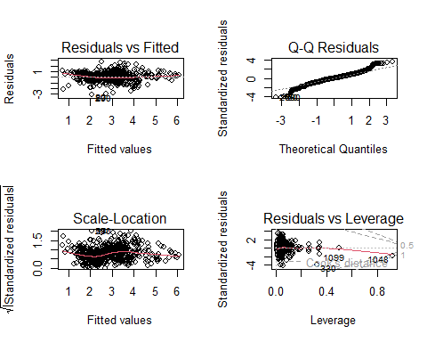
par(mfrow=c(1,1))
# 2.b)Optimal Grouping ----------------------------------------------------
#Proviamo a unire livelli delle variabili categoriche del nostro modello e osserviamo i risultati.
#le nostre variabili categoriche sono: "cdi","mmi","net","continent"
#vediamo quanti livelli hanno ciascuna:
sapply(dp2[ , c("cdi","mmi","net","continent")], function(x) length(unique(x)))
## cdi mmi net continent
## 10 9 11 8
library(factorMerger)
## Welcome to factorMerger 0.4.0!
#Iniziamo con cdi
liv <- mergeFactors(response = dp2$depth, factor = dp2$cdi)
## Warning: `arrange_()` was deprecated in dplyr 0.7.0.
## ℹ Please use `arrange()` instead.
## ℹ See vignette('programming') for more help
## ℹ The deprecated feature was likely used in the factorMerger package.
## Please report the issue to the authors.
## This warning is displayed once every 8 hours.
## Call `lifecycle::last_lifecycle_warnings()` to see where this warning was
## generated.
plot(liv , panel = "GIC",title = "Optimal grouping cdi", panelGrid = FALSE )
## Warning: Vectorized input to `element_text()` is not officially supported.
## ℹ Results may be unexpected or may change in future versions of ggplot2.
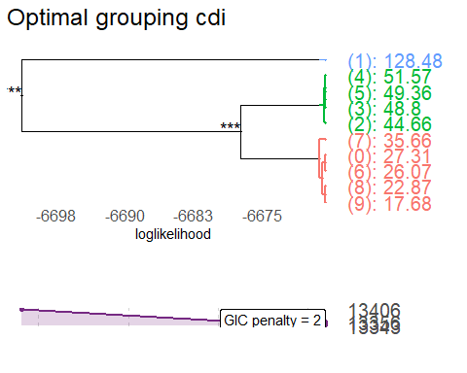
#Inseriamo i nuovi livelli nel dataset
cdiop=cutTree(liv)
dp2$optimal_group=cdiop
dp2$cdi_group =as.factor(as.numeric(dp2$optimal_group))
plot(dp2$cdi,dp2$depth)
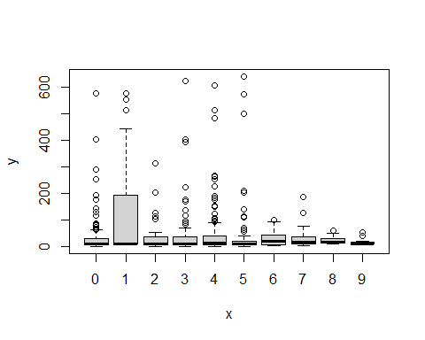
table(dp2$cdi_group,dp2$cdi)
##
## 0 1 2 3 4 5 6 7 8 9
## 1 365 0 0 0 0 0 79 59 30 23
## 2 0 0 77 169 156 132 0 0 0 0
## 3 0 47 0 0 0 0 0 0 0 0
plot(dp2$cdi_group,dp2$depth)
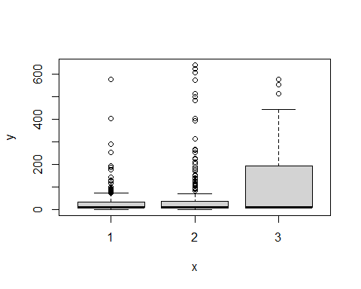
#Compariamo i modelli con e senza optimal grouping
lm3_merge1 <- lm(log(depth) ~ magnitude + I(updated^3) + felt + cdi + mmi + tsunami
+ net + I(nst^3 + nst^2) + I(dmin^3) + I(rms^2) + I(log(gap)) + I(latitude^2)
+ I(distanceKM^3) + continent + I(log(longitude)) , data=dp2)
summary(lm3_merge1)#R2 = 0.6023
##
## Call:
## lm(formula = log(depth) ~ magnitude + I(updated^3) + felt + cdi +
## mmi + tsunami + net + I(nst^3 + nst^2) + I(dmin^3) + I(rms^2) +
## I(log(gap)) + I(latitude^2) + I(distanceKM^3) + continent +
## I(log(longitude)), data = dp2)
##
## Residuals:
## Min 1Q Median 3Q Max
## -3.03173 -0.39454 0.01493 0.40548 2.66847
##
## Coefficients:
## Estimate Std. Error t value Pr(>|t|)
## (Intercept) 2.453e+00 2.100e+00 1.168 0.243132
## magnitude 7.578e-01 6.028e-02 12.572 < 2e-16 ***
## I(updated^3) -1.021e-37 3.780e-37 -0.270 0.787040
## felt 9.727e-07 4.073e-06 0.239 0.811293
## cdi1 -1.155e-01 1.259e-01 -0.917 0.359154
## cdi2 4.114e-02 9.856e-02 0.417 0.676431
## cdi3 1.908e-01 7.622e-02 2.503 0.012452 *
## cdi4 1.746e-01 8.190e-02 2.132 0.033235 *
## cdi5 2.257e-01 9.256e-02 2.438 0.014915 *
## cdi6 9.339e-02 1.120e-01 0.834 0.404516
## cdi7 8.954e-02 1.291e-01 0.694 0.488116
## cdi8 2.560e-01 1.797e-01 1.424 0.154654
## cdi9 1.153e-01 2.384e-01 0.484 0.628748
## mmi2 1.910e-01 1.993e-01 0.958 0.338036
## mmi3 6.364e-02 1.884e-01 0.338 0.735555
## mmi4 -5.797e-01 1.931e-01 -3.002 0.002746 **
## mmi5 -1.331e+00 2.072e-01 -6.423 1.99e-10 ***
## mmi6 -1.933e+00 2.137e-01 -9.044 < 2e-16 ***
## mmi7 -2.184e+00 2.220e-01 -9.836 < 2e-16 ***
## mmi8 -2.516e+00 2.866e-01 -8.780 < 2e-16 ***
## mmi9 -3.325e+00 4.494e-01 -7.399 2.74e-13 ***
## tsunami1 -2.090e-01 1.239e-01 -1.686 0.092040 .
## netat 1.622e+00 4.948e-01 3.278 0.001078 **
## netci 1.272e+00 2.799e-01 4.545 6.12e-06 ***
## netnc 3.551e-01 3.346e-01 1.061 0.288877
## netnm 1.569e+00 5.223e-01 3.003 0.002734 **
## netnn 1.005e+00 3.033e-01 3.314 0.000949 ***
## netok 1.470e+00 3.616e-01 4.064 5.17e-05 ***
## nettx 1.513e+00 2.870e-01 5.271 1.64e-07 ***
## netus 1.522e+00 2.804e-01 5.426 7.11e-08 ***
## netuu 1.377e+00 3.762e-01 3.660 0.000264 ***
## netuw 1.297e+00 5.911e-01 2.194 0.028473 *
## I(nst^3 + nst^2) -5.844e-10 1.498e-09 -0.390 0.696534
## I(dmin^3) -5.521e-04 1.835e-04 -3.008 0.002692 **
## I(rms^2) 1.934e-01 7.106e-02 2.722 0.006591 **
## I(log(gap)) -3.169e-01 5.109e-02 -6.202 7.92e-10 ***
## I(latitude^2) 9.011e-05 4.787e-05 1.882 0.060067 .
## I(distanceKM^3) -1.936e-08 8.568e-09 -2.260 0.024015 *
## continentAsia 4.759e-01 4.489e-01 1.060 0.289300
## continentEurope 2.462e-01 5.646e-01 0.436 0.662903
## continentInsular Oceania 1.499e+00 5.081e-01 2.949 0.003252 **
## continentNorth America -3.291e-01 4.570e-01 -0.720 0.471586
## continentOcean -5.209e-01 4.542e-01 -1.147 0.251730
## continentOceania 5.779e-01 8.826e-01 0.655 0.512791
## continentSouth America 8.241e-01 4.577e-01 1.800 0.072067 .
## I(log(longitude)) -4.789e-01 8.561e-02 -5.594 2.81e-08 ***
## ---
## Signif. codes: 0 '***' 0.001 '**' 0.01 '*' 0.05 '.' 0.1 ' ' 1
##
## Residual standard error: 0.7531 on 1091 degrees of freedom
## Multiple R-squared: 0.6181, Adjusted R-squared: 0.6023
## F-statistic: 39.24 on 45 and 1091 DF, p-value: < 2.2e-16
resettest(lm3_merge1, power = 3, type = "fitted", data = dp2)#0.002679
##
## RESET test
##
## data: lm3_merge1
## RESET = 9.0554, df1 = 1, df2 = 1090, p-value = 0.002679
lm3_merge2 <- lm(log(depth) ~ magnitude + I(updated^3) + felt + cdi_group + mmi + tsunami
+ net + I(nst^3 + nst^2) + I(dmin^3) + I(rms^2) + I(log(gap)) + I(latitude^2)
+ I(distanceKM^3) + continent + I(log(longitude)) , data=dp2)
summary(lm3_merge2)#R2 = 0.6033
##
## Call:
## lm(formula = log(depth) ~ magnitude + I(updated^3) + felt + cdi_group +
## mmi + tsunami + net + I(nst^3 + nst^2) + I(dmin^3) + I(rms^2) +
## I(log(gap)) + I(latitude^2) + I(distanceKM^3) + continent +
## I(log(longitude)), data = dp2)
##
## Residuals:
## Min 1Q Median 3Q Max
## -2.98613 -0.40679 0.02493 0.40523 2.70297
##
## Coefficients:
## Estimate Std. Error t value Pr(>|t|)
## (Intercept) 2.092e+00 2.071e+00 1.010 0.312632
## magnitude 7.886e-01 5.735e-02 13.750 < 2e-16 ***
## I(updated^3) -4.776e-38 3.733e-37 -0.128 0.898230
## felt 1.032e-06 4.051e-06 0.255 0.798918
## cdi_group2 1.344e-01 5.051e-02 2.661 0.007912 **
## cdi_group3 -1.324e-01 1.236e-01 -1.072 0.283996
## mmi2 1.752e-01 1.975e-01 0.887 0.375212
## mmi3 5.016e-02 1.868e-01 0.268 0.788390
## mmi4 -5.766e-01 1.919e-01 -3.004 0.002723 **
## mmi5 -1.301e+00 2.045e-01 -6.363 2.90e-10 ***
## mmi6 -1.878e+00 2.105e-01 -8.922 < 2e-16 ***
## mmi7 -2.149e+00 2.192e-01 -9.804 < 2e-16 ***
## mmi8 -2.385e+00 2.637e-01 -9.045 < 2e-16 ***
## mmi9 -3.283e+00 3.993e-01 -8.221 5.63e-16 ***
## tsunami1 -2.289e-01 1.211e-01 -1.890 0.058986 .
## netat 1.643e+00 4.939e-01 3.326 0.000911 ***
## netci 1.333e+00 2.747e-01 4.853 1.39e-06 ***
## netnc 4.308e-01 3.311e-01 1.301 0.193431
## netnm 1.673e+00 5.126e-01 3.264 0.001132 **
## netnn 1.027e+00 3.010e-01 3.413 0.000666 ***
## netok 1.536e+00 3.552e-01 4.325 1.66e-05 ***
## nettx 1.546e+00 2.849e-01 5.426 7.08e-08 ***
## netus 1.549e+00 2.786e-01 5.559 3.40e-08 ***
## netuu 1.453e+00 3.718e-01 3.908 9.87e-05 ***
## netuw 1.381e+00 5.876e-01 2.350 0.018975 *
## I(nst^3 + nst^2) -1.057e-09 1.464e-09 -0.722 0.470407
## I(dmin^3) -5.567e-04 1.828e-04 -3.045 0.002379 **
## I(rms^2) 1.953e-01 7.061e-02 2.765 0.005779 **
## I(log(gap)) -3.225e-01 5.062e-02 -6.371 2.76e-10 ***
## I(latitude^2) 9.571e-05 4.746e-05 2.017 0.043990 *
## I(distanceKM^3) -2.030e-08 8.522e-09 -2.382 0.017394 *
## continentAsia 4.768e-01 4.452e-01 1.071 0.284466
## continentEurope 2.672e-01 5.385e-01 0.496 0.619810
## continentInsular Oceania 1.526e+00 5.053e-01 3.019 0.002591 **
## continentNorth America -3.067e-01 4.531e-01 -0.677 0.498684
## continentOcean -5.266e-01 4.501e-01 -1.170 0.242219
## continentOceania 6.085e-01 8.759e-01 0.695 0.487409
## continentSouth America 8.240e-01 4.541e-01 1.814 0.069894 .
## I(log(longitude)) -4.905e-01 8.523e-02 -5.755 1.12e-08 ***
## ---
## Signif. codes: 0 '***' 0.001 '**' 0.01 '*' 0.05 '.' 0.1 ' ' 1
##
## Residual standard error: 0.7522 on 1098 degrees of freedom
## Multiple R-squared: 0.6165, Adjusted R-squared: 0.6033
## F-statistic: 46.46 on 38 and 1098 DF, p-value: < 2.2e-16
resettest(lm3_merge2, power = 3, type = "fitted", data = dp2)#0.003335
##
## RESET test
##
## data: lm3_merge2
## RESET = 8.6525, df1 = 1, df2 = 1097, p-value = 0.003335
drop1(lm3_merge1,test="F")
## Single term deletions
##
## Model:
## log(depth) ~ magnitude + I(updated^3) + felt + cdi + mmi + tsunami +
## net + I(nst^3 + nst^2) + I(dmin^3) + I(rms^2) + I(log(gap)) +
## I(latitude^2) + I(distanceKM^3) + continent + I(log(longitude))
## Df Sum of Sq RSS AIC F value Pr(>F)
## <none> 618.73 -599.85
## magnitude 1 89.630 708.36 -448.03 158.0450 < 2.2e-16 ***
## I(updated^3) 1 0.041 618.77 -601.77 0.0730 0.787040
## felt 1 0.032 618.76 -601.79 0.0570 0.811293
## cdi 9 8.021 626.75 -603.20 1.5715 0.118897
## mmi 8 242.426 861.15 -239.94 53.4336 < 2.2e-16 ***
## tsunami 1 1.613 620.34 -598.89 2.8433 0.092040 .
## net 10 32.324 651.05 -561.95 5.6997 2.276e-08 ***
## I(nst^3 + nst^2) 1 0.086 618.81 -601.69 0.1522 0.696534
## I(dmin^3) 1 5.131 623.86 -592.46 9.0470 0.002692 **
## I(rms^2) 1 4.202 622.93 -594.15 7.4096 0.006591 **
## I(log(gap)) 1 21.812 640.54 -562.45 38.4603 7.916e-10 ***
## I(latitude^2) 1 2.009 620.74 -598.16 3.5429 0.060067 .
## I(distanceKM^3) 1 2.897 621.62 -596.53 5.1078 0.024015 *
## continent 7 141.506 760.23 -379.67 35.6453 < 2.2e-16 ***
## I(log(longitude)) 1 17.746 636.47 -569.69 31.2914 2.806e-08 ***
## ---
## Signif. codes: 0 '***' 0.001 '**' 0.01 '*' 0.05 '.' 0.1 ' ' 1
drop1(lm3_merge2,test="F")
## Single term deletions
##
## Model:
## log(depth) ~ magnitude + I(updated^3) + felt + cdi_group + mmi +
## tsunami + net + I(nst^3 + nst^2) + I(dmin^3) + I(rms^2) +
## I(log(gap)) + I(latitude^2) + I(distanceKM^3) + continent +
## I(log(longitude))
## Df Sum of Sq RSS AIC F value Pr(>F)
## <none> 621.23 -609.25
## magnitude 1 106.972 728.21 -430.61 189.0683 < 2.2e-16 ***
## I(updated^3) 1 0.009 621.24 -611.23 0.0164 0.898230
## felt 1 0.037 621.27 -611.18 0.0649 0.798918
## cdi_group 2 5.516 626.75 -603.20 4.8745 0.007805 **
## mmi 8 281.803 903.04 -199.95 62.2591 < 2.2e-16 ***
## tsunami 1 2.022 623.25 -607.56 3.5731 0.058986 .
## net 10 32.494 653.73 -571.28 5.7431 1.897e-08 ***
## I(nst^3 + nst^2) 1 0.295 621.53 -610.71 0.5214 0.470407
## I(dmin^3) 1 5.247 626.48 -601.69 9.2742 0.002379 **
## I(rms^2) 1 4.327 625.56 -603.36 7.6480 0.005779 **
## I(log(gap)) 1 22.963 644.20 -569.98 40.5853 2.763e-10 ***
## I(latitude^2) 1 2.301 623.53 -607.05 4.0663 0.043990 *
## I(distanceKM^3) 1 3.210 624.44 -605.39 5.6734 0.017394 *
## continent 7 144.526 765.76 -385.43 36.4919 < 2.2e-16 ***
## I(log(longitude)) 1 18.739 639.97 -577.46 33.1204 1.123e-08 ***
## ---
## Signif. codes: 0 '***' 0.001 '**' 0.01 '*' 0.05 '.' 0.1 ' ' 1
AIC(lm3_merge1,lm3_merge2)
## df AIC
## lm3_merge1 47 2628.821
## lm3_merge2 40 2619.415
#Migliorano sia R2 che linearità. L'AIC migliora. teniamo i valori raggruppati di cdi
#Facciamo lo stesso con MMI
liv <- mergeFactors(response = dp2$depth, factor = dp2$mmi)
plot(liv , panel = "GIC",title = "Optimal grouping mmi", panelGrid = FALSE )
## Warning: Vectorized input to `element_text()` is not officially supported.
## ℹ Results may be unexpected or may change in future versions of ggplot2.
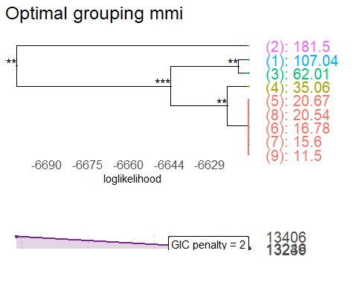
#Inseriamo i nuovi livelli nel dataset
mmiop=cutTree(liv)
dp2$optimal_group=mmiop
dp2$mmi_group =as.factor(as.numeric(dp2$optimal_group))
table(dp2$mmi_group,dp2$mmi)
##
## 1 2 3 4 5 6 7 8 9
## 1 0 0 0 0 146 105 84 26 6
## 2 0 0 0 490 0 0 0 0 0
## 3 0 0 210 0 0 0 0 0 0
## 4 28 0 0 0 0 0 0 0 0
## 5 0 42 0 0 0 0 0 0 0
plot(dp2$mmi_group,dp2$depth)
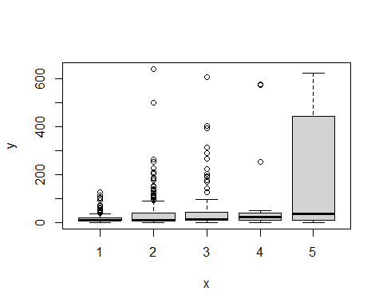
#Compariamo i modelli con e senza optimal grouping
lm3_merge3 <- lm(log(depth) ~ magnitude + I(updated^3) + felt + cdi_group + mmi_group + tsunami
+ net + I(nst^3 + nst^2) + I(dmin^3) + I(rms^2) + I(log(gap)) + I(latitude^2)
+ I(distanceKM^3) + continent + I(log(longitude)) , data=dp2)
summary(lm3_merge3)#R2 = 0.571
##
## Call:
## lm(formula = log(depth) ~ magnitude + I(updated^3) + felt + cdi_group +
## mmi_group + tsunami + net + I(nst^3 + nst^2) + I(dmin^3) +
## I(rms^2) + I(log(gap)) + I(latitude^2) + I(distanceKM^3) +
## continent + I(log(longitude)), data = dp2)
##
## Residuals:
## Min 1Q Median 3Q Max
## -3.06728 -0.43815 -0.03838 0.47222 2.66381
##
## Coefficients:
## Estimate Std. Error t value Pr(>|t|)
## (Intercept) 1.005e+00 2.151e+00 0.467 0.640413
## magnitude 6.763e-01 5.679e-02 11.909 < 2e-16 ***
## I(updated^3) -1.441e-37 3.855e-37 -0.374 0.708557
## felt 1.741e-06 4.195e-06 0.415 0.678257
## cdi_group2 2.223e-01 5.133e-02 4.331 1.62e-05 ***
## cdi_group3 -2.799e-02 1.279e-01 -0.219 0.826757
## mmi_group2 1.045e+00 6.516e-02 16.034 < 2e-16 ***
## mmi_group3 1.646e+00 9.280e-02 17.736 < 2e-16 ***
## mmi_group4 1.530e+00 2.080e-01 7.355 3.72e-13 ***
## mmi_group5 1.734e+00 1.582e-01 10.958 < 2e-16 ***
## tsunami1 -3.030e-01 1.249e-01 -2.426 0.015428 *
## netat 1.729e+00 5.131e-01 3.369 0.000780 ***
## netci 1.226e+00 2.851e-01 4.300 1.86e-05 ***
## netnc 3.172e-01 3.436e-01 0.923 0.356113
## netnm 1.559e+00 5.327e-01 2.927 0.003494 **
## netnn 9.101e-01 3.125e-01 2.912 0.003664 **
## netok 1.297e+00 3.681e-01 3.524 0.000442 ***
## nettx 1.451e+00 2.958e-01 4.904 1.08e-06 ***
## netus 1.465e+00 2.894e-01 5.063 4.84e-07 ***
## netuu 1.385e+00 3.862e-01 3.586 0.000350 ***
## netuw 1.262e+00 6.107e-01 2.066 0.039093 *
## I(nst^3 + nst^2) -3.374e-09 1.480e-09 -2.280 0.022770 *
## I(dmin^3) -6.679e-04 1.890e-04 -3.533 0.000428 ***
## I(rms^2) 2.487e-01 7.300e-02 3.407 0.000681 ***
## I(log(gap)) -3.146e-01 5.254e-02 -5.987 2.89e-09 ***
## I(latitude^2) 4.355e-05 4.882e-05 0.892 0.372503
## I(distanceKM^3) -1.465e-08 8.828e-09 -1.660 0.097299 .
## continentAsia 7.741e-01 4.597e-01 1.684 0.092487 .
## continentEurope 7.911e-01 5.526e-01 1.432 0.152498
## continentInsular Oceania 1.902e+00 5.223e-01 3.642 0.000283 ***
## continentNorth America 6.048e-02 4.671e-01 0.129 0.896997
## continentOcean -3.824e-02 4.628e-01 -0.083 0.934175
## continentOceania 5.125e-01 9.106e-01 0.563 0.573649
## continentSouth America 1.280e+00 4.676e-01 2.737 0.006301 **
## I(log(longitude)) -4.621e-01 8.814e-02 -5.243 1.89e-07 ***
## ---
## Signif. codes: 0 '***' 0.001 '**' 0.01 '*' 0.05 '.' 0.1 ' ' 1
##
## Residual standard error: 0.7822 on 1102 degrees of freedom
## Multiple R-squared: 0.5839, Adjusted R-squared: 0.571
## F-statistic: 45.47 on 34 and 1102 DF, p-value: < 2.2e-16
resettest(lm3_merge3, power = 3, type = "fitted", data = dp2)#0.01029
##
## RESET test
##
## data: lm3_merge3
## RESET = 6.6071, df1 = 1, df2 = 1101, p-value = 0.01029
drop1(lm3_merge2,test="F")
## Single term deletions
##
## Model:
## log(depth) ~ magnitude + I(updated^3) + felt + cdi_group + mmi +
## tsunami + net + I(nst^3 + nst^2) + I(dmin^3) + I(rms^2) +
## I(log(gap)) + I(latitude^2) + I(distanceKM^3) + continent +
## I(log(longitude))
## Df Sum of Sq RSS AIC F value Pr(>F)
## <none> 621.23 -609.25
## magnitude 1 106.972 728.21 -430.61 189.0683 < 2.2e-16 ***
## I(updated^3) 1 0.009 621.24 -611.23 0.0164 0.898230
## felt 1 0.037 621.27 -611.18 0.0649 0.798918
## cdi_group 2 5.516 626.75 -603.20 4.8745 0.007805 **
## mmi 8 281.803 903.04 -199.95 62.2591 < 2.2e-16 ***
## tsunami 1 2.022 623.25 -607.56 3.5731 0.058986 .
## net 10 32.494 653.73 -571.28 5.7431 1.897e-08 ***
## I(nst^3 + nst^2) 1 0.295 621.53 -610.71 0.5214 0.470407
## I(dmin^3) 1 5.247 626.48 -601.69 9.2742 0.002379 **
## I(rms^2) 1 4.327 625.56 -603.36 7.6480 0.005779 **
## I(log(gap)) 1 22.963 644.20 -569.98 40.5853 2.763e-10 ***
## I(latitude^2) 1 2.301 623.53 -607.05 4.0663 0.043990 *
## I(distanceKM^3) 1 3.210 624.44 -605.39 5.6734 0.017394 *
## continent 7 144.526 765.76 -385.43 36.4919 < 2.2e-16 ***
## I(log(longitude)) 1 18.739 639.97 -577.46 33.1204 1.123e-08 ***
## ---
## Signif. codes: 0 '***' 0.001 '**' 0.01 '*' 0.05 '.' 0.1 ' ' 1
drop1(lm3_merge3,test="F")
## Single term deletions
##
## Model:
## log(depth) ~ magnitude + I(updated^3) + felt + cdi_group + mmi_group +
## tsunami + net + I(nst^3 + nst^2) + I(dmin^3) + I(rms^2) +
## I(log(gap)) + I(latitude^2) + I(distanceKM^3) + continent +
## I(log(longitude))
## Df Sum of Sq RSS AIC F value Pr(>F)
## <none> 674.20 -524.22
## magnitude 1 86.760 760.96 -388.58 141.8128 < 2.2e-16 ***
## I(updated^3) 1 0.086 674.28 -526.08 0.1398 0.7085571
## felt 1 0.105 674.30 -526.05 0.1722 0.6782566
## cdi_group 2 12.127 686.33 -507.95 9.9111 5.419e-05 ***
## mmi_group 4 228.837 903.04 -199.95 93.5102 < 2.2e-16 ***
## tsunami 1 3.601 677.80 -520.17 5.8853 0.0154276 *
## net 10 31.987 706.19 -491.52 5.2285 1.559e-07 ***
## I(nst^3 + nst^2) 1 3.182 677.38 -520.87 5.2006 0.0227698 *
## I(dmin^3) 1 7.637 681.84 -513.42 12.4833 0.0004276 ***
## I(rms^2) 1 7.100 681.30 -514.31 11.6050 0.0006815 ***
## I(log(gap)) 1 21.929 696.13 -489.83 35.8442 2.889e-09 ***
## I(latitude^2) 1 0.487 674.69 -525.40 0.7959 0.3725034
## I(distanceKM^3) 1 1.685 675.88 -523.38 2.7539 0.0972992 .
## continent 7 125.879 800.08 -343.59 29.3933 < 2.2e-16 ***
## I(log(longitude)) 1 16.821 691.02 -498.20 27.4939 1.888e-07 ***
## ---
## Signif. codes: 0 '***' 0.001 '**' 0.01 '*' 0.05 '.' 0.1 ' ' 1
AIC(lm3_merge2,lm3_merge3)
## df AIC
## lm3_merge2 40 2619.415
## lm3_merge3 36 2704.443
#Tengo mmi originale, AIC peggiora sensibilmente raggruppandolo.
#Ora lo facciamo su NET
liv <- mergeFactors(response = dp2$depth, factor = dp2$net)
plot(liv , panel = "GIC",title = "Optimal grouping net", panelGrid = FALSE )
## Warning: Vectorized input to `element_text()` is not officially supported.
## ℹ Results may be unexpected or may change in future versions of ggplot2.
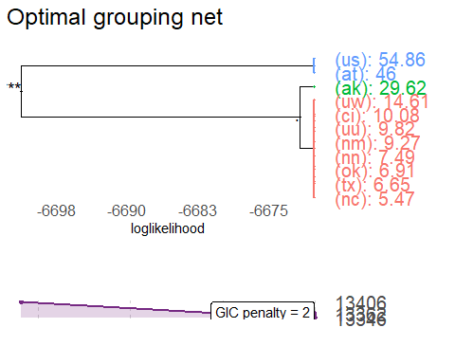
#Inseriamo i nuovi livelli nel dataset
netop=cutTree(liv)
dp2$optimal_group=netop
dp2$net_group =as.factor(as.numeric(dp2$optimal_group))
table(dp2$net_group,dp2$net)
##
## ak at ci nc nm nn ok tx us uu uw
## 1 0 0 68 13 3 30 11 150 0 9 2
## 2 53 0 0 0 0 0 0 0 0 0 0
## 3 0 4 0 0 0 0 0 0 794 0 0
plot(dp2$net_group,dp2$depth)
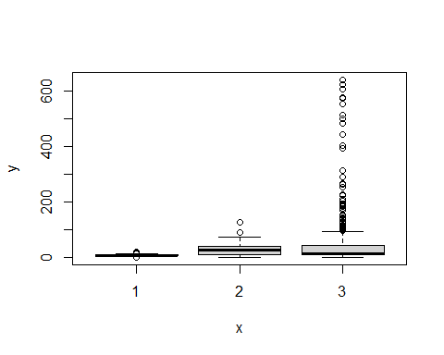
#vediamo i modelli
lm3_merge4 <- lm(log(depth) ~ magnitude + I(updated^3) + felt + cdi_group + mmi + tsunami
+ net_group + I(nst^3 + nst^2) + I(dmin^3) + I(rms^2) + I(log(gap)) + I(latitude^2)
+ I(distanceKM^3) + continent + I(log(longitude)) , data=dp2)
summary(lm3_merge4)#R2 = 0.5944
##
## Call:
## lm(formula = log(depth) ~ magnitude + I(updated^3) + felt + cdi_group +
## mmi + tsunami + net_group + I(nst^3 + nst^2) + I(dmin^3) +
## I(rms^2) + I(log(gap)) + I(latitude^2) + I(distanceKM^3) +
## continent + I(log(longitude)), data = dp2)
##
## Residuals:
## Min 1Q Median 3Q Max
## -3.11183 -0.40709 0.04517 0.42617 2.67334
##
## Coefficients:
## Estimate Std. Error t value Pr(>|t|)
## (Intercept) 3.464e+00 2.125e+00 1.630 0.10334
## magnitude 8.011e-01 5.771e-02 13.880 < 2e-16 ***
## I(updated^3) -1.039e-37 3.766e-37 -0.276 0.78267
## felt 9.482e-07 4.068e-06 0.233 0.81574
## cdi_group2 1.068e-01 5.012e-02 2.130 0.03339 *
## cdi_group3 -1.521e-01 1.248e-01 -1.219 0.22321
## mmi2 1.880e-01 1.993e-01 0.944 0.34551
## mmi3 6.747e-03 1.874e-01 0.036 0.97129
## mmi4 -5.318e-01 1.923e-01 -2.766 0.00577 **
## mmi5 -1.247e+00 2.052e-01 -6.075 1.70e-09 ***
## mmi6 -1.823e+00 2.113e-01 -8.628 < 2e-16 ***
## mmi7 -2.101e+00 2.205e-01 -9.528 < 2e-16 ***
## mmi8 -2.346e+00 2.657e-01 -8.830 < 2e-16 ***
## mmi9 -3.229e+00 4.032e-01 -8.009 2.90e-15 ***
## tsunami1 -2.638e-01 1.201e-01 -2.196 0.02827 *
## net_group2 -1.201e+00 2.718e-01 -4.417 1.10e-05 ***
## net_group3 1.455e-01 8.730e-02 1.667 0.09585 .
## I(nst^3 + nst^2) -8.719e-10 1.479e-09 -0.590 0.55552
## I(dmin^3) -5.510e-04 1.848e-04 -2.982 0.00293 **
## I(rms^2) 2.031e-01 7.133e-02 2.848 0.00448 **
## I(log(gap)) -2.931e-01 5.004e-02 -5.858 6.19e-09 ***
## I(latitude^2) 8.710e-05 4.759e-05 1.830 0.06747 .
## I(distanceKM^3) -1.713e-08 8.551e-09 -2.003 0.04541 *
## continentAsia 4.648e-01 4.500e-01 1.033 0.30194
## continentEurope 2.591e-01 5.443e-01 0.476 0.63418
## continentInsular Oceania 1.536e+00 5.108e-01 3.007 0.00270 **
## continentNorth America -2.564e-01 4.577e-01 -0.560 0.57547
## continentOcean -4.933e-01 4.548e-01 -1.085 0.27826
## continentOceania 6.160e-01 8.856e-01 0.696 0.48679
## continentSouth America 8.486e-01 4.587e-01 1.850 0.06459 .
## I(log(longitude)) -4.713e-01 8.449e-02 -5.578 3.06e-08 ***
## ---
## Signif. codes: 0 '***' 0.001 '**' 0.01 '*' 0.05 '.' 0.1 ' ' 1
##
## Residual standard error: 0.7605 on 1106 degrees of freedom
## Multiple R-squared: 0.6051, Adjusted R-squared: 0.5944
## F-statistic: 56.5 on 30 and 1106 DF, p-value: < 2.2e-16
resettest(lm3_merge4, power = 3, type = "fitted", data = dp2)#0.0124
##
## RESET test
##
## data: lm3_merge4
## RESET = 6.2731, df1 = 1, df2 = 1105, p-value = 0.0124
drop1(lm3_merge2,test="F")
## Single term deletions
##
## Model:
## log(depth) ~ magnitude + I(updated^3) + felt + cdi_group + mmi +
## tsunami + net + I(nst^3 + nst^2) + I(dmin^3) + I(rms^2) +
## I(log(gap)) + I(latitude^2) + I(distanceKM^3) + continent +
## I(log(longitude))
## Df Sum of Sq RSS AIC F value Pr(>F)
## <none> 621.23 -609.25
## magnitude 1 106.972 728.21 -430.61 189.0683 < 2.2e-16 ***
## I(updated^3) 1 0.009 621.24 -611.23 0.0164 0.898230
## felt 1 0.037 621.27 -611.18 0.0649 0.798918
## cdi_group 2 5.516 626.75 -603.20 4.8745 0.007805 **
## mmi 8 281.803 903.04 -199.95 62.2591 < 2.2e-16 ***
## tsunami 1 2.022 623.25 -607.56 3.5731 0.058986 .
## net 10 32.494 653.73 -571.28 5.7431 1.897e-08 ***
## I(nst^3 + nst^2) 1 0.295 621.53 -610.71 0.5214 0.470407
## I(dmin^3) 1 5.247 626.48 -601.69 9.2742 0.002379 **
## I(rms^2) 1 4.327 625.56 -603.36 7.6480 0.005779 **
## I(log(gap)) 1 22.963 644.20 -569.98 40.5853 2.763e-10 ***
## I(latitude^2) 1 2.301 623.53 -607.05 4.0663 0.043990 *
## I(distanceKM^3) 1 3.210 624.44 -605.39 5.6734 0.017394 *
## continent 7 144.526 765.76 -385.43 36.4919 < 2.2e-16 ***
## I(log(longitude)) 1 18.739 639.97 -577.46 33.1204 1.123e-08 ***
## ---
## Signif. codes: 0 '***' 0.001 '**' 0.01 '*' 0.05 '.' 0.1 ' ' 1
drop1(lm3_merge4,test="F")
## Single term deletions
##
## Model:
## log(depth) ~ magnitude + I(updated^3) + felt + cdi_group + mmi +
## tsunami + net_group + I(nst^3 + nst^2) + I(dmin^3) + I(rms^2) +
## I(log(gap)) + I(latitude^2) + I(distanceKM^3) + continent +
## I(log(longitude))
## Df Sum of Sq RSS AIC F value Pr(>F)
## <none> 639.72 -591.90
## magnitude 1 111.430 751.15 -411.33 192.6474 < 2.2e-16 ***
## I(updated^3) 1 0.044 639.77 -593.82 0.0761 0.782674
## felt 1 0.031 639.76 -593.85 0.0543 0.815739
## cdi_group 2 4.230 643.95 -588.41 3.6564 0.026137 *
## mmi 8 277.227 916.95 -198.56 59.9113 < 2.2e-16 ***
## tsunami 1 2.790 642.51 -588.95 4.8239 0.028275 *
## net_group 2 14.003 653.73 -571.28 12.1043 6.308e-06 ***
## I(nst^3 + nst^2) 1 0.201 639.93 -593.54 0.3477 0.555519
## I(dmin^3) 1 5.144 644.87 -584.80 8.8925 0.002926 **
## I(rms^2) 1 4.691 644.41 -585.60 8.1097 0.004484 **
## I(log(gap)) 1 19.846 659.57 -559.17 34.3107 6.190e-09 ***
## I(latitude^2) 1 1.938 641.66 -590.46 3.3500 0.067475 .
## I(distanceKM^3) 1 2.321 642.05 -589.78 4.0124 0.045409 *
## continent 7 138.565 778.29 -382.98 34.2231 < 2.2e-16 ***
## I(log(longitude)) 1 17.996 657.72 -562.36 31.1134 3.059e-08 ***
## ---
## Signif. codes: 0 '***' 0.001 '**' 0.01 '*' 0.05 '.' 0.1 ' ' 1
AIC(lm3_merge2,lm3_merge4)
## df AIC
## lm3_merge2 40 2619.415
## lm3_merge4 32 2636.765
#tengo net sciolto, AIC peggiora.
#Ora lo facciamo su continent
liv <- mergeFactors(response = dp2$depth, factor = dp2$continent)
plot(liv , panel = "GIC",title = "Optimal grouping continent", panelGrid = FALSE )
## Warning: Vectorized input to `element_text()` is not officially supported.
## ℹ Results may be unexpected or may change in future versions of ggplot2.
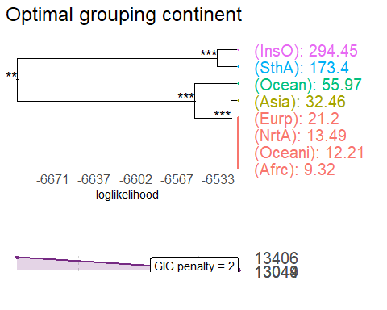
#Inseriamo i nuovi livelli nel dataset
contop=cutTree(liv)
dp2$optimal_group=contop
dp2$cont_group =as.factor(as.numeric(dp2$optimal_group))
table(dp2$cont_group,dp2$continent)
##
## Africa Asia Europe Insular Oceania North America Ocean Oceania
## 1 3 0 7 0 452 0 1
## 2 0 342 0 0 0 0 0
## 3 0 0 0 0 0 244 0
## 4 0 0 0 0 0 0 0
## 5 0 0 0 10 0 0 0
##
## South America
## 1 0
## 2 0
## 3 0
## 4 78
## 5 0
plot(dp2$cont_group,dp2$depth)
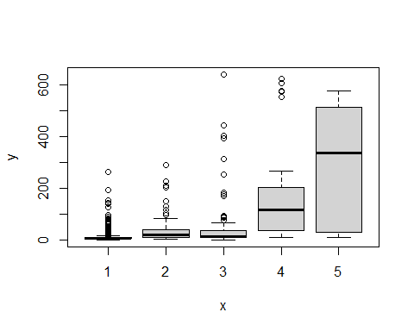
#vediamo i modelli
lm3_merge5 <- lm(log(depth) ~ magnitude + I(updated^3) + felt + cdi_group + mmi + tsunami
+ net + I(nst^3 + nst^2) + I(dmin^3) + I(rms^2) + I(log(gap)) + I(latitude^2)
+ I(distanceKM^3) + cont_group + I(log(longitude)) , data=dp2)
summary(lm3_merge5)#R2 = 0.5141
##
## Call:
## lm(formula = log(depth) ~ magnitude + I(updated^3) + felt + cdi_group +
## mmi + tsunami + net + I(nst^3 + nst^2) + I(dmin^3) + I(rms^2) +
## I(log(gap)) + I(latitude^2) + I(distanceKM^3) + cont_group +
## I(log(longitude)), data = dp2)
##
## Residuals:
## Min 1Q Median 3Q Max
## -3.00809 -0.41489 0.02491 0.41325 2.68810
##
## Coefficients:
## Estimate Std. Error t value Pr(>|t|)
## (Intercept) 1.690e+00 2.040e+00 0.829 0.407426
## magnitude 8.058e-01 5.675e-02 14.198 < 2e-16 ***
## I(updated^3) -6.323e-38 3.729e-37 -0.170 0.865373
## felt 5.525e-07 4.048e-06 0.136 0.891460
## cdi_group2 1.275e-01 4.999e-02 2.551 0.010864 *
## cdi_group3 -1.525e-01 1.233e-01 -1.237 0.216399
## mmi2 1.523e-01 1.973e-01 0.772 0.440413
## mmi3 -1.104e-02 1.848e-01 -0.060 0.952395
## mmi4 -6.339e-01 1.902e-01 -3.333 0.000887 ***
## mmi5 -1.350e+00 2.033e-01 -6.639 4.95e-11 ***
## mmi6 -1.912e+00 2.099e-01 -9.109 < 2e-16 ***
## mmi7 -2.187e+00 2.183e-01 -10.017 < 2e-16 ***
## mmi8 -2.447e+00 2.622e-01 -9.333 < 2e-16 ***
## mmi9 -3.359e+00 3.980e-01 -8.440 < 2e-16 ***
## tsunami1 -2.430e-01 1.210e-01 -2.009 0.044802 *
## netat 1.682e+00 4.939e-01 3.406 0.000684 ***
## netci 1.326e+00 2.741e-01 4.839 1.49e-06 ***
## netnc 4.309e-01 3.307e-01 1.303 0.192869
## netnm 1.650e+00 5.126e-01 3.218 0.001327 **
## netnn 1.021e+00 3.007e-01 3.397 0.000706 ***
## netok 1.514e+00 3.545e-01 4.271 2.12e-05 ***
## nettx 1.532e+00 2.843e-01 5.388 8.72e-08 ***
## netus 1.551e+00 2.784e-01 5.572 3.16e-08 ***
## netuu 1.442e+00 3.715e-01 3.882 0.000110 ***
## netuw 1.372e+00 5.878e-01 2.334 0.019750 *
## I(nst^3 + nst^2) -1.054e-09 1.462e-09 -0.721 0.471239
## I(dmin^3) -5.619e-04 1.828e-04 -3.073 0.002170 **
## I(rms^2) 2.111e-01 7.016e-02 3.009 0.002683 **
## I(log(gap)) -3.227e-01 5.064e-02 -6.374 2.71e-10 ***
## I(latitude^2) 1.104e-04 4.657e-05 2.371 0.017892 *
## I(distanceKM^3) -1.926e-08 8.507e-09 -2.264 0.023757 *
## cont_group2 6.761e-01 1.147e-01 5.895 4.97e-09 ***
## cont_group3 -3.083e-01 1.137e-01 -2.712 0.006792 **
## cont_group4 1.057e+00 1.395e-01 7.573 7.70e-14 ***
## cont_group5 1.719e+00 2.762e-01 6.224 6.87e-10 ***
## I(log(longitude)) -4.538e-01 8.364e-02 -5.425 7.11e-08 ***
## ---
## Signif. codes: 0 '***' 0.001 '**' 0.01 '*' 0.05 '.' 0.1 ' ' 1
##
## Residual standard error: 0.7528 on 1101 degrees of freedom
## Multiple R-squared: 0.6149, Adjusted R-squared: 0.6026
## F-statistic: 50.22 on 35 and 1101 DF, p-value: < 2.2e-16
resettest(lm3_merge5, power = 3, type = "fitted", data = dp2)#03e-13
##
## RESET test
##
## data: lm3_merge5
## RESET = 8.9625, df1 = 1, df2 = 1100, p-value = 0.002817
drop1(lm3_merge2,test="F")
## Single term deletions
##
## Model:
## log(depth) ~ magnitude + I(updated^3) + felt + cdi_group + mmi +
## tsunami + net + I(nst^3 + nst^2) + I(dmin^3) + I(rms^2) +
## I(log(gap)) + I(latitude^2) + I(distanceKM^3) + continent +
## I(log(longitude))
## Df Sum of Sq RSS AIC F value Pr(>F)
## <none> 621.23 -609.25
## magnitude 1 106.972 728.21 -430.61 189.0683 < 2.2e-16 ***
## I(updated^3) 1 0.009 621.24 -611.23 0.0164 0.898230
## felt 1 0.037 621.27 -611.18 0.0649 0.798918
## cdi_group 2 5.516 626.75 -603.20 4.8745 0.007805 **
## mmi 8 281.803 903.04 -199.95 62.2591 < 2.2e-16 ***
## tsunami 1 2.022 623.25 -607.56 3.5731 0.058986 .
## net 10 32.494 653.73 -571.28 5.7431 1.897e-08 ***
## I(nst^3 + nst^2) 1 0.295 621.53 -610.71 0.5214 0.470407
## I(dmin^3) 1 5.247 626.48 -601.69 9.2742 0.002379 **
## I(rms^2) 1 4.327 625.56 -603.36 7.6480 0.005779 **
## I(log(gap)) 1 22.963 644.20 -569.98 40.5853 2.763e-10 ***
## I(latitude^2) 1 2.301 623.53 -607.05 4.0663 0.043990 *
## I(distanceKM^3) 1 3.210 624.44 -605.39 5.6734 0.017394 *
## continent 7 144.526 765.76 -385.43 36.4919 < 2.2e-16 ***
## I(log(longitude)) 1 18.739 639.97 -577.46 33.1204 1.123e-08 ***
## ---
## Signif. codes: 0 '***' 0.001 '**' 0.01 '*' 0.05 '.' 0.1 ' ' 1
drop1(lm3_merge5,test="F")
## Single term deletions
##
## Model:
## log(depth) ~ magnitude + I(updated^3) + felt + cdi_group + mmi +
## tsunami + net + I(nst^3 + nst^2) + I(dmin^3) + I(rms^2) +
## I(log(gap)) + I(latitude^2) + I(distanceKM^3) + cont_group +
## I(log(longitude))
## Df Sum of Sq RSS AIC F value Pr(>F)
## <none> 623.97 -610.25
## magnitude 1 114.247 738.22 -421.08 201.5901 < 2.2e-16 ***
## I(updated^3) 1 0.016 623.99 -612.22 0.0288 0.865373
## felt 1 0.011 623.98 -612.23 0.0186 0.891460
## cdi_group 2 5.462 629.43 -604.34 4.8187 0.008248 **
## mmi 8 279.893 903.86 -204.91 61.7342 < 2.2e-16 ***
## tsunami 1 2.287 626.26 -608.09 4.0353 0.044802 *
## net 10 32.308 656.28 -572.85 5.7008 2.255e-08 ***
## I(nst^3 + nst^2) 1 0.294 624.26 -611.72 0.5194 0.471239
## I(dmin^3) 1 5.352 629.32 -602.54 9.4442 0.002170 **
## I(rms^2) 1 5.130 629.10 -602.94 9.0526 0.002683 **
## I(log(gap)) 1 23.024 646.99 -571.05 40.6256 2.706e-10 ***
## I(latitude^2) 1 3.187 627.16 -606.46 5.6236 0.017892 *
## I(distanceKM^3) 1 2.905 626.88 -606.97 5.1265 0.023757 *
## cont_group 4 141.788 765.76 -385.43 62.5466 < 2.2e-16 ***
## I(log(longitude)) 1 16.682 640.65 -582.25 29.4349 7.108e-08 ***
## ---
## Signif. codes: 0 '***' 0.001 '**' 0.01 '*' 0.05 '.' 0.1 ' ' 1
AIC(lm3_lin, lm3_merge2,lm3_merge3,lm3_merge4,lm3_merge5)
## df AIC
## lm3_lin 47 2628.821
## lm3_merge2 40 2619.415
## lm3_merge3 36 2704.443
## lm3_merge4 32 2636.765
## lm3_merge5 37 2618.415
#Quello di cont è il peggior raggruppamento finora
#Dunque l'optimal grouping va fatto solo su cdi, sulle altre variabili non è utile.
#tengo lm3_merge2 come modello.
par(mfrow=c(2,2))
plot(lm3_merge2)
## Warning: non si riesce a fare il plot senza sfruttarne uno:
## 476
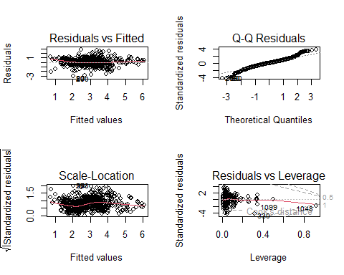
par(mfrow=c(1,1))
# 3)Analisi outliers e leverage: Diagnostiche e Robust regression ---------
library(car)
## Warning: il pacchetto 'car' è stato creato con R versione 4.4.1
## Caricamento del pacchetto richiesto: carData
## Warning: il pacchetto 'carData' è stato creato con R versione 4.4.1
##
## Caricamento pacchetto: 'car'
##
## Il seguente oggetto è mascherato da 'package:dplyr':
##
## recode
influencePlot(lm3_merge2, main="Influence Plot", sub="Circle size is proportial to Cook's Distance" )
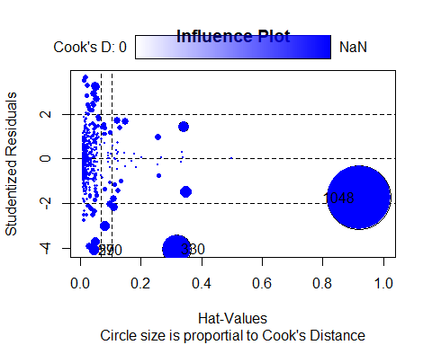
## StudRes Hat CookD
## 27 -4.094170 0.04627579 0.02055928
## 330 -4.066434 0.31846157 0.19535644
## 476 NaN 1.00000000 NaN
## 590 -4.094170 0.04627579 0.02055928
## 1048 -1.770166 0.91994621 0.92151176
stzed <- rstudent(lm3_merge2)
lever <- hat(model.matrix(lm3_merge2))
dffits1 <- dffits(lm3_merge2)
cooksd <- cooks.distance(lm3_merge2)
#noto che la osservazione 476 ha valori anomali -> è l'unica osservazione con contintent = "Oceania"!!!!
#Nel togliere gli outliers probabilmente perderò le categorie con poche osservazioni.
cutoffhv = (2*length(lm3_merge2$coefficients) + 2)/nrow(dp2) # 0.0703606
cutoffck = 4/length(lm3_merge2$coefficients) #0.1025641
cutoffdf = 2*sqrt(length(lm3_merge2$coefficients)/nrow(dp2)) #0.3704095
stzfiltr <- dp2[abs(stzed)<2.5 & !is.na(stzed), ]
levfiltr <- dp2[abs(lever)<cutoffhv & !is.na(lever), ]
dfsfiltr <- dp2[abs(dffits1)<cutoffdf & !is.na(dffits1), ]
cokfiltr <- dp2[abs(cooksd)<cutoffck & !is.na(cooksd), ]
nrow(dp2) - nrow(stzfiltr) #37 oss. droppate
## [1] 37
nrow(dp2) - nrow(levfiltr) #92 oss. droppate
## [1] 92
nrow(dp2) - nrow(dfsfiltr) #79 oss. droppate
## [1] 79
nrow(dp2) - nrow(cokfiltr) #3 oss.droppate
## [1] 3
lm4 <- lm(log(depth) ~ magnitude + I(updated^3) + felt + cdi_group + mmi + tsunami
+ net + I(nst^3 + nst^2) + I(dmin^3) + I(rms^2) + I(log(gap)) + I(latitude^2)
+ I(distanceKM^3) + continent + I(log(longitude)) , data=dfsfiltr)
summary(lm4)#R2 = 0.7088
##
## Call:
## lm(formula = log(depth) ~ magnitude + I(updated^3) + felt + cdi_group +
## mmi + tsunami + net + I(nst^3 + nst^2) + I(dmin^3) + I(rms^2) +
## I(log(gap)) + I(latitude^2) + I(distanceKM^3) + continent +
## I(log(longitude)), data = dfsfiltr)
##
## Residuals:
## Min 1Q Median 3Q Max
## -1.86474 -0.34380 0.01327 0.31839 1.84835
##
## Coefficients:
## Estimate Std. Error t value Pr(>|t|)
## (Intercept) 2.784e+00 1.668e+00 1.668 0.09556 .
## magnitude 6.902e-01 4.616e-02 14.952 < 2e-16 ***
## I(updated^3) 4.219e-38 2.930e-37 0.144 0.88554
## felt 1.072e-05 1.075e-05 0.997 0.31882
## cdi_group2 3.851e-02 3.954e-02 0.974 0.33029
## cdi_group3 -2.628e-01 9.654e-02 -2.722 0.00660 **
## mmi2 5.168e-01 1.812e-01 2.851 0.00444 **
## mmi3 2.095e-01 1.749e-01 1.198 0.23134
## mmi4 -1.371e-01 1.816e-01 -0.755 0.45065
## mmi5 -8.559e-01 1.900e-01 -4.505 7.42e-06 ***
## mmi6 -1.413e+00 1.941e-01 -7.279 6.72e-13 ***
## mmi7 -1.629e+00 2.010e-01 -8.107 1.48e-15 ***
## mmi8 -1.893e+00 2.306e-01 -8.208 6.76e-16 ***
## mmi9 -2.509e+00 3.282e-01 -7.644 4.85e-14 ***
## tsunami1 -3.042e-01 1.016e-01 -2.994 0.00282 **
## netat 2.008e-01 4.778e-01 0.420 0.67445
## netci 6.654e-01 2.164e-01 3.074 0.00216 **
## netnc 1.844e-01 3.147e-01 0.586 0.55812
## netnm 6.395e-01 3.934e-01 1.625 0.10440
## netnn 1.560e-01 2.382e-01 0.655 0.51255
## netok 3.852e-01 2.872e-01 1.341 0.18017
## nettx 4.693e-01 2.289e-01 2.050 0.04058 *
## netus 3.844e-01 2.250e-01 1.708 0.08791 .
## netuu 4.871e-01 3.632e-01 1.341 0.18023
## netuw 7.275e-01 4.467e-01 1.629 0.10369
## I(nst^3 + nst^2) -1.251e-10 1.115e-09 -0.112 0.91075
## I(dmin^3) -4.030e-04 1.385e-04 -2.910 0.00369 **
## I(rms^2) 5.004e-01 6.516e-02 7.679 3.75e-14 ***
## I(log(gap)) -1.598e-01 4.021e-02 -3.974 7.55e-05 ***
## I(latitude^2) 1.491e-05 3.824e-05 0.390 0.69664
## I(distanceKM^3) -1.068e-08 7.217e-09 -1.480 0.13911
## continentAsia 4.086e-01 5.741e-01 0.712 0.47688
## continentEurope 1.028e-01 6.186e-01 0.166 0.86806
## continentInsular Oceania 1.851e+00 6.309e-01 2.933 0.00343 **
## continentNorth America -6.051e-01 5.784e-01 -1.046 0.29577
## continentOcean -7.463e-01 5.770e-01 -1.294 0.19611
## continentSouth America 7.262e-01 5.776e-01 1.257 0.20893
## I(log(longitude)) -5.781e-01 7.128e-02 -8.109 1.45e-15 ***
## ---
## Signif. codes: 0 '***' 0.001 '**' 0.01 '*' 0.05 '.' 0.1 ' ' 1
##
## Residual standard error: 0.565 on 1020 degrees of freedom
## Multiple R-squared: 0.719, Adjusted R-squared: 0.7088
## F-statistic: 70.52 on 37 and 1020 DF, p-value: < 2.2e-16
resettest(lm4, power = 3, type = "fitted", data = dfsfiltr)#0.03969
##
## RESET test
##
## data: lm4
## RESET = 4.2422, df1 = 1, df2 = 1019, p-value = 0.03969
#ottengo i valori migliori togliendo i dfitts
#tolgo ora i punti di leva
influencePlot(lm4, main="Influence Plot", sub="Circle size is proportial to Cook's Distance" )
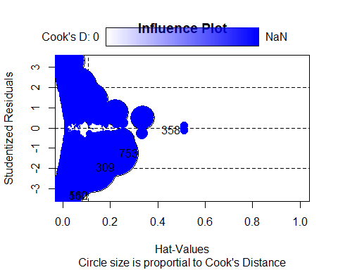
## StudRes Hat CookD
## 160 -3.3396991 0.0137953 0.0040653067
## 309 -1.9626921 0.1244731 0.0143718947
## 358 -0.1137858 0.5099428 0.0003548852
## 512 -3.3396991 0.0137953 0.0040653067
## 753 -1.2674280 0.2230377 0.0121278340
## 1103 NaN 1.0000000 NaN
par(mfrow=c(2,2))
plot(lm4)
## Warning: non si riesce a fare il plot senza sfruttarne uno:
## 1024
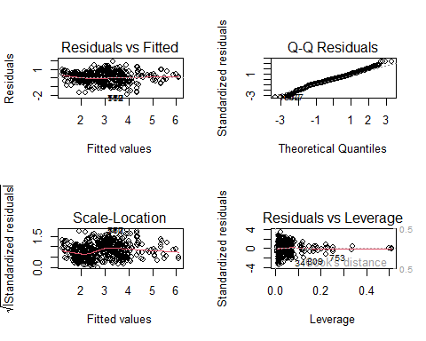
par(mfrow=c(1,1))
lever2 <- hat(model.matrix(lm4))
cutoffhv2 = (2*length(lm4$coefficients) + 2)/nrow(dfsfiltr)#
levfiltr2 <- dfsfiltr[abs(lever2)<cutoffhv2 & !is.na(lever2), ]
nrow(dfsfiltr) - nrow(levfiltr2) #79 oss droppate
## [1] 79
lm4b <- lm(log(depth) ~ magnitude + I(updated^3) + felt + cdi_group + mmi + tsunami
+ net + I(nst^3 + nst^2) + I(dmin^3) + I(rms^2) + I(log(gap)) + I(latitude^2)
+ I(distanceKM^3) + continent + I(log(longitude)) , data=levfiltr2)
summary(lm4b)#R2 = 0.6864
##
## Call:
## lm(formula = log(depth) ~ magnitude + I(updated^3) + felt + cdi_group +
## mmi + tsunami + net + I(nst^3 + nst^2) + I(dmin^3) + I(rms^2) +
## I(log(gap)) + I(latitude^2) + I(distanceKM^3) + continent +
## I(log(longitude)), data = levfiltr2)
##
## Residuals:
## Min 1Q Median 3Q Max
## -1.93126 -0.34170 0.00801 0.35889 1.79201
##
## Coefficients:
## Estimate Std. Error t value Pr(>|t|)
## (Intercept) 2.515e+00 1.673e+00 1.504 0.13304
## magnitude 6.328e-01 4.950e-02 12.784 < 2e-16 ***
## I(updated^3) 2.382e-37 3.022e-37 0.788 0.43069
## felt 2.105e-06 3.109e-05 0.068 0.94604
## cdi_group2 3.559e-02 4.088e-02 0.871 0.38419
## cdi_group3 -4.381e-01 1.057e-01 -4.146 3.68e-05 ***
## mmi2 4.354e-01 2.166e-01 2.010 0.04470 *
## mmi3 3.614e-01 1.976e-01 1.829 0.06767 .
## mmi4 8.539e-02 2.047e-01 0.417 0.67669
## mmi5 -6.071e-01 2.132e-01 -2.848 0.00450 **
## mmi6 -1.181e+00 2.172e-01 -5.437 6.91e-08 ***
## mmi7 -1.348e+00 2.245e-01 -6.005 2.72e-09 ***
## mmi8 -1.649e+00 2.552e-01 -6.461 1.66e-10 ***
## tsunami1 -2.702e-01 1.198e-01 -2.256 0.02428 *
## netci 4.344e-01 2.278e-01 1.907 0.05681 .
## netnn -3.807e-02 2.453e-01 -0.155 0.87671
## nettx 2.290e-01 2.377e-01 0.963 0.33561
## netus 1.549e-01 2.335e-01 0.663 0.50719
## I(nst^3 + nst^2) 4.556e-09 2.229e-09 2.044 0.04126 *
## I(dmin^3) -4.696e-04 3.163e-04 -1.485 0.13798
## I(rms^2) 5.443e-01 6.854e-02 7.942 5.59e-15 ***
## I(log(gap)) -1.250e-01 4.176e-02 -2.992 0.00284 **
## I(latitude^2) -1.202e-05 3.990e-05 -0.301 0.76324
## I(distanceKM^3) 1.828e-09 9.771e-09 0.187 0.85167
## continentNorth America -1.093e+00 1.106e-01 -9.880 < 2e-16 ***
## continentOcean -1.075e+00 6.901e-02 -15.582 < 2e-16 ***
## continentSouth America 2.410e-01 1.112e-01 2.167 0.03047 *
## I(log(longitude)) -6.070e-01 7.638e-02 -7.948 5.34e-15 ***
## ---
## Signif. codes: 0 '***' 0.001 '**' 0.01 '*' 0.05 '.' 0.1 ' ' 1
##
## Residual standard error: 0.568 on 951 degrees of freedom
## Multiple R-squared: 0.695, Adjusted R-squared: 0.6864
## F-statistic: 80.27 on 27 and 951 DF, p-value: < 2.2e-16
resettest(lm4b, power = 3, type = "fitted", data = levfiltr2)#0.7064
##
## RESET test
##
## data: lm4b
## RESET = 0.14199, df1 = 1, df2 = 950, p-value = 0.7064
influencePlot(lm4b, main="Influence Plot", sub="Circle size is proportial to Cook's Distance" )
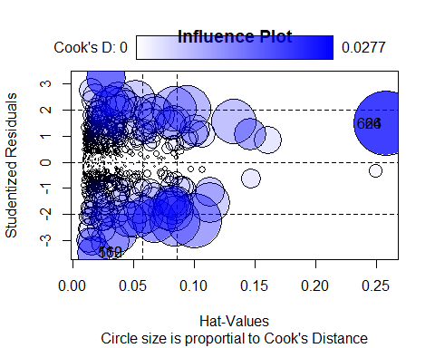
## StudRes Hat CookD
## 66 1.492667 0.25817622 0.027658127
## 160 -3.449153 0.01725853 0.007377064
## 512 -3.449153 0.01725853 0.007377064
## 624 1.492667 0.25817622 0.027658127
par(mfrow=c(2,2))
plot(lm4b)
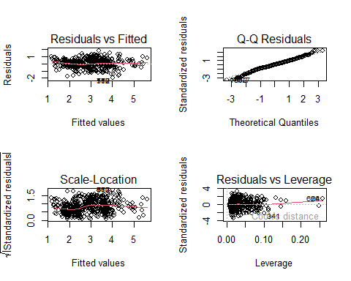
par(mfrow=c(1,1))
#Perdo leggermente in quanto a R2, guadagno moltissimo in linearità: di fatto ho eliminato le oss.
#che hanno come osservazioni qualitative "rare", cioè quelle che hanno valori unici o quasi.
#Giusto eliminarle: costruire il modello su pochi casi rari non ha senso, non sono sufficienti
#per avere un modello robusto.
#Questo spiega anche la perdita in R2.
# 3.b)Robust Regression ---------------------------------------------------
#vediamo cosa otteniamo usando la robust regression.
#library(robustbase)
#control <- lmrob.control(maxit = 500, tuning.psi = 3.0)
#mrobfit <- lmrob(log(depth) ~ magnitude + cdi_group + mmi + tsunami +
# net + I(nst^3 + nst^2) + I(rms^2) + I(log(gap)) +
# continent + I(log(longitude)),
# data = levfiltr2, control = control)
#
#summary(lmrobfit)
#par(mfrow=c(3,2))
#plot(lmrobfit)
#par(mfrow=c(1,1))
#doesn't work well
# 4)Model Selection -------------------------------------------------------
step <- stepAIC(lm4b, direction="both")
## Start: AIC=-1079.76
## log(depth) ~ magnitude + I(updated^3) + felt + cdi_group + mmi +
## tsunami + net + I(nst^3 + nst^2) + I(dmin^3) + I(rms^2) +
## I(log(gap)) + I(latitude^2) + I(distanceKM^3) + continent +
## I(log(longitude))
##
## Df Sum of Sq RSS AIC
## - felt 1 0.001 306.87 -1081.76
## - I(distanceKM^3) 1 0.011 306.88 -1081.73
## - I(latitude^2) 1 0.029 306.89 -1081.67
## - I(updated^3) 1 0.201 307.06 -1081.12
## <none> 306.86 -1079.76
## - I(dmin^3) 1 0.711 307.58 -1079.50
## - I(nst^3 + nst^2) 1 1.348 308.21 -1077.47
## - tsunami 1 1.643 308.51 -1076.54
## - net 4 4.767 311.63 -1072.67
## - I(log(gap)) 1 2.889 309.75 -1072.59
## - cdi_group 2 6.306 313.17 -1063.85
## - I(rms^2) 1 20.354 327.22 -1018.89
## - I(log(longitude)) 1 20.384 327.25 -1018.80
## - magnitude 1 52.734 359.60 -926.51
## - continent 3 127.455 434.32 -745.68
## - mmi 7 180.515 487.38 -640.84
##
## Step: AIC=-1081.76
## log(depth) ~ magnitude + I(updated^3) + cdi_group + mmi + tsunami +
## net + I(nst^3 + nst^2) + I(dmin^3) + I(rms^2) + I(log(gap)) +
## I(latitude^2) + I(distanceKM^3) + continent + I(log(longitude))
##
## Df Sum of Sq RSS AIC
## - I(distanceKM^3) 1 0.011 306.88 -1083.72
## - I(latitude^2) 1 0.029 306.89 -1083.67
## - I(updated^3) 1 0.202 307.07 -1083.12
## <none> 306.87 -1081.76
## - I(dmin^3) 1 0.712 307.58 -1081.49
## + felt 1 0.001 306.86 -1079.76
## - I(nst^3 + nst^2) 1 1.347 308.21 -1079.47
## - tsunami 1 1.652 308.52 -1078.50
## - I(log(gap)) 1 2.891 309.76 -1074.58
## - net 4 5.330 312.20 -1072.90
## - cdi_group 2 6.304 313.17 -1065.85
## - I(rms^2) 1 20.357 327.22 -1020.88
## - I(log(longitude)) 1 20.386 327.25 -1020.79
## - magnitude 1 54.941 361.81 -922.52
## - continent 3 129.536 436.40 -743.00
## - mmi 7 181.892 488.76 -640.08
##
## Step: AIC=-1083.72
## log(depth) ~ magnitude + I(updated^3) + cdi_group + mmi + tsunami +
## net + I(nst^3 + nst^2) + I(dmin^3) + I(rms^2) + I(log(gap)) +
## I(latitude^2) + continent + I(log(longitude))
##
## Df Sum of Sq RSS AIC
## - I(latitude^2) 1 0.026 306.90 -1085.64
## - I(updated^3) 1 0.218 307.10 -1085.03
## <none> 306.88 -1083.72
## - I(dmin^3) 1 0.701 307.58 -1083.49
## + I(distanceKM^3) 1 0.011 306.87 -1081.76
## + felt 1 0.001 306.88 -1081.73
## - I(nst^3 + nst^2) 1 1.344 308.22 -1081.45
## - tsunami 1 1.654 308.53 -1080.46
## - I(log(gap)) 1 2.887 309.76 -1076.56
## - net 4 5.337 312.21 -1074.84
## - cdi_group 2 6.349 313.23 -1067.68
## - I(rms^2) 1 20.355 327.23 -1022.85
## - I(log(longitude)) 1 20.615 327.49 -1022.07
## - magnitude 1 55.598 362.47 -922.71
## - continent 3 129.652 436.53 -744.72
## - mmi 7 188.033 494.91 -629.83
##
## Step: AIC=-1085.64
## log(depth) ~ magnitude + I(updated^3) + cdi_group + mmi + tsunami +
## net + I(nst^3 + nst^2) + I(dmin^3) + I(rms^2) + I(log(gap)) +
## continent + I(log(longitude))
##
## Df Sum of Sq RSS AIC
## - I(updated^3) 1 0.231 307.13 -1086.91
## <none> 306.90 -1085.64
## - I(dmin^3) 1 0.697 307.60 -1085.42
## + I(latitude^2) 1 0.026 306.88 -1083.72
## + I(distanceKM^3) 1 0.008 306.89 -1083.67
## + felt 1 0.001 306.90 -1083.64
## - I(nst^3 + nst^2) 1 1.319 308.22 -1083.44
## - tsunami 1 1.642 308.54 -1082.42
## - I(log(gap)) 1 2.893 309.80 -1078.46
## - net 4 5.685 312.59 -1075.67
## - cdi_group 2 6.324 313.23 -1069.68
## - I(rms^2) 1 20.394 327.30 -1024.66
## - I(log(longitude)) 1 23.804 330.71 -1014.51
## - magnitude 1 55.730 362.63 -924.29
## - continent 3 133.711 440.61 -737.60
## - mmi 7 188.740 495.64 -630.38
##
## Step: AIC=-1086.91
## log(depth) ~ magnitude + cdi_group + mmi + tsunami + net + I(nst^3 +
## nst^2) + I(dmin^3) + I(rms^2) + I(log(gap)) + continent +
## I(log(longitude))
##
## Df Sum of Sq RSS AIC
## <none> 307.13 -1086.91
## - I(dmin^3) 1 0.737 307.87 -1086.56
## + I(updated^3) 1 0.231 306.90 -1085.64
## + I(latitude^2) 1 0.038 307.10 -1085.03
## + I(distanceKM^3) 1 0.022 307.11 -1084.98
## + felt 1 0.002 307.13 -1084.91
## - I(nst^3 + nst^2) 1 1.325 308.46 -1084.69
## - tsunami 1 1.528 308.66 -1084.05
## - I(log(gap)) 1 2.946 310.08 -1079.56
## - net 4 5.952 313.09 -1076.11
## - cdi_group 2 6.457 313.59 -1070.54
## - I(rms^2) 1 21.576 328.71 -1022.44
## - I(log(longitude)) 1 25.690 332.82 -1010.26
## - magnitude 1 55.564 362.70 -926.11
## - continent 3 134.368 441.50 -737.63
## - mmi 7 188.533 495.67 -632.34
step
##
## Call:
## lm(formula = log(depth) ~ magnitude + cdi_group + mmi + tsunami +
## net + I(nst^3 + nst^2) + I(dmin^3) + I(rms^2) + I(log(gap)) +
## continent + I(log(longitude)), data = levfiltr2)
##
## Coefficients:
## (Intercept) magnitude cdi_group2
## 3.721e+00 6.335e-01 3.494e-02
## cdi_group3 mmi2 mmi3
## -4.422e-01 4.258e-01 3.470e-01
## mmi4 mmi5 mmi6
## 6.685e-02 -6.220e-01 -1.197e+00
## mmi7 mmi8 tsunami1
## -1.371e+00 -1.667e+00 -2.573e-01
## netci netnn nettx
## 4.710e-01 -8.635e-03 2.611e-01
## netus I(nst^3 + nst^2) I(dmin^3)
## 1.757e-01 4.485e-09 -4.726e-04
## I(rms^2) I(log(gap)) continentNorth America
## 5.535e-01 -1.261e-01 -1.087e+00
## continentOcean continentSouth America I(log(longitude))
## -1.087e+00 2.332e-01 -6.112e-01
step$anova
## Stepwise Model Path
## Analysis of Deviance Table
##
## Initial Model:
## log(depth) ~ magnitude + I(updated^3) + felt + cdi_group + mmi +
## tsunami + net + I(nst^3 + nst^2) + I(dmin^3) + I(rms^2) +
## I(log(gap)) + I(latitude^2) + I(distanceKM^3) + continent +
## I(log(longitude))
##
## Final Model:
## log(depth) ~ magnitude + cdi_group + mmi + tsunami + net + I(nst^3 +
## nst^2) + I(dmin^3) + I(rms^2) + I(log(gap)) + continent +
## I(log(longitude))
##
##
## Step Df Deviance Resid. Df Resid. Dev AIC
## 1 951 306.8640 -1079.764
## 2 - felt 1 0.001478623 952 306.8655 -1081.760
## 3 - I(distanceKM^3) 1 0.011265086 953 306.8767 -1083.724
## 4 - I(latitude^2) 1 0.025620614 954 306.9024 -1085.642
## 5 - I(updated^3) 1 0.230997078 955 307.1334 -1086.905
lm5 <- lm(log(depth) ~ magnitude + cdi_group + mmi + tsunami
+ net + I(nst^3 + nst^2) + I(dmin^3) + I(rms^2) + I(log(gap)) +
+ continent + I(log(longitude)) , data=levfiltr2)
summary(lm5)#R2 = 0.6874
##
## Call:
## lm(formula = log(depth) ~ magnitude + cdi_group + mmi + tsunami +
## net + I(nst^3 + nst^2) + I(dmin^3) + I(rms^2) + I(log(gap)) +
## +continent + I(log(longitude)), data = levfiltr2)
##
## Residuals:
## Min 1Q Median 3Q Max
## -1.90928 -0.33613 0.00337 0.37176 1.79102
##
## Coefficients:
## Estimate Std. Error t value Pr(>|t|)
## (Intercept) 3.721e+00 2.969e-01 12.535 < 2e-16 ***
## magnitude 6.335e-01 4.820e-02 13.144 < 2e-16 ***
## cdi_group2 3.494e-02 3.999e-02 0.874 0.38240
## cdi_group3 -4.422e-01 1.052e-01 -4.203 2.88e-05 ***
## mmi2 4.258e-01 2.145e-01 1.985 0.04740 *
## mmi3 3.470e-01 1.956e-01 1.774 0.07637 .
## mmi4 6.685e-02 2.028e-01 0.330 0.74173
## mmi5 -6.220e-01 2.111e-01 -2.947 0.00329 **
## mmi6 -1.197e+00 2.148e-01 -5.574 3.24e-08 ***
## mmi7 -1.371e+00 2.211e-01 -6.199 8.45e-10 ***
## mmi8 -1.667e+00 2.515e-01 -6.629 5.63e-11 ***
## tsunami1 -2.573e-01 1.181e-01 -2.180 0.02953 *
## netci 4.710e-01 2.142e-01 2.199 0.02812 *
## netnn -8.635e-03 2.385e-01 -0.036 0.97112
## nettx 2.611e-01 2.284e-01 1.143 0.25317
## netus 1.757e-01 2.266e-01 0.776 0.43813
## I(nst^3 + nst^2) 4.485e-09 2.210e-09 2.029 0.04269 *
## I(dmin^3) -4.726e-04 3.121e-04 -1.514 0.13028
## I(rms^2) 5.535e-01 6.758e-02 8.191 8.27e-16 ***
## I(log(gap)) -1.261e-01 4.167e-02 -3.027 0.00254 **
## continentNorth America -1.087e+00 1.068e-01 -10.177 < 2e-16 ***
## continentOcean -1.087e+00 6.745e-02 -16.116 < 2e-16 ***
## continentSouth America 2.332e-01 1.022e-01 2.281 0.02274 *
## I(log(longitude)) -6.112e-01 6.839e-02 -8.938 < 2e-16 ***
## ---
## Signif. codes: 0 '***' 0.001 '**' 0.01 '*' 0.05 '.' 0.1 ' ' 1
##
## Residual standard error: 0.5671 on 955 degrees of freedom
## Multiple R-squared: 0.6948, Adjusted R-squared: 0.6874
## F-statistic: 94.51 on 23 and 955 DF, p-value: < 2.2e-16
resettest(lm5, power = 3, type = "fitted", data = levfiltr2)#0.6304
##
## RESET test
##
## data: lm5
## RESET = 0.23165, df1 = 1, df2 = 954, p-value = 0.6304
drop1(lm5,test="F")#dmin^3 non è significativo, lo tolgo.
## Single term deletions
##
## Model:
## log(depth) ~ magnitude + cdi_group + mmi + tsunami + net + I(nst^3 +
## nst^2) + I(dmin^3) + I(rms^2) + I(log(gap)) + +continent +
## I(log(longitude))
## Df Sum of Sq RSS AIC F value Pr(>F)
## <none> 307.13 -1086.91
## magnitude 1 55.564 362.70 -926.11 172.7699 < 2.2e-16 ***
## cdi_group 2 6.457 313.59 -1070.54 10.0382 4.849e-05 ***
## mmi 7 188.533 495.67 -632.34 83.7461 < 2.2e-16 ***
## tsunami 1 1.528 308.66 -1084.05 4.7506 0.029531 *
## net 4 5.952 313.09 -1076.11 4.6271 0.001054 **
## I(nst^3 + nst^2) 1 1.325 308.46 -1084.69 4.1186 0.042691 *
## I(dmin^3) 1 0.737 307.87 -1086.56 2.2931 0.130282
## I(rms^2) 1 21.576 328.71 -1022.44 67.0892 8.274e-16 ***
## I(log(gap)) 1 2.946 310.08 -1079.56 9.1605 0.002539 **
## continent 3 134.368 441.50 -737.63 139.2681 < 2.2e-16 ***
## I(log(longitude)) 1 25.690 332.82 -1010.26 79.8810 < 2.2e-16 ***
## ---
## Signif. codes: 0 '***' 0.001 '**' 0.01 '*' 0.05 '.' 0.1 ' ' 1
lm5 <- lm(log(depth) ~ magnitude + cdi_group + mmi + tsunami
+ net + I(nst^3 + nst^2) + I(rms^2) + I(log(gap)) +
+ continent + I(log(longitude)) , data=levfiltr2)
summary(lm5)#R2 = 0.687
##
## Call:
## lm(formula = log(depth) ~ magnitude + cdi_group + mmi + tsunami +
## net + I(nst^3 + nst^2) + I(rms^2) + I(log(gap)) + +continent +
## I(log(longitude)), data = levfiltr2)
##
## Residuals:
## Min 1Q Median 3Q Max
## -1.90124 -0.35003 -0.00354 0.37559 1.80215
##
## Coefficients:
## Estimate Std. Error t value Pr(>|t|)
## (Intercept) 3.748e+00 2.965e-01 12.638 < 2e-16 ***
## magnitude 6.302e-01 4.818e-02 13.080 < 2e-16 ***
## cdi_group2 3.251e-02 3.998e-02 0.813 0.41641
## cdi_group3 -4.478e-01 1.052e-01 -4.256 2.29e-05 ***
## mmi2 3.997e-01 2.139e-01 1.868 0.06201 .
## mmi3 3.471e-01 1.957e-01 1.774 0.07643 .
## mmi4 7.148e-02 2.029e-01 0.352 0.72467
## mmi5 -6.167e-01 2.112e-01 -2.920 0.00358 **
## mmi6 -1.189e+00 2.149e-01 -5.536 4.00e-08 ***
## mmi7 -1.384e+00 2.211e-01 -6.258 5.86e-10 ***
## mmi8 -1.697e+00 2.509e-01 -6.765 2.33e-11 ***
## tsunami1 -2.429e-01 1.178e-01 -2.063 0.03942 *
## netci 4.696e-01 2.143e-01 2.191 0.02867 *
## netnn -8.372e-03 2.386e-01 -0.035 0.97202
## nettx 2.592e-01 2.285e-01 1.134 0.25691
## netus 1.715e-01 2.267e-01 0.756 0.44958
## I(nst^3 + nst^2) 4.652e-09 2.209e-09 2.106 0.03545 *
## I(rms^2) 5.606e-01 6.746e-02 8.309 3.27e-16 ***
## I(log(gap)) -1.262e-01 4.170e-02 -3.027 0.00253 **
## continentNorth America -1.083e+00 1.068e-01 -10.137 < 2e-16 ***
## continentOcean -1.088e+00 6.748e-02 -16.129 < 2e-16 ***
## continentSouth America 2.320e-01 1.023e-01 2.268 0.02357 *
## I(log(longitude)) -6.155e-01 6.837e-02 -9.002 < 2e-16 ***
## ---
## Signif. codes: 0 '***' 0.001 '**' 0.01 '*' 0.05 '.' 0.1 ' ' 1
##
## Residual standard error: 0.5675 on 956 degrees of freedom
## Multiple R-squared: 0.694, Adjusted R-squared: 0.687
## F-statistic: 98.57 on 22 and 956 DF, p-value: < 2.2e-16
resettest(lm5, power=3, type = "fitted", data = levfiltr2)#0.5588
##
## RESET test
##
## data: lm5
## RESET = 0.34204, df1 = 1, df2 = 955, p-value = 0.5588
#Vediamo con BIC
step2 <- stepAIC(lm4b, direction="both", k=log(nrow(levfiltr2)))
## Start: AIC=-942.94
## log(depth) ~ magnitude + I(updated^3) + felt + cdi_group + mmi +
## tsunami + net + I(nst^3 + nst^2) + I(dmin^3) + I(rms^2) +
## I(log(gap)) + I(latitude^2) + I(distanceKM^3) + continent +
## I(log(longitude))
##
## Df Sum of Sq RSS AIC
## - net 4 4.767 311.63 -955.40
## - felt 1 0.001 306.87 -949.82
## - I(distanceKM^3) 1 0.011 306.88 -949.79
## - I(latitude^2) 1 0.029 306.89 -949.73
## - I(updated^3) 1 0.201 307.06 -949.19
## - I(dmin^3) 1 0.711 307.58 -947.56
## - I(nst^3 + nst^2) 1 1.348 308.21 -945.54
## - tsunami 1 1.643 308.51 -944.60
## <none> 306.86 -942.94
## - I(log(gap)) 1 2.889 309.75 -940.66
## - cdi_group 2 6.306 313.17 -936.80
## - I(rms^2) 1 20.354 327.22 -886.96
## - I(log(longitude)) 1 20.384 327.25 -886.86
## - magnitude 1 52.734 359.60 -794.58
## - continent 3 127.455 434.32 -623.52
## - mmi 7 180.515 487.38 -538.23
##
## Step: AIC=-955.4
## log(depth) ~ magnitude + I(updated^3) + felt + cdi_group + mmi +
## tsunami + I(nst^3 + nst^2) + I(dmin^3) + I(rms^2) + I(log(gap)) +
## I(latitude^2) + I(distanceKM^3) + continent + I(log(longitude))
##
## Df Sum of Sq RSS AIC
## - I(distanceKM^3) 1 0.023 311.65 -962.21
## - I(updated^3) 1 0.314 311.95 -961.30
## - I(latitude^2) 1 0.376 312.01 -961.10
## - felt 1 0.564 312.20 -960.51
## - I(dmin^3) 1 0.699 312.33 -960.09
## - tsunami 1 1.563 313.19 -957.38
## - I(nst^3 + nst^2) 1 1.659 313.29 -957.08
## <none> 311.63 -955.40
## - cdi_group 2 7.324 318.96 -946.42
## + net 4 4.767 306.86 -942.94
## - I(log(gap)) 1 7.550 319.18 -938.85
## - I(log(longitude)) 1 21.305 332.94 -897.54
## - I(rms^2) 1 21.555 333.19 -896.81
## - magnitude 1 50.981 362.61 -813.95
## - continent 3 128.623 440.25 -637.78
## - mmi 7 184.288 495.92 -548.77
##
## Step: AIC=-962.21
## log(depth) ~ magnitude + I(updated^3) + felt + cdi_group + mmi +
## tsunami + I(nst^3 + nst^2) + I(dmin^3) + I(rms^2) + I(log(gap)) +
## I(latitude^2) + continent + I(log(longitude))
##
## Df Sum of Sq RSS AIC
## - I(updated^3) 1 0.341 311.99 -968.03
## - I(latitude^2) 1 0.362 312.02 -967.96
## - felt 1 0.560 312.21 -967.34
## - I(dmin^3) 1 0.677 312.33 -966.97
## - tsunami 1 1.567 313.22 -964.19
## - I(nst^3 + nst^2) 1 1.657 313.31 -963.90
## <none> 311.65 -962.21
## + I(distanceKM^3) 1 0.023 311.63 -955.40
## - cdi_group 2 7.389 319.04 -953.04
## + net 4 4.779 306.88 -949.79
## - I(log(gap)) 1 7.542 319.20 -945.69
## - I(log(longitude)) 1 21.526 333.18 -903.71
## - I(rms^2) 1 21.589 333.24 -903.53
## - magnitude 1 51.782 363.44 -818.61
## - continent 3 128.705 440.36 -644.43
## - mmi 7 189.835 501.49 -544.72
##
## Step: AIC=-968.03
## log(depth) ~ magnitude + felt + cdi_group + mmi + tsunami + I(nst^3 +
## nst^2) + I(dmin^3) + I(rms^2) + I(log(gap)) + I(latitude^2) +
## continent + I(log(longitude))
##
## Df Sum of Sq RSS AIC
## - I(latitude^2) 1 0.446 312.44 -973.52
## - felt 1 0.624 312.62 -972.96
## - I(dmin^3) 1 0.729 312.72 -972.63
## - tsunami 1 1.427 313.42 -970.44
## - I(nst^3 + nst^2) 1 1.672 313.67 -969.68
## <none> 311.99 -968.03
## + I(updated^3) 1 0.341 311.65 -962.21
## + I(distanceKM^3) 1 0.050 311.95 -961.30
## - cdi_group 2 7.672 319.67 -958.02
## + net 4 4.902 307.09 -955.99
## - I(log(gap)) 1 7.719 319.71 -950.99
## - I(rms^2) 1 22.405 334.40 -907.02
## - I(log(longitude)) 1 23.679 335.67 -903.30
## - magnitude 1 51.446 363.44 -825.49
## - continent 3 129.134 441.13 -649.61
## - mmi 7 189.498 501.49 -551.60
##
## Step: AIC=-973.52
## log(depth) ~ magnitude + felt + cdi_group + mmi + tsunami + I(nst^3 +
## nst^2) + I(dmin^3) + I(rms^2) + I(log(gap)) + continent +
## I(log(longitude))
##
## Df Sum of Sq RSS AIC
## - felt 1 0.645 313.09 -978.38
## - I(dmin^3) 1 0.715 313.16 -978.17
## - tsunami 1 1.340 313.78 -976.21
## - I(nst^3 + nst^2) 1 1.537 313.98 -975.60
## <none> 312.44 -973.52
## + I(latitude^2) 1 0.446 311.99 -968.03
## + I(updated^3) 1 0.424 312.02 -967.96
## + I(distanceKM^3) 1 0.029 312.41 -966.72
## - cdi_group 2 7.578 320.02 -963.83
## + net 4 5.309 307.13 -962.75
## - I(log(gap)) 1 7.373 319.81 -957.57
## - I(rms^2) 1 22.343 334.78 -912.78
## - I(log(longitude)) 1 27.100 339.54 -898.97
## - magnitude 1 51.524 363.96 -830.97
## - continent 3 132.232 444.67 -648.66
## - mmi 7 189.299 501.74 -558.00
##
## Step: AIC=-978.38
## log(depth) ~ magnitude + cdi_group + mmi + tsunami + I(nst^3 +
## nst^2) + I(dmin^3) + I(rms^2) + I(log(gap)) + continent +
## I(log(longitude))
##
## Df Sum of Sq RSS AIC
## - I(dmin^3) 1 0.742 313.83 -982.95
## - tsunami 1 1.121 314.21 -981.77
## - I(nst^3 + nst^2) 1 1.537 314.62 -980.47
## <none> 313.09 -978.38
## + felt 1 0.645 312.44 -973.52
## + I(updated^3) 1 0.499 312.59 -973.06
## + I(latitude^2) 1 0.467 312.62 -972.96
## + I(distanceKM^3) 1 0.025 313.06 -971.57
## + net 4 5.952 307.13 -969.63
## - cdi_group 2 7.606 320.69 -968.66
## - I(log(gap)) 1 7.448 320.53 -962.25
## - I(rms^2) 1 21.883 334.97 -919.13
## - I(log(longitude)) 1 27.249 340.33 -903.57
## - magnitude 1 54.687 367.77 -827.66
## - continent 3 132.288 445.37 -654.01
## - mmi 7 189.005 502.09 -564.20
##
## Step: AIC=-982.95
## log(depth) ~ magnitude + cdi_group + mmi + tsunami + I(nst^3 +
## nst^2) + I(rms^2) + I(log(gap)) + continent + I(log(longitude))
##
## Df Sum of Sq RSS AIC
## - tsunami 1 0.981 314.81 -986.78
## - I(nst^3 + nst^2) 1 1.644 315.47 -984.72
## <none> 313.83 -982.95
## + I(dmin^3) 1 0.742 313.09 -978.38
## + felt 1 0.673 313.16 -978.17
## + I(updated^3) 1 0.562 313.27 -977.82
## + I(latitude^2) 1 0.452 313.38 -977.48
## + I(distanceKM^3) 1 0.002 313.83 -976.07
## + net 4 5.957 307.87 -974.17
## - cdi_group 2 7.692 321.52 -973.02
## - I(log(gap)) 1 7.551 321.38 -966.56
## - I(rms^2) 1 22.486 336.31 -922.09
## - I(log(longitude)) 1 27.736 341.56 -906.93
## - magnitude 1 54.180 368.01 -833.92
## - continent 3 132.200 446.03 -659.46
## - mmi 7 191.598 505.43 -564.61
##
## Step: AIC=-986.78
## log(depth) ~ magnitude + cdi_group + mmi + I(nst^3 + nst^2) +
## I(rms^2) + I(log(gap)) + continent + I(log(longitude))
##
## Df Sum of Sq RSS AIC
## - I(nst^3 + nst^2) 1 1.787 316.60 -988.12
## <none> 314.81 -986.78
## + tsunami 1 0.981 313.83 -982.95
## + I(dmin^3) 1 0.603 314.21 -981.77
## + felt 1 0.458 314.35 -981.32
## + I(updated^3) 1 0.377 314.43 -981.07
## + I(latitude^2) 1 0.373 314.44 -981.05
## + I(distanceKM^3) 1 0.003 314.81 -979.90
## - cdi_group 2 7.529 322.34 -977.42
## + net 4 5.569 309.24 -976.71
## - I(log(gap)) 1 6.941 321.75 -972.32
## - I(rms^2) 1 22.808 337.62 -925.19
## - I(log(longitude)) 1 27.473 342.28 -911.75
## - magnitude 1 56.346 371.16 -832.47
## - continent 3 136.214 451.02 -655.44
## - mmi 7 191.668 506.48 -569.46
##
## Step: AIC=-988.12
## log(depth) ~ magnitude + cdi_group + mmi + I(rms^2) + I(log(gap)) +
## continent + I(log(longitude))
##
## Df Sum of Sq RSS AIC
## <none> 316.60 -988.12
## + I(nst^3 + nst^2) 1 1.787 314.81 -986.78
## + tsunami 1 1.125 315.47 -984.72
## + I(dmin^3) 1 0.694 315.90 -983.39
## + felt 1 0.447 316.15 -982.62
## + I(updated^3) 1 0.370 316.23 -982.38
## + I(latitude^2) 1 0.237 316.36 -981.97
## - cdi_group 2 6.594 323.19 -981.72
## + I(distanceKM^3) 1 0.002 316.59 -981.25
## + net 4 5.776 310.82 -978.61
## - I(log(gap)) 1 7.463 324.06 -972.20
## - I(rms^2) 1 21.272 337.87 -931.35
## - I(log(longitude)) 1 26.382 342.98 -916.65
## - magnitude 1 58.359 374.96 -829.39
## - continent 3 144.134 460.73 -641.48
## - mmi 7 190.561 507.16 -575.03
step2
##
## Call:
## lm(formula = log(depth) ~ magnitude + cdi_group + mmi + I(rms^2) +
## I(log(gap)) + continent + I(log(longitude)), data = levfiltr2)
##
## Coefficients:
## (Intercept) magnitude cdi_group2
## 3.62345 0.59135 0.06012
## cdi_group3 mmi2 mmi3
## -0.40766 0.34922 0.28444
## mmi4 mmi5 mmi6
## 0.02911 -0.64427 -1.21781
## mmi7 mmi8 I(rms^2)
## -1.41840 -1.59031 0.50259
## I(log(gap)) continentNorth America continentOcean
## -0.10000 -1.03475 -1.06130
## continentSouth America I(log(longitude))
## 0.34138 -0.52986
step2$anova
## Stepwise Model Path
## Analysis of Deviance Table
##
## Initial Model:
## log(depth) ~ magnitude + I(updated^3) + felt + cdi_group + mmi +
## tsunami + net + I(nst^3 + nst^2) + I(dmin^3) + I(rms^2) +
## I(log(gap)) + I(latitude^2) + I(distanceKM^3) + continent +
## I(log(longitude))
##
## Final Model:
## log(depth) ~ magnitude + cdi_group + mmi + I(rms^2) + I(log(gap)) +
## continent + I(log(longitude))
##
##
## Step Df Deviance Resid. Df Resid. Dev AIC
## 1 951 306.8640 -942.9414
## 2 - net 4 4.76721459 955 311.6312 -955.3955
## 3 - I(distanceKM^3) 1 0.02296748 956 311.6542 -962.2099
## 4 - I(updated^3) 1 0.34055839 957 311.9947 -968.0272
## 5 - I(latitude^2) 1 0.44561709 958 312.4404 -973.5164
## 6 - felt 1 0.64541630 959 313.0858 -978.3827
## 7 - I(dmin^3) 1 0.74242989 960 313.8282 -982.9504
## 8 - tsunami 1 0.98120969 961 314.8094 -986.7808
## 9 - I(nst^3 + nst^2) 1 1.78745895 962 316.5969 -988.1244
#Mi fa togliere molte più covariate! (BIC preferisce modelli più semplici)
lm5b <- lm(log(depth) ~ magnitude + cdi_group + mmi + I(rms^2) + I(log(gap)) + continent + I(log(longitude)) , data=levfiltr2)
summary(lm5b)#R2 = 0.6801
##
## Call:
## lm(formula = log(depth) ~ magnitude + cdi_group + mmi + I(rms^2) +
## I(log(gap)) + continent + I(log(longitude)), data = levfiltr2)
##
## Residuals:
## Min 1Q Median 3Q Max
## -1.81698 -0.35106 -0.01763 0.36130 1.81606
##
## Coefficients:
## Estimate Std. Error t value Pr(>|t|)
## (Intercept) 3.62345 0.28253 12.825 < 2e-16 ***
## magnitude 0.59135 0.04441 13.316 < 2e-16 ***
## cdi_group2 0.06012 0.03965 1.516 0.129829
## cdi_group3 -0.40766 0.10356 -3.937 8.86e-05 ***
## mmi2 0.34922 0.21581 1.618 0.105942
## mmi3 0.28444 0.19572 1.453 0.146472
## mmi4 0.02911 0.20292 0.143 0.885952
## mmi5 -0.64427 0.21129 -3.049 0.002357 **
## mmi6 -1.21781 0.21494 -5.666 1.93e-08 ***
## mmi7 -1.41840 0.22003 -6.446 1.81e-10 ***
## mmi8 -1.59031 0.24945 -6.375 2.83e-10 ***
## I(rms^2) 0.50259 0.06251 8.040 2.63e-15 ***
## I(log(gap)) -0.10000 0.02100 -4.762 2.21e-06 ***
## continentNorth America -1.03475 0.10176 -10.168 < 2e-16 ***
## continentOcean -1.06130 0.06680 -15.887 < 2e-16 ***
## continentSouth America 0.34138 0.09710 3.516 0.000459 ***
## I(log(longitude)) -0.52986 0.05918 -8.953 < 2e-16 ***
## ---
## Signif. codes: 0 '***' 0.001 '**' 0.01 '*' 0.05 '.' 0.1 ' ' 1
##
## Residual standard error: 0.5737 on 962 degrees of freedom
## Multiple R-squared: 0.6854, Adjusted R-squared: 0.6801
## F-statistic: 131 on 16 and 962 DF, p-value: < 2.2e-16
resettest(lm5b,power = 3, type = "fitted", data = levfiltr2)#0.5628
##
## RESET test
##
## data: lm5b
## RESET = 0.33517, df1 = 1, df2 = 961, p-value = 0.5628
#il primo ha AIC minore, il secondo BIC minore. (il secondo è più semplice, cosa che BIC apprezza)
AIC(lm5,lm5b)
## df AIC
## lm5 24 1693.724
## lm5b 18 1709.086
BIC(lm5,lm5b)
## df BIC
## lm5 24 1811.001
## lm5b 18 1797.044
length(lm5$coefficients)#23
## [1] 23
length(lm5b$coefficients)#17
## [1] 17
bptest(lm5)
##
## studentized Breusch-Pagan test
##
## data: lm5
## BP = 151.71, df = 22, p-value < 2.2e-16
bptest(lm5b)
##
## studentized Breusch-Pagan test
##
## data: lm5b
## BP = 125.6, df = 16, p-value < 2.2e-16
# 5)Interpretazione modello: Effetti e significatività parametri ----------
#Confrontiamo i plot del modello iniziale con quello finale
par(mfrow=c(2,2))
plot(lm)
## Warning: non si riesce a fare il plot senza sfruttarne uno:
## 476

par(mfrow=c(1,1))
par(mfrow=c(2,2))
plot(lm5b)
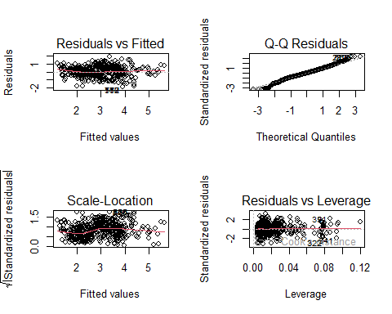
par(mfrow=c(1,1))
#grandissimo miglioramento
library(gvlma)
gvlma(lm5b)
##
## Call:
## lm(formula = log(depth) ~ magnitude + cdi_group + mmi + I(rms^2) +
## I(log(gap)) + continent + I(log(longitude)), data = levfiltr2)
##
## Coefficients:
## (Intercept) magnitude cdi_group2
## 3.62345 0.59135 0.06012
## cdi_group3 mmi2 mmi3
## -0.40766 0.34922 0.28444
## mmi4 mmi5 mmi6
## 0.02911 -0.64427 -1.21781
## mmi7 mmi8 I(rms^2)
## -1.41840 -1.59031 0.50259
## I(log(gap)) continentNorth America continentOcean
## -0.10000 -1.03475 -1.06130
## continentSouth America I(log(longitude))
## 0.34138 -0.52986
##
##
## ASSESSMENT OF THE LINEAR MODEL ASSUMPTIONS
## USING THE GLOBAL TEST ON 4 DEGREES-OF-FREEDOM:
## Level of Significance = 0.05
##
## Call:
## gvlma(x = lm5b)
##
## Value p-value Decision
## Global Stat 39.112 6.605e-08 Assumptions NOT satisfied!
## Skewness 2.231 1.353e-01 Assumptions acceptable.
## Kurtosis 25.022 5.668e-07 Assumptions NOT satisfied!
## Link Function 11.642 6.447e-04 Assumptions NOT satisfied!
## Heteroscedasticity 0.217 6.413e-01 Assumptions acceptable.
library(sandwich)
## Warning: il pacchetto 'sandwich' è stato creato con R versione 4.4.1
coeftest(lm5b, vcov=vcovHC(lm5b))
##
## t test of coefficients:
##
## Estimate Std. Error t value Pr(>|t|)
## (Intercept) 3.623446 0.343146 10.5595 < 2.2e-16 ***
## magnitude 0.591347 0.054197 10.9111 < 2.2e-16 ***
## cdi_group2 0.060120 0.040195 1.4957 0.1350589
## cdi_group3 -0.407664 0.084977 -4.7973 1.863e-06 ***
## mmi2 0.349225 0.285429 1.2235 0.2214375
## mmi3 0.284438 0.251052 1.1330 0.2575018
## mmi4 0.029113 0.256637 0.1134 0.9097056
## mmi5 -0.644268 0.264966 -2.4315 0.0152177 *
## mmi6 -1.217814 0.265054 -4.5946 4.913e-06 ***
## mmi7 -1.418402 0.267779 -5.2969 1.460e-07 ***
## mmi8 -1.590315 0.293939 -5.4104 7.941e-08 ***
## I(rms^2) 0.502587 0.074232 6.7705 2.230e-11 ***
## I(log(gap)) -0.099995 0.026924 -3.7139 0.0002158 ***
## continentNorth America -1.034748 0.124035 -8.3424 2.505e-16 ***
## continentOcean -1.061300 0.081485 -13.0245 < 2.2e-16 ***
## continentSouth America 0.341377 0.111374 3.0651 0.0022365 **
## I(log(longitude)) -0.529864 0.074183 -7.1427 1.805e-12 ***
## ---
## Signif. codes: 0 '***' 0.001 '**' 0.01 '*' 0.05 '.' 0.1 ' ' 1
library(lsmeans)
## Warning: il pacchetto 'lsmeans' è stato creato con R versione 4.4.1
## Caricamento del pacchetto richiesto: emmeans
## Warning: il pacchetto 'emmeans' è stato creato con R versione 4.4.1
## Welcome to emmeans.
## Caution: You lose important information if you filter this package's results.
## See '? untidy'
## The 'lsmeans' package is now basically a front end for 'emmeans'.
## Users are encouraged to switch the rest of the way.
## See help('transition') for more information, including how to
## convert old 'lsmeans' objects and scripts to work with 'emmeans'.
avPlots(lm5b)
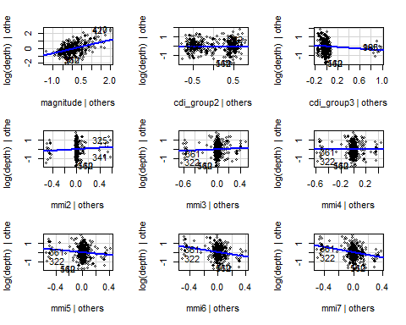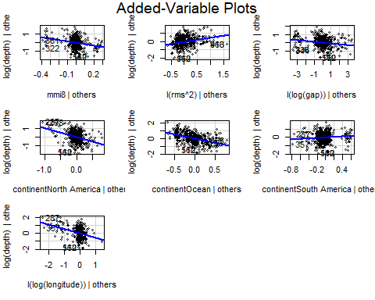
drop1(lm5b, test="F")
## Single term deletions
##
## Model:
## log(depth) ~ magnitude + cdi_group + mmi + I(rms^2) + I(log(gap)) +
## continent + I(log(longitude))
## Df Sum of Sq RSS AIC F value Pr(>F)
## <none> 316.60 -1071.20
## magnitude 1 58.359 374.96 -907.57 177.327 < 2.2e-16 ***
## cdi_group 2 6.594 323.19 -1055.01 10.018 4.940e-05 ***
## mmi 7 190.561 507.16 -623.90 82.719 < 2.2e-16 ***
## I(rms^2) 1 21.272 337.87 -1009.53 64.636 2.631e-15 ***
## I(log(gap)) 1 7.463 324.06 -1050.39 22.677 2.212e-06 ***
## continent 3 144.134 460.73 -709.89 145.987 < 2.2e-16 ***
## I(log(longitude)) 1 26.382 342.98 -994.84 80.162 < 2.2e-16 ***
## ---
## Signif. codes: 0 '***' 0.001 '**' 0.01 '*' 0.05 '.' 0.1 ' ' 1
lm5b$coefficients
## (Intercept) magnitude cdi_group2
## 3.62344560 0.59134659 0.06011950
## cdi_group3 mmi2 mmi3
## -0.40766448 0.34922467 0.28443821
## mmi4 mmi5 mmi6
## 0.02911278 -0.64426797 -1.21781358
## mmi7 mmi8 I(rms^2)
## -1.41840156 -1.59031460 0.50258744
## I(log(gap)) continentNorth America continentOcean
## -0.09999536 -1.03474825 -1.06129991
## continentSouth America I(log(longitude))
## 0.34137701 -0.52986414
library(forestmodel)
## Warning: il pacchetto 'forestmodel' è stato creato con R versione 4.4.1
print(forest_model(lm5b))
## Warning in recalculate_width_panels(panel_positions, mapped_text = mapped_text,
## : Unable to resize forest panel to be smaller than its heading; consider a
## smaller text size
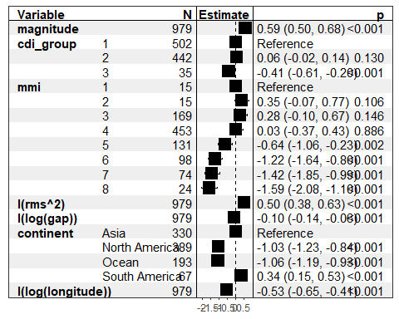
library(coefplot)
## Warning: il pacchetto 'coefplot' è stato creato con R versione 4.4.1
coefplot(lm5b, intercept=FALSE)
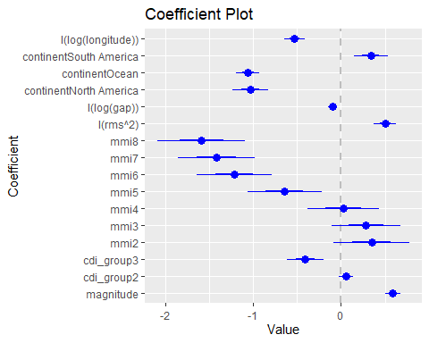
#effetti categoriche. Uso lsmeans, vedo le medie marginali dei valori previsti con una certa categoria.
#vedo anche come cambiano in base alla categoria nei contrast.
ls=lsmeans(lm5b,pairwise ~ cdi_group, adjust="tukey")
ls
## $lsmeans
## cdi_group lsmean SE df lower.CL upper.CL
## 1 2.49 0.0527 962 2.39 2.59
## 2 2.55 0.0577 962 2.44 2.66
## 3 2.08 0.1109 962 1.87 2.30
##
## Results are averaged over the levels of: mmi, continent
## Results are given on the log (not the response) scale.
## Confidence level used: 0.95
##
## $contrasts
## contrast estimate SE df t.ratio p.value
## cdi_group1 - cdi_group2 -0.0601 0.0397 962 -1.516 0.2838
## cdi_group1 - cdi_group3 0.4077 0.1036 962 3.937 0.0003
## cdi_group2 - cdi_group3 0.4678 0.1052 962 4.447 <.0001
##
## Results are averaged over the levels of: mmi, continent
## Results are given on the log (not the response) scale.
## P value adjustment: tukey method for comparing a family of 3 estimates
plot(ls$lsmeans, alpha = .05)
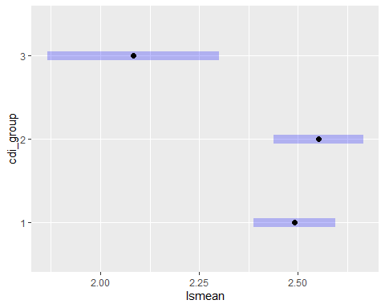
ls2=lsmeans(lm5b,pairwise ~ mmi)
ls2
## $lsmeans
## mmi lsmean SE df lower.CL upper.CL
## 1 2.90 0.2032 962 2.50 3.30
## 2 3.25 0.1795 962 2.90 3.60
## 3 3.19 0.0590 962 3.07 3.30
## 4 2.93 0.0453 962 2.84 3.02
## 5 2.26 0.0669 962 2.13 2.39
## 6 1.68 0.0770 962 1.53 1.83
## 7 1.48 0.0887 962 1.31 1.66
## 8 1.31 0.1440 962 1.03 1.59
##
## Results are averaged over the levels of: cdi_group, continent
## Results are given on the log (not the response) scale.
## Confidence level used: 0.95
##
## $contrasts
## contrast estimate SE df t.ratio p.value
## mmi1 - mmi2 -0.3492 0.2158 962 -1.618 0.7393
## mmi1 - mmi3 -0.2844 0.1957 962 -1.453 0.8318
## mmi1 - mmi4 -0.0291 0.2029 962 -0.143 1.0000
## mmi1 - mmi5 0.6443 0.2113 962 3.049 0.0483
## mmi1 - mmi6 1.2178 0.2149 962 5.666 <.0001
## mmi1 - mmi7 1.4184 0.2200 962 6.446 <.0001
## mmi1 - mmi8 1.5903 0.2495 962 6.375 <.0001
## mmi2 - mmi3 0.0648 0.1748 962 0.371 1.0000
## mmi2 - mmi4 0.3201 0.1800 962 1.778 0.6352
## mmi2 - mmi5 0.9935 0.1889 962 5.259 <.0001
## mmi2 - mmi6 1.5670 0.1936 962 8.095 <.0001
## mmi2 - mmi7 1.7676 0.1995 962 8.859 <.0001
## mmi2 - mmi8 1.9395 0.2327 962 8.337 <.0001
## mmi3 - mmi4 0.2553 0.0562 962 4.539 0.0002
## mmi3 - mmi5 0.9287 0.0749 962 12.407 <.0001
## mmi3 - mmi6 1.5023 0.0853 962 17.609 <.0001
## mmi3 - mmi7 1.7028 0.0972 962 17.522 <.0001
## mmi3 - mmi8 1.8748 0.1476 962 12.700 <.0001
## mmi4 - mmi5 0.6734 0.0588 962 11.449 <.0001
## mmi4 - mmi6 1.2469 0.0701 962 17.795 <.0001
## mmi4 - mmi7 1.4475 0.0821 962 17.638 <.0001
## mmi4 - mmi8 1.6194 0.1364 962 11.869 <.0001
## mmi5 - mmi6 0.5735 0.0782 962 7.331 <.0001
## mmi5 - mmi7 0.7741 0.0880 962 8.797 <.0001
## mmi5 - mmi8 0.9460 0.1380 962 6.855 <.0001
## mmi6 - mmi7 0.2006 0.0899 962 2.232 0.3335
## mmi6 - mmi8 0.3725 0.1375 962 2.709 0.1209
## mmi7 - mmi8 0.1719 0.1384 962 1.242 0.9191
##
## Results are averaged over the levels of: cdi_group, continent
## Results are given on the log (not the response) scale.
## P value adjustment: tukey method for comparing a family of 8 estimates
plot(ls2$lsmeans, alpha = .05)
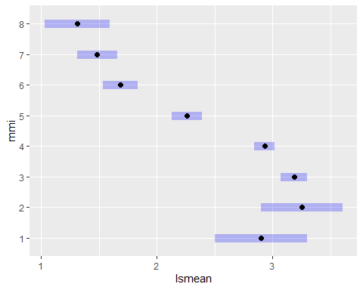
ls3=lsmeans(lm5b,pairwise ~ continent, adjust="tukey")
ls3
## $lsmeans
## continent lsmean SE df lower.CL upper.CL
## Asia 2.81 0.0615 962 2.69 2.93
## North America 1.78 0.0954 962 1.59 1.97
## Ocean 1.75 0.0665 962 1.62 1.88
## South America 3.16 0.1061 962 2.95 3.36
##
## Results are averaged over the levels of: cdi_group, mmi
## Results are given on the log (not the response) scale.
## Confidence level used: 0.95
##
## $contrasts
## contrast estimate SE df t.ratio p.value
## Asia - North America 1.0347 0.1018 962 10.168 <.0001
## Asia - Ocean 1.0613 0.0668 962 15.887 <.0001
## Asia - South America -0.3414 0.0971 962 -3.516 0.0026
## North America - Ocean 0.0266 0.1058 962 0.251 0.9945
## North America - South America -1.3761 0.1141 962 -12.062 <.0001
## Ocean - South America -1.4027 0.0957 962 -14.661 <.0001
##
## Results are averaged over the levels of: cdi_group, mmi
## Results are given on the log (not the response) scale.
## P value adjustment: tukey method for comparing a family of 4 estimates
plot(ls3$lsmeans, alpha = .05)
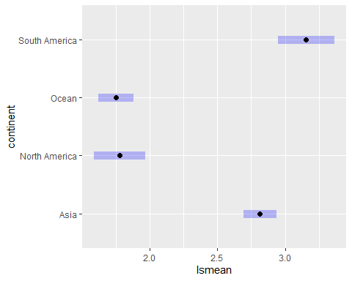
#confronto a coppie:
ls$contrasts#cdi_group
## contrast estimate SE df t.ratio p.value
## cdi_group1 - cdi_group2 -0.0601 0.0397 962 -1.516 0.2838
## cdi_group1 - cdi_group3 0.4077 0.1036 962 3.937 0.0003
## cdi_group2 - cdi_group3 0.4678 0.1052 962 4.447 <.0001
##
## Results are averaged over the levels of: mmi, continent
## Results are given on the log (not the response) scale.
## P value adjustment: tukey method for comparing a family of 3 estimates
ls2$contrasts#mmi
## contrast estimate SE df t.ratio p.value
## mmi1 - mmi2 -0.3492 0.2158 962 -1.618 0.7393
## mmi1 - mmi3 -0.2844 0.1957 962 -1.453 0.8318
## mmi1 - mmi4 -0.0291 0.2029 962 -0.143 1.0000
## mmi1 - mmi5 0.6443 0.2113 962 3.049 0.0483
## mmi1 - mmi6 1.2178 0.2149 962 5.666 <.0001
## mmi1 - mmi7 1.4184 0.2200 962 6.446 <.0001
## mmi1 - mmi8 1.5903 0.2495 962 6.375 <.0001
## mmi2 - mmi3 0.0648 0.1748 962 0.371 1.0000
## mmi2 - mmi4 0.3201 0.1800 962 1.778 0.6352
## mmi2 - mmi5 0.9935 0.1889 962 5.259 <.0001
## mmi2 - mmi6 1.5670 0.1936 962 8.095 <.0001
## mmi2 - mmi7 1.7676 0.1995 962 8.859 <.0001
## mmi2 - mmi8 1.9395 0.2327 962 8.337 <.0001
## mmi3 - mmi4 0.2553 0.0562 962 4.539 0.0002
## mmi3 - mmi5 0.9287 0.0749 962 12.407 <.0001
## mmi3 - mmi6 1.5023 0.0853 962 17.609 <.0001
## mmi3 - mmi7 1.7028 0.0972 962 17.522 <.0001
## mmi3 - mmi8 1.8748 0.1476 962 12.700 <.0001
## mmi4 - mmi5 0.6734 0.0588 962 11.449 <.0001
## mmi4 - mmi6 1.2469 0.0701 962 17.795 <.0001
## mmi4 - mmi7 1.4475 0.0821 962 17.638 <.0001
## mmi4 - mmi8 1.6194 0.1364 962 11.869 <.0001
## mmi5 - mmi6 0.5735 0.0782 962 7.331 <.0001
## mmi5 - mmi7 0.7741 0.0880 962 8.797 <.0001
## mmi5 - mmi8 0.9460 0.1380 962 6.855 <.0001
## mmi6 - mmi7 0.2006 0.0899 962 2.232 0.3335
## mmi6 - mmi8 0.3725 0.1375 962 2.709 0.1209
## mmi7 - mmi8 0.1719 0.1384 962 1.242 0.9191
##
## Results are averaged over the levels of: cdi_group, continent
## Results are given on the log (not the response) scale.
## P value adjustment: tukey method for comparing a family of 8 estimates
ls3$contrasts#continent
## contrast estimate SE df t.ratio p.value
## Asia - North America 1.0347 0.1018 962 10.168 <.0001
## Asia - Ocean 1.0613 0.0668 962 15.887 <.0001
## Asia - South America -0.3414 0.0971 962 -3.516 0.0026
## North America - Ocean 0.0266 0.1058 962 0.251 0.9945
## North America - South America -1.3761 0.1141 962 -12.062 <.0001
## Ocean - South America -1.4027 0.0957 962 -14.661 <.0001
##
## Results are averaged over the levels of: cdi_group, mmi
## Results are given on the log (not the response) scale.
## P value adjustment: tukey method for comparing a family of 4 estimates
# 6)Robust Inference ------------------------------------------------------
BOOT.MOD=Boot(lm5b, R=1999)
summary(BOOT.MOD, high.moments=TRUE)
##
## Number of bootstrap replications R = 1999
## original bootBias bootSE bootMed bootSkew
## (Intercept) 3.623446 0.01531955 0.336505 3.650452 -0.1065984
## magnitude 0.591347 -0.00185604 0.052888 0.590626 -0.0616263
## cdi_group2 0.060120 -0.00127827 0.038871 0.058694 0.0083349
## cdi_group3 -0.407664 0.00058127 0.082920 -0.407694 -0.0683185
## mmi2 0.349225 0.00202220 0.268873 0.357166 -0.0778099
## mmi3 0.284438 0.00260877 0.243504 0.289478 -0.0397610
## mmi4 0.029113 0.00476043 0.247234 0.029647 0.0036124
## mmi5 -0.644268 0.00525505 0.256674 -0.638419 -0.0109083
## mmi6 -1.217814 0.00629835 0.256234 -1.207768 -0.0067429
## mmi7 -1.418402 0.00334527 0.260202 -1.410587 0.0107999
## mmi8 -1.590315 0.00664461 0.284681 -1.588155 -0.0210305
## I(rms^2) 0.502587 0.00211404 0.073344 0.505770 0.0199241
## I(log(gap)) -0.099995 0.00025427 0.027006 -0.099920 0.0103082
## continentNorth America -1.034748 -0.00547874 0.121094 -1.044673 0.0953380
## continentOcean -1.061300 -0.00181741 0.079628 -1.061677 -0.0634210
## continentSouth America 0.341377 -0.00349364 0.109666 0.338474 -0.0480700
## I(log(longitude)) -0.529864 -0.00180003 0.072734 -0.534682 0.1171704
## bootKurtosis
## (Intercept) -0.050888
## magnitude -0.015986
## cdi_group2 -0.021943
## cdi_group3 0.172926
## mmi2 0.181374
## mmi3 0.106736
## mmi4 0.046085
## mmi5 0.086682
## mmi6 0.160799
## mmi7 0.185985
## mmi8 0.157833
## I(rms^2) -0.047662
## I(log(gap)) -0.215434
## continentNorth America -0.184063
## continentOcean -0.016739
## continentSouth America -0.034951
## I(log(longitude)) -0.060921
Confint(BOOT.MOD, level=c(.95), type="perc")
## Bootstrap percent confidence intervals
##
## Estimate 2.5 % 97.5 %
## (Intercept) 3.62344560 2.9578221 4.30097844
## magnitude 0.59134659 0.4845589 0.69375665
## cdi_group2 0.06011950 -0.0182448 0.13435127
## cdi_group3 -0.40766448 -0.5701244 -0.24460035
## mmi2 0.34922467 -0.2181081 0.87050810
## mmi3 0.28443821 -0.2151168 0.75606545
## mmi4 0.02911278 -0.4637386 0.50095469
## mmi5 -0.64426797 -1.1598271 -0.13820431
## mmi6 -1.21781358 -1.7282967 -0.70494761
## mmi7 -1.41840156 -1.9420360 -0.89334315
## mmi8 -1.59031460 -2.1538061 -1.02787175
## I(rms^2) 0.50258744 0.3629054 0.64778206
## I(log(gap)) -0.09999536 -0.1500438 -0.04754399
## continentNorth America -1.03474825 -1.2745219 -0.79487371
## continentOcean -1.06129991 -1.2191319 -0.90747366
## continentSouth America 0.34137701 0.1262009 0.55621049
## I(log(longitude)) -0.52986414 -0.6700500 -0.38128697
hist(BOOT.MOD, legend="separate")
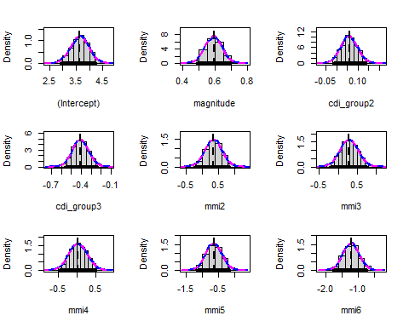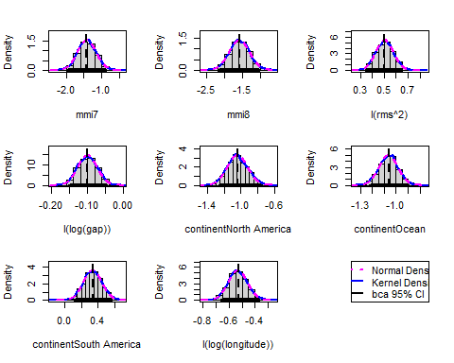
#Tutti i coefficienti del nostro modello sono all'interno dei rispettivi intervalli di confidenza.
#per alcuni valori di mmi ci sono beta che potrebbero avere valore 0 (compreso nell'intervallo di confidenza),
#tuttavia lo sapevamo già, guardando i test.
#Tutti i coefficienti del nostro modello corrispondono, o sono molto vicini, alla media. Hanno bias ristretto.

Parte 2: modello variabile binaria
# Parte 2: Modellazione variabile binaria ---------------------------------
#rm(list=ls())
#setwd("C:/Users/Università/Documents/Università/2024-25/Data Mining e Machine Learning/Elaborato")
#Carichiamo i dati:
#data <- read.csv("earthquakes.csv", stringsAsFactors = T, na.strings = "")
#trattiamo tsunami, mmi e cdi come factors
load("Pozzoli_Farina.RData")
data$tsunami = as.factor(data$tsunami)
data$mmi = as.factor(data$mmi)
data$cdi = as.factor(data$cdi)
#trasformiamo la variabile target (depth) in binaria, discretizzandola.
hist(data$depth)
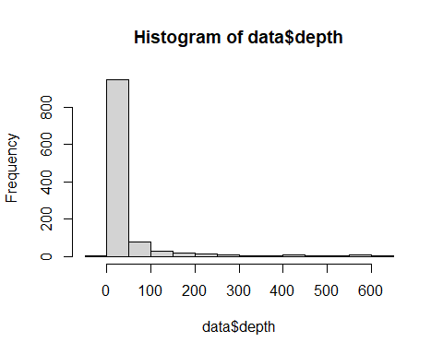
#Usiamo la soglia di 70 km di profondità.
#al di sotto troviamo i terremoti poco profondi ("shallow"), valore 0
#al di sopra abbiamo i terremoti profondi ("deep"), valore 1
data$dbin <- ifelse(data$depth > 70, 1, 0)
#Sistemiamo i missing data come abbiamo fatto precedentemente
library(dplyr)
## Warning: il pacchetto 'dplyr' è stato creato con R versione 4.4.1
##
## Caricamento pacchetto: 'dplyr'
## I seguenti oggetti sono mascherati da 'package:stats':
##
## filter, lag
## I seguenti oggetti sono mascherati da 'package:base':
##
## intersect, setdiff, setequal, union
b <- data %>% select(-id,-depth,-type,-title,-date,-url,-detailUrl,-status,-sig,-magType,-geometryType,-place,-placeOnly,-location,-subnational,-city,-locality,-postcode,-what3words,-locationDetails,-types,-ids,-code, -sources, -timezone)
b$continent[b$continent == "Insluar Oceania"] <- "Insular Oceania"
library(Hmisc)
## Warning: il pacchetto 'Hmisc' è stato creato con R versione 4.4.1
##
## Caricamento pacchetto: 'Hmisc'
## I seguenti oggetti sono mascherati da 'package:dplyr':
##
## src, summarize
## I seguenti oggetti sono mascherati da 'package:base':
##
## format.pval, units
b$alert=impute(b$alert, "white")
b <- b %>%
mutate(continent = case_when(
country == "Chile" & is.na(continent) ~ factor("South America", levels = levels(continent)), # Nuova categoria
TRUE ~ continent # Mantieni i valori esistenti
))
b <- b %>%
mutate(continent = case_when(
country == "Peru" & is.na(continent) ~ factor("South America", levels = levels(continent)), # Nuova categoria
TRUE ~ continent # Mantieni i valori esistenti
))
b <- b %>%
mutate(continent = case_when(
country == "Japan" & is.na(continent) ~ factor("Asia", levels = levels(continent)), # Nuova categoria
TRUE ~ continent # Mantieni i valori esistenti
))
b <- b %>%
mutate(continent = case_when(
country == "Taiwan (Province of China)" & is.na(continent) ~ factor("Asia", levels = levels(continent)), # Nuova categoria
TRUE ~ continent # Mantieni i valori esistenti
))
b <- b %>%
mutate(continent = case_when(
country == "United States of America (the)" & is.na(continent) ~ factor("North America", levels = levels(continent)), # Nuova categoria
TRUE ~ continent # Mantieni i valori esistenti
))
b <- b %>%
mutate(continent = case_when(
country == "Indonesia" & is.na(continent) ~ factor("Insular Oceania", levels = levels(continent)), # Nuova categoria
TRUE ~ continent # Mantieni i valori esistenti
))
b$continent <- factor(b$continent, levels = c(levels(b$continent), "Ocean"))
b <- b %>%
mutate(continent = case_when(
is.na(country) & is.na(continent) ~ "Ocean", # Sostituzione con "Ocean"
TRUE ~ as.factor(continent) # Mantieni i valori esistenti come caratteri
))
b <- b %>% select(-country)
colnames(b)
## [1] "magnitude" "time" "updated" "felt" "cdi"
## [6] "mmi" "alert" "tsunami" "net" "nst"
## [11] "dmin" "rms" "gap" "latitude" "longitude"
## [16] "distanceKM" "continent" "dbin"
b$continent <- factor(b$continent)
#Abbiamo così sistemato i missing values.
#Diamo un'occhiata ai dati
table(b$dbin)
##
## 0 1
## 1001 136
prop.table(table(b$dbin))
##
## 0 1
## 0.880387 0.119613
# Modello -----------------------------------------------------------------
#Costruiamo il nostro modello
logi2 = glm(dbin ~ magnitude + tsunami + rms + longitude, data=b,family = binomial)
summary(logi2)
##
## Call:
## glm(formula = dbin ~ magnitude + tsunami + rms + longitude, family = binomial,
## data = b)
##
## Coefficients:
## Estimate Std. Error z value Pr(>|z|)
## (Intercept) -11.407070 0.934283 -12.209 < 2e-16 ***
## magnitude 1.519530 0.171832 8.843 < 2e-16 ***
## tsunami1 -1.588606 0.438848 -3.620 0.000295 ***
## rms 2.337307 0.412251 5.670 1.43e-08 ***
## longitude -0.007682 0.001147 -6.698 2.11e-11 ***
## ---
## Signif. codes: 0 '***' 0.001 '**' 0.01 '*' 0.05 '.' 0.1 ' ' 1
##
## (Dispersion parameter for binomial family taken to be 1)
##
## Null deviance: 832.63 on 1136 degrees of freedom
## Residual deviance: 641.40 on 1132 degrees of freedom
## AIC: 651.4
##
## Number of Fisher Scoring iterations: 6
#Osserviamo i valori dei coefficienti
library(coefplot)
## Warning: il pacchetto 'coefplot' è stato creato con R versione 4.4.1
## Caricamento del pacchetto richiesto: ggplot2
## Warning: il pacchetto 'ggplot2' è stato creato con R versione 4.4.1
coefplot(logi2, intercept=FALSE)
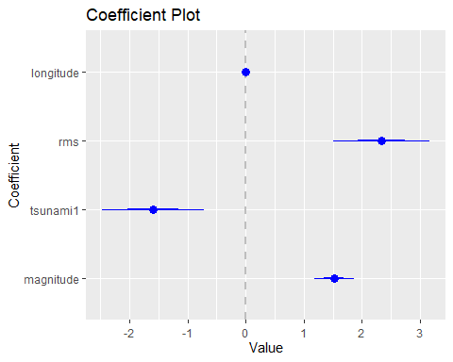
library(forestmodel)
## Warning: il pacchetto 'forestmodel' è stato creato con R versione 4.4.1
print(forest_model(logi2))
## Warning in recalculate_width_panels(panel_positions, mapped_text = mapped_text,
## : Unable to resize forest panel to be smaller than its heading; consider a
## smaller text size
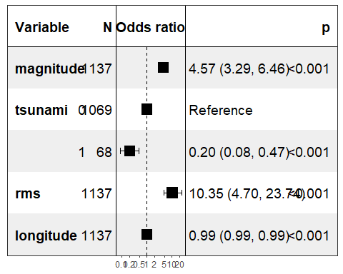
#Verifichiamo la Zero Variance
library(funModeling)
## Warning: il pacchetto 'funModeling' è stato creato con R versione 4.4.1
## funModeling v.1.9.5 :)
## Examples and tutorials at livebook.datascienceheroes.com
## / Now in Spanish: librovivodecienciadedatos.ai
status=df_status( b[ ,c("magnitude" , "tsunami" , "rms" , "longitude") ], print_results = F)
status
## variable q_zeros p_zeros q_na p_na q_inf p_inf type unique
## 1 magnitude 0 0.00 0 0 0 0 numeric 86
## 2 tsunami 1069 94.02 0 0 0 0 factor 2
## 3 rms 2 0.18 0 0 0 0 numeric 130
## 4 longitude 0 0.00 0 0 0 0 numeric 590
#Non ho zero variance, tutte le variabili hanno diversi valori diversi.
#non ho nemmeno Na in quanot li ho gestiti prima.
#Controlliamo la collinearità
#Valutiamo VIF e TOL
library(mctest)
#usiamo target fittizio
y = as.numeric(row.names( b))
#selezioniamo covariate.
cov=attr(terms(logi2), "term.labels")
d_numeric <- b[,cov]%>% dplyr::select_if(is.numeric)
X<-d_numeric
X=as.matrix(X)
fit=lm(y ~ X)
imcdiag(fit)
##
## Call:
## imcdiag(mod = fit)
##
##
## All Individual Multicollinearity Diagnostics Result
##
## VIF TOL Wi Fi Leamer CVIF Klein IND1 IND2
## Xmagnitude 2.8617 0.3494 1055.5605 2112.9828 0.5911 3.0173 1 0.0006 1.2440
## Xrms 1.5636 0.6396 319.5340 639.6315 0.7997 1.6486 1 0.0011 0.6892
## Xlongitude 2.2615 0.4422 715.2934 1431.8484 0.6650 2.3845 1 0.0008 1.0667
##
## 1 --> COLLINEARITY is detected by the test
## 0 --> COLLINEARITY is not detected by the test
##
## Xrms , coefficient(s) are non-significant may be due to multicollinearity
##
## R-square of y on all x: 0.0547
##
## * use method argument to check which regressors may be the reason of collinearity
## ===================================
#Non è presente collinearità: ho VIF contenuti e TOL maggiori di 0.3
#Odds Ratio (quanto il valore 1 è più probabile dello 0 date le x_i)
exp(logi2$coefficients)
## (Intercept) magnitude tsunami1 rms longitude
## 1.111661e-05 4.570077e+00 2.042102e-01 1.035331e+01 9.923479e-01
exp(confint(logi2))
## Waiting for profiling to be done...
## 2.5 % 97.5 %
## (Intercept) 1.650802e-06 6.485410e-05
## magnitude 3.286999e+00 6.456194e+00
## tsunami1 8.282237e-02 4.658421e-01
## rms 4.696384e+00 2.374222e+01
## longitude 9.900912e-01 9.945584e-01
#Osserviamo
a=exp(cbind(OR=coef(logi2), confint(logi2)))
## Waiting for profiling to be done...
round(a, digits = 4)
## OR 2.5 % 97.5 %
## (Intercept) 0.0000 0.0000 0.0001
## magnitude 4.5701 3.2870 6.4562
## tsunami1 0.2042 0.0828 0.4658
## rms 10.3533 4.6964 23.7422
## longitude 0.9923 0.9901 0.9946
#Guardiamo come cambia la devianza del modello se escludiamo una variabile.
drop1(logi2, test="LRT")
## Single term deletions
##
## Model:
## dbin ~ magnitude + tsunami + rms + longitude
## Df Deviance AIC LRT Pr(>Chi)
## <none> 641.40 651.40
## magnitude 1 730.85 738.85 89.442 < 2.2e-16 ***
## tsunami 1 656.73 664.73 15.322 9.066e-05 ***
## rms 1 675.61 683.61 34.206 4.957e-09 ***
## longitude 1 688.31 696.31 46.902 7.461e-12 ***
## ---
## Signif. codes: 0 '***' 0.001 '**' 0.01 '*' 0.05 '.' 0.1 ' ' 1
#controlliamo se c'è separation tra tsunami e dbin
table(b$dbin,b$tsunami)
##
## 0 1
## 0 945 56
## 1 124 12
# non c'è
#Le variabili sono tutte significative, il modello peggiora se escludiamo una delle var
par(mfrow=c(2,2))
plot(logi2)
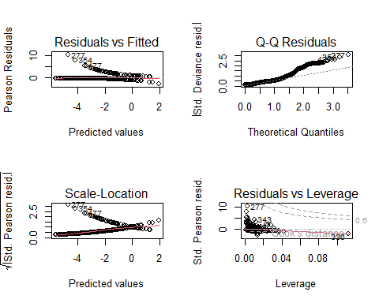
par(mfrow=c(1,1))
#Guardiamo quanto è accurato nelle prediction il nostro modello
predicted_p <- predict(logi2, b, type="response")
head(predicted_p)
## 1 2 3 4 5 6
## 0.099073713 0.066621910 0.014518059 0.011602882 0.022603685 0.006836466
b$predicted_p <- predict(logi2, b, type="response")
tail(b)
## magnitude time updated felt cdi mmi alert tsunami net nst
## 1132 5.9 1.696664e+12 1.702589e+12 3 5 7 yellow 0 us 227
## 1133 6.3 1.696663e+12 1.702589e+12 11 9 8 orange 0 us 244
## 1134 5.4 1.696661e+12 1.702589e+12 0 0 7 yellow 0 us 165
## 1135 6.3 1.696661e+12 1.702589e+12 19 8 8 orange 0 us 279
## 1136 5.7 1.696325e+12 1.702589e+12 131 8 7 green 0 us 226
## 1137 5.8 1.691251e+12 1.696715e+12 25 5 4 green 0 us 211
## dmin rms gap latitude longitude distanceKM continent dbin predicted_p
## 1132 5.810 0.59 43 34.6391 62.0327 35 Asia 0 0.17663121
## 1133 5.904 0.50 43 34.5492 61.8840 25 Asia 0 0.24218388
## 1134 5.858 0.47 54 34.5414 61.9547 26 Asia 0 0.07050335
## 1135 5.872 0.58 43 34.6259 61.9260 32 Asia 0 0.27806472
## 1136 3.930 0.33 23 29.5163 81.2118 39 Asia 0 0.06924974
## 1137 2.347 0.88 15 36.4512 70.7023 47 Asia 1 0.25349267
#Vediamo le previsioni
b$predicted_y <- ifelse(b$predicted_p > 0.5,1,0)
tail(b)
## magnitude time updated felt cdi mmi alert tsunami net nst
## 1132 5.9 1.696664e+12 1.702589e+12 3 5 7 yellow 0 us 227
## 1133 6.3 1.696663e+12 1.702589e+12 11 9 8 orange 0 us 244
## 1134 5.4 1.696661e+12 1.702589e+12 0 0 7 yellow 0 us 165
## 1135 6.3 1.696661e+12 1.702589e+12 19 8 8 orange 0 us 279
## 1136 5.7 1.696325e+12 1.702589e+12 131 8 7 green 0 us 226
## 1137 5.8 1.691251e+12 1.696715e+12 25 5 4 green 0 us 211
## dmin rms gap latitude longitude distanceKM continent dbin predicted_p
## 1132 5.810 0.59 43 34.6391 62.0327 35 Asia 0 0.17663121
## 1133 5.904 0.50 43 34.5492 61.8840 25 Asia 0 0.24218388
## 1134 5.858 0.47 54 34.5414 61.9547 26 Asia 0 0.07050335
## 1135 5.872 0.58 43 34.6259 61.9260 32 Asia 0 0.27806472
## 1136 3.930 0.33 23 29.5163 81.2118 39 Asia 0 0.06924974
## 1137 2.347 0.88 15 36.4512 70.7023 47 Asia 1 0.25349267
## predicted_y
## 1132 0
## 1133 0
## 1134 0
## 1135 0
## 1136 0
## 1137 0
#Classificazione:
table(observed=b$dbin, predicted=b$predicted_y)
## predicted
## observed 0 1
## 0 984 17
## 1 102 34
#in percentuale
t=table(observed=b$dbin,predicted=b$predicted_y)
t
## predicted
## observed 0 1
## 0 984 17
## 1 102 34
t2=t/sum(t)
t2
## predicted
## observed 0 1
## 0 0.86543536 0.01495163
## 1 0.08970976 0.02990325
#accuratezza
acc=t2[1,1]+t2[2,2]
acc
## [1] 0.8953386
#Error rate
1-acc
## [1] 0.1046614
#buono nel predire gli 0, male per gli 1.

